

PROJECT

TOP2121 – OBJECT-ORIENTED PROGRAMMING
TRIMESTER 1, 2023/2024 (TERM 2310)

Project Title: Malaysian Medicinal Plants and Herbs Database System
Lab Section: 1B
Submission Date: 14 FEB 2024

NO | STUDENT ID | STUDENT NAME | MAJOR
 | 1221302732 | Hani Hamizah binti Hamzan | ST
 | 1211305334 | Siti Noorsyazwanie binti Ahmad Supiee | ST

Contents
Task Distribution 2
1. Introduction 3
2. Problem Statements 4
3. Objectives 5
4. Program Scope 6
5. Detailed Description 7
6. Screenshot of the program 13
7. Reference 23
8. Appendix 25

Task Distribution
No. | Student ID | Student Name | Tasks Completed
 | 1221302732 | Hani Hamizah binti Hamzan | - Performed the coding and database  - Program Scope  - Use Case Diagram  - Draft Interface Design and details  - Provide the screenshot of the system and tagging  - Citing references
 | 1211305334 | Siti Noorsyazwanie binti Ahmad Supiee | - Introduction  - Problem Statement  - Objective  - Class Diagram & State Diagram  - Explanation for the screenshot  - Provide pictures for system

Introduction
The Malaysian Medicinal Plants and Herbs Database System is a cutting-edge and all-encompassing platform created to organize and distribute information regarding the abundant variety of medicinal plants and herbs discovered in Malaysia. The purpose of this system is to facilitate access to accurate and current information regarding the traditional and modern applications of these valuable resources for researchers, healthcare professionals and the general public.

This approach offers unique insights on the traditional applications, scientific characteristics, and cultural importance of these plant gems. Malaysia possesses a diverse range of plants that possess powerful medicinal characteristics, which are closely tied to the country's abundant cultural legacy and traditional methods of healing. The Malaysian Medicinal Plants and Herbs Database functions as a digital repository, consolidating a wide array of information on these plants, facilitating convenient access for researchers, healthcare professionals, and enthusiasts.

2. Problem Statements
- Incomplete database - The system might not contain exhaustive information on all Malaysian medicinal plants and herbs, resulting in incomplete or erroneous data.
- Limited User Accessibility - The system may not be readily accessible to a wide range of users, including persons with varying degrees of technical expertise or those with disabilities.
- Insufficient Multimedia Content - The absence of visual aids such as photographs, videos, or illustrations may impede the comprehension of plant attributes and use.
- Inefficient Search and Navigation - The website's search functionality and navigation system may lack effectiveness or user-friendliness, impeding users' ability to promptly locate pertinent information.
- Limited Awareness of Conservation Practices - There is a lack of awareness regarding the significance of protecting medicinal plant species and advancing sustainable procedures for harvesting and production.

Objectives
- To offer precise and current information regarding the identification, characteristics, traditional applications, and prospective therapeutic advantages of medicinal plants. It caters to a wide range of users, including researchers, healthcare practitioners, and the general public.
- The database provides a credible source of information for researchers, students, and educators who are interested in herbal medicine and associated sciences. It facilitates the acquisition of knowledge and promotes academic progress in this field.
- The system can contribute to the preservation of cultural traditions and the biodiversity of medicinal plant species by recording traditional applications of these plants and promoting sustainable harvesting practices.
- To establish a platform that fosters collaboration between traditional medicine practitioners and modern healthcare experts, allowing for the coexistence of traditional and scientific knowledge.
- To educate users on responsible methods that promote the sustainable availability of medicinal plants while minimising harm to ecosystems and the risk of jeopardising plant species.

Program Scope

Features
This program needs a user to verify whether they will log in as a user or as an admin. Admin will have separate role that allows them to few other functions such as viewing the current user and their profile for security and documentation purpose. Meanwhile for users, they will be log in and only allow to some features in the program. This program consists of Home page, Browse Page, About page, Buy page and Quiz page.
Home page is consists of a brief introduction about this organization.
About page consists of the introduction to collaborated research centres
Browse section is the main section of this program. This is where users can find any traditional medicinal plants and herb from 3 main cultures in Malaysia which are Malay, Indian and Chinese.
In Buy section, users can buy plants they want by clicking the link that redirecting them to buying form.
In Game section, there are 6 simple questions about plants’ name. Users can choose using radio button and click submit button to check their answer.

Functions
Functions in this program including users can register as new users, or existing users, users can browse plants plants and playing quiz to measure their knowledge of plant’s name.
Meanwhile for admin, there a few additional functions such as viewing all users’s information and record.

Constraints
There are some constraints in this program such as:
      - Starting from the beginning of the program, there is no back button for user to return after choosing whether to login as an admin or as a user. Thus, if the user accidentally chose admin login, they must exit the program and choose again.
      - Secondly, there is no auto updated user list after admin adding new user, so admin must close the user list panel after adding new user and open it again to see the new users added.
      - Lastly, the major constraint in our project is, the image icon set on jLabel is not working in jar file. However, they are working well when running on compiler (Netbeans 17).

Detailed Description

Use Case Diagram
Use case diagram is used to show the simplify version of how our system works. In our system, admin is a subclass of browser which mean the admin can do all browser do but with an additional feature which the admin can manipulate data of user such as create and delete the user when not needed anymore. As from general functionalities, browser can browse the plants, can create user as for new user, can buy palnts from farmer, and can play the quiz. When user is create or when user is deleted, the system will access user database. As for browsing plants, when users are browsing plants, they can opt to see 3 types of traditional herbs whether from Malay, Indian or Chinese traditional herbs. Our system is called Malaysia Herbs.

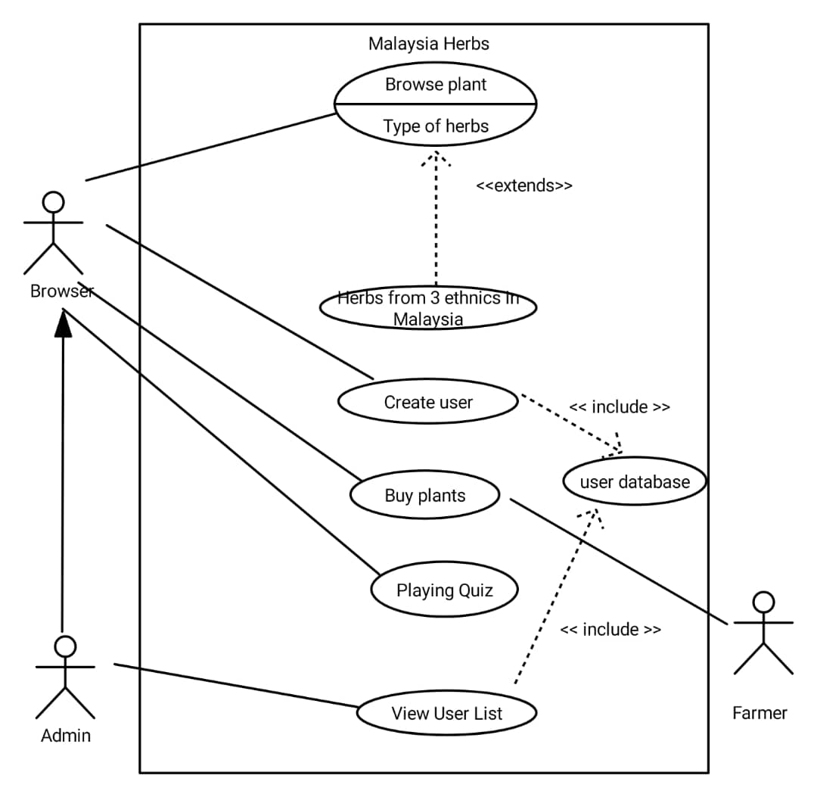
Figure 1. Use case Diagram of Malaysia Herb System

Class Diagram
Class Diagram is a type of UML that shows static structure diagram of the system by showing classes involved in the system, attributes, systems and insteraction between classes.

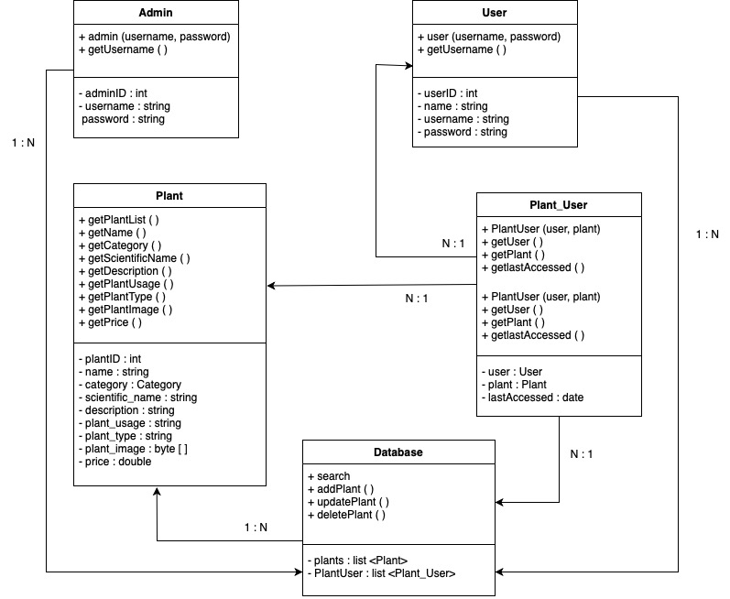
Figure 2 Class Diagram of Malaysia Herb system

State Diagram
State diagram is a behavioral diagram that shows hwo the system start until the end of the system. Our system started with Login and will end at the game pae for the user.
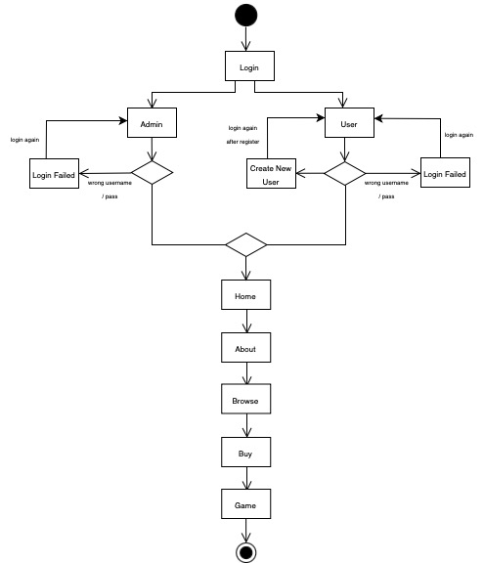
Figure 3 State Diagram of Malaysia Herb system

Draft Interface Design
For draft interface design, we are planning to use sql file to store all data because sql file supporting picture format which is a need in our system. At first, we are also planning to make hyperlink text to take user to their our collaborators and research centre. For browse page, the intial design is to separate each pane and table according to what traditional herbs are they. Users also should be able to download pdf file of plants information.
Our draft design discussion also includes recognizing entities involves in the system. We are also planning to make a buy page where users can buy their own plants. As for login, initially we were planning to make this system available without login as a user, instead only admin needed to login into the system.
A for additional features, we are planning to make search field so users can easily find any plants or herbs. Our draft interfaces are shown in figure 4 until figure 6.
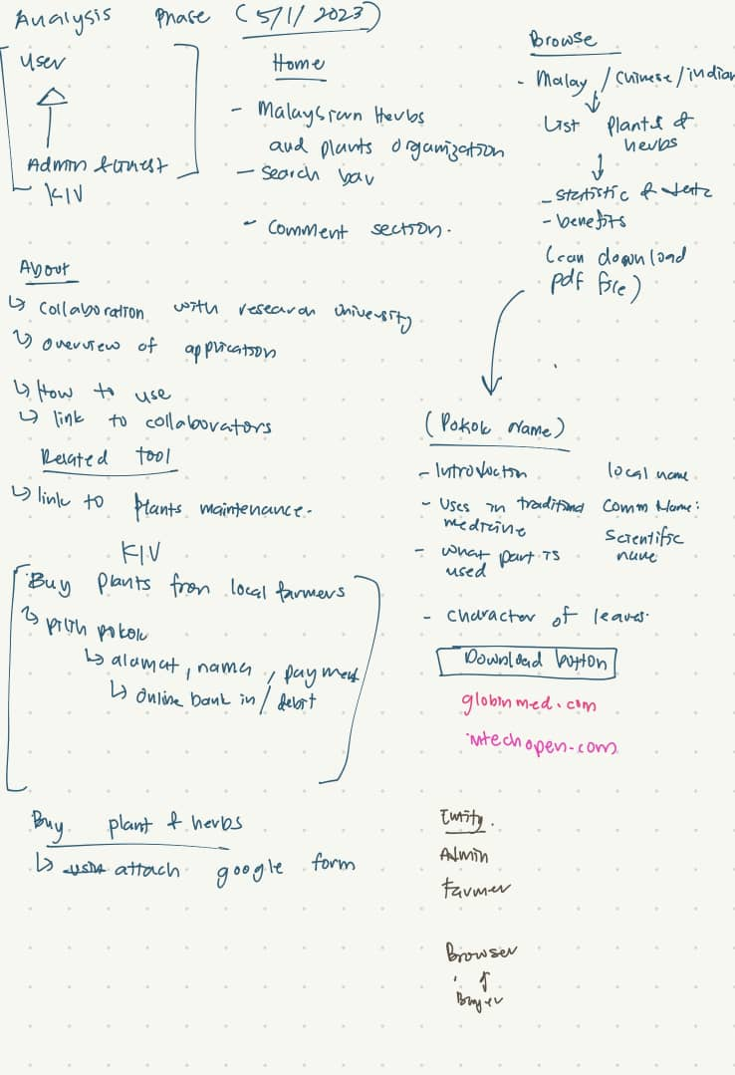
Figure 4 Draft of discussion on 5th January 2024

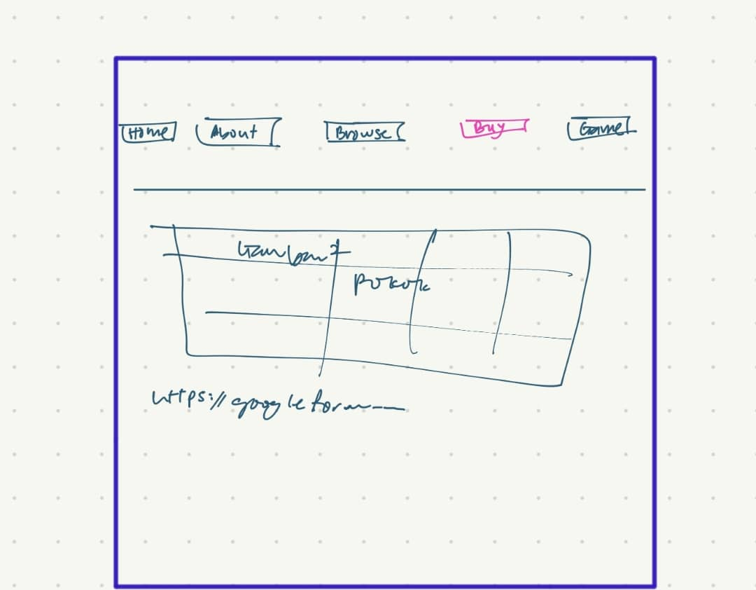
Figure 5 Draft interface for buy page
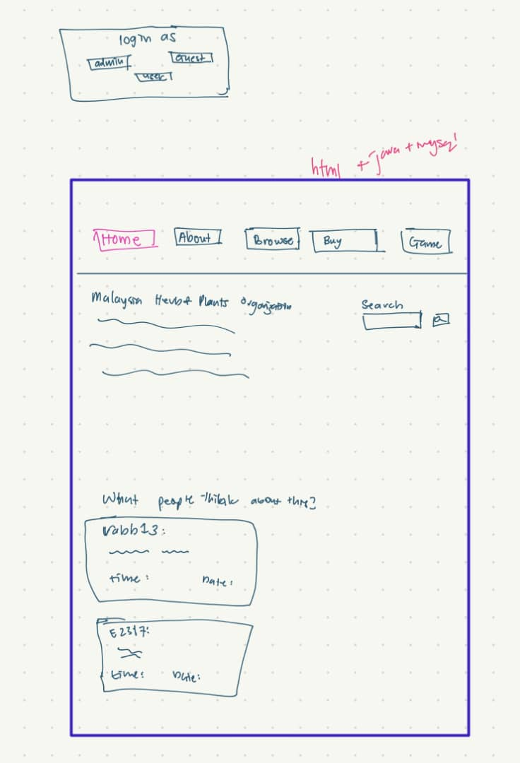
Figure 6 Draft interface for home page after login

Detail Final Program
In this final program, there are 3 main classes used to interact and get information.
- Database.java
This class is used to connect to the database so that everytime any class need to connect to database, this class will be called upon. In this database class, username, password, database name and connection is established. Error handling here is to handle the error if connection cannot be established.
- Plant_User.java
In this class users name and details are declared to be called upon. For example, attribute in this class will be called in userlogin.java when users want to login into system. Set or get method also will be used when displaying list user for admin and when admin want to delete or create new users
- Plant.java
In this class, plants’ detail will be declared so that any other class can call the attributes in it. This class is connected to plants table in malaysiaherbs database. Get method and set method in this class is used to display plants’ details in MAIN_WINDOW.java
For our final design, we demolish search function and displaced text on about page with picture talking about our collaborators in research instead. We also displayed the list of plants in a list with type of traditional herbs instead of making different pane for each section. As we are using tabbedpane in java swing, I figure it is not possible for one button (previous and next button) when browsing the plants to access different plants.
We also taking users’ convenience into account when designing this program so that users do not need to open too many panel instead they can stay on the main window. As for sql, I figure we can store picture in the longblob type and to make it display in the java program, we must use byte[] type.
Get methods in each class is used to return the data value from the database. Meanwhile the set methos in each class is used to display the value from the database into java program.
As for user interface, we are using java swing because as it is lighter and faster than java applet. Pictures in our program are displayed using JLabel as icon using ImageIcon class. As for tabbed pane, jPanel is used as containers. Colours for each containers are determined by using rgb pixels value. jDialog are also used to show messages such as “New User Created” or “delete this user?”or any error message such as “Invalid password”.

Screenshot of the program
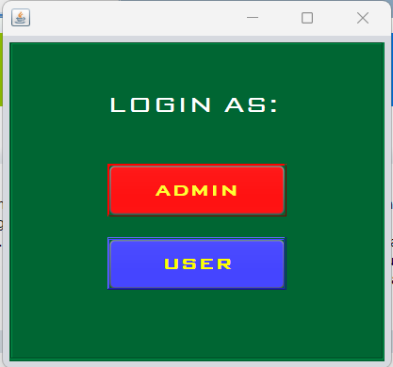
Figure 7 Initial Login Page
“Login” page serves as the entry point for users to access the Malaysian Medicinal Herbs & Plants Database System. Users are presented with the option to log in as either an administrator (admin) or a regular user.

      - User Login
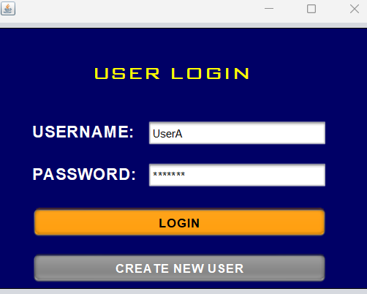
Figure 8 User Login panel
“User Login” Interface is designed to authenticate individual users and grant access to the Malaysian Medicinal Herbs & Plants Database System. This interface prompts users to provide their login credentials, consisting of a username and password. Users are required to enter their unique username and corresponding password in the designated input fields.

Figure 9 Homepage of the system
There’s a ”Home” page that users are redirected to after successfully logging in. Home Page serves as the central hub of the Malaysian Medicinal Herbs & Plants Database System, providing users with an overview and quick access to key functionalities.


Figure 10 About us page
There’s an ”About” page that provides information about the project and the team behind it. This page offers users insights into the Malaysian Medicinal Herbs & Plants Database System, providing a glimpse into the project's purpose, goals, and the individuals or team responsible for its development.
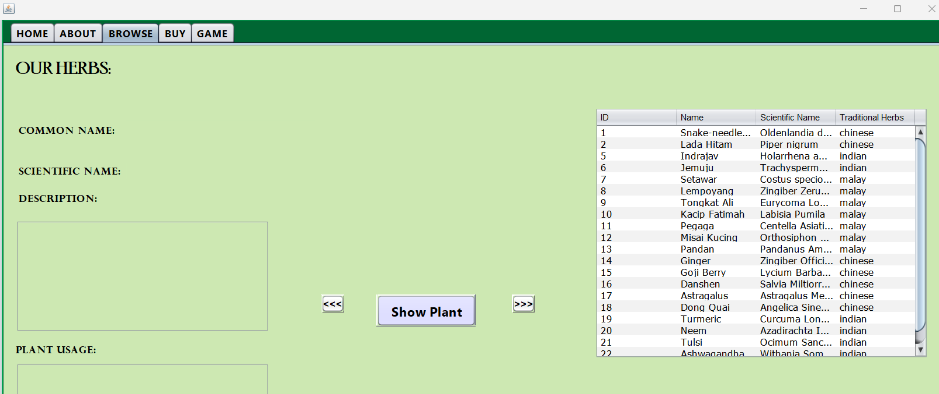

Figure 11 Browse page

There's a Browse page that displays information about different herbs, including their common name, scientific name, description, and plant usage. The red square is a button for user to go to the first plants in the list.

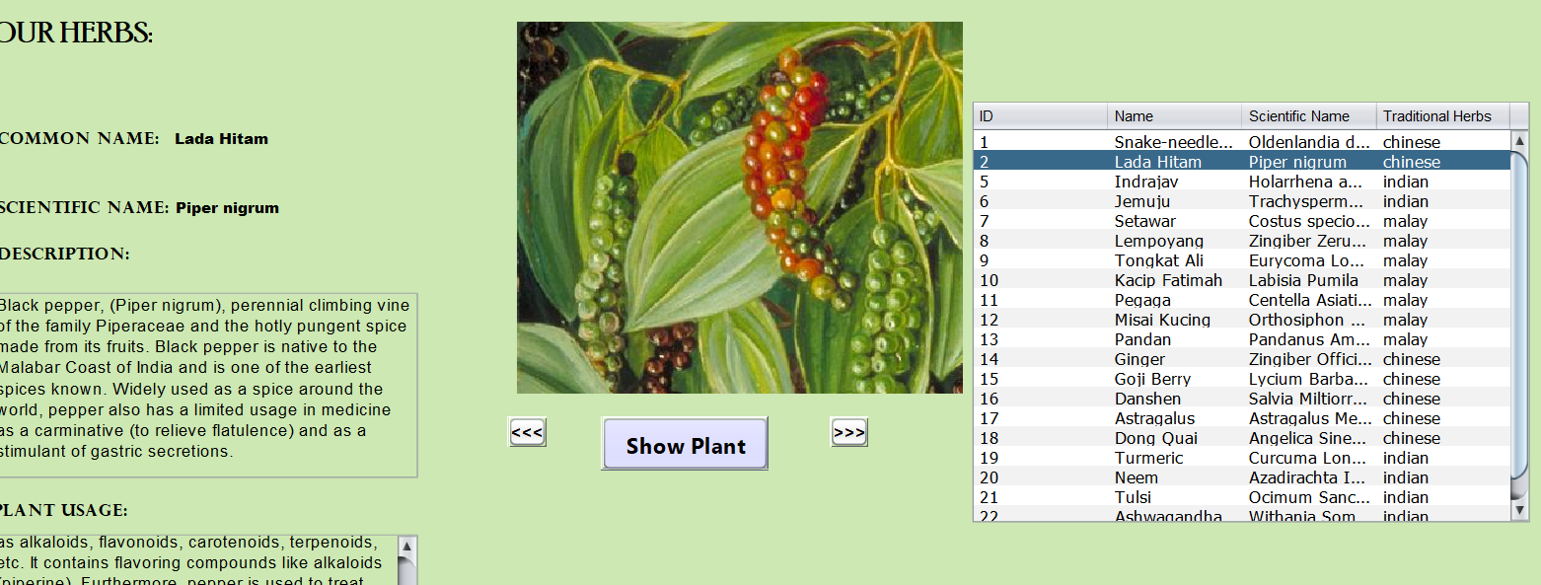
Figure 12 Browse page showing picture when you clicked on the name in the list
The "Browse” page is a comprehensive catalog within the Malaysian Medicinal Herbs & Plants Database System, allowing users to explore and learn about various herbs.

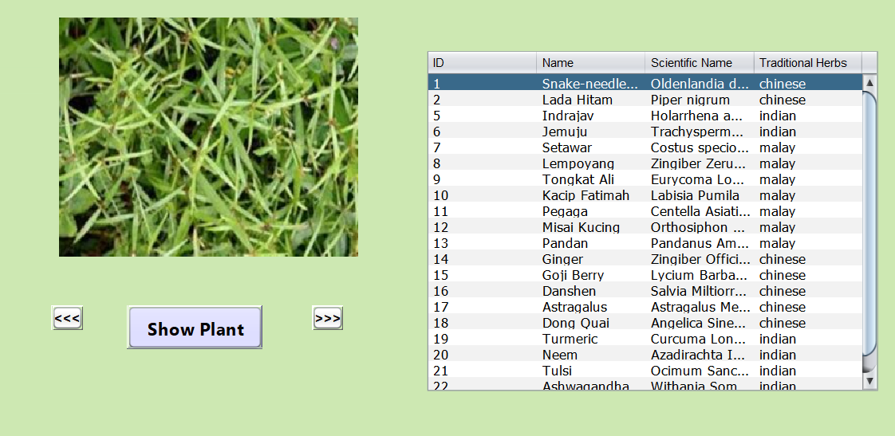
Figure 13 showing the plant list with previous and next button for users to browse one by one plants

The page presents a list of herbs with essential details such as image, common name, scientific name, description, and plant usage. Users can use this page to gain knowledge about the diverse range of medicinal herbs and plants available in the database. The red square is previous button for user to click when to see one by one plants in the list.
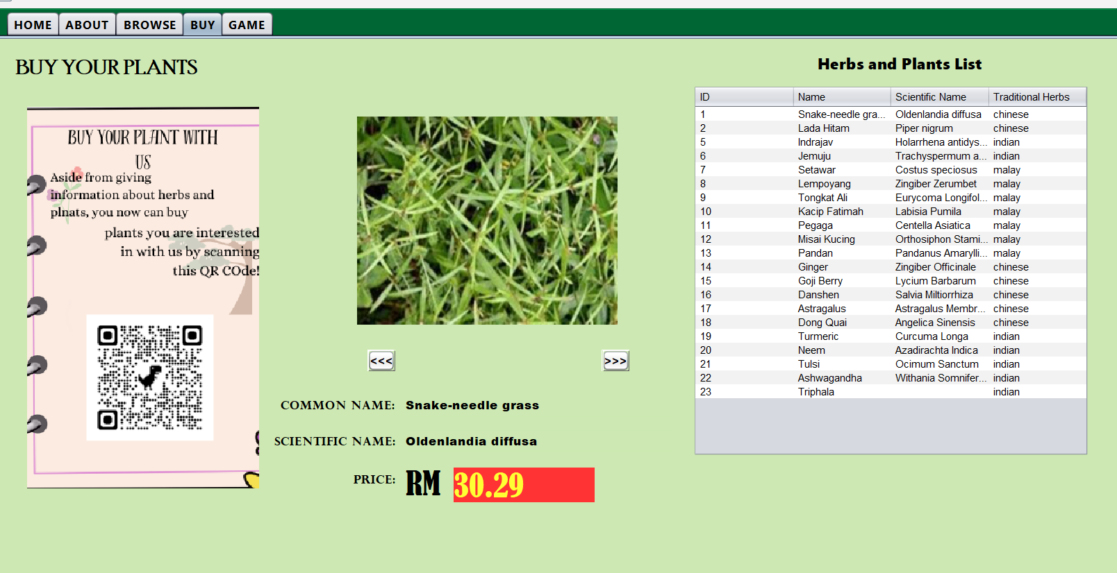
Figure 14 BUy page showing the price of plants
The “Buy” page facilitates the purchase of plants within the system by utilizing QR codes. Users can scan the provided QR codes to access detailed information about specific plants, including their prices. The page provides a seamless and interactive shopping experience for users interested in acquiring medicinal plants.

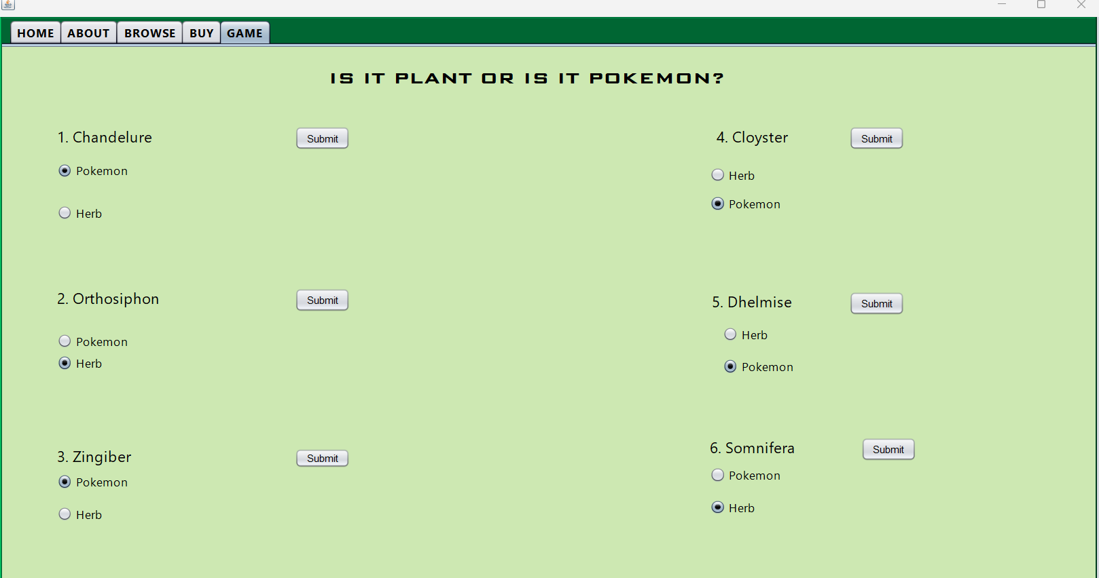
Figure 15 Initial state of Game page
The “Game” page provides an interactive and educational experience by offering users a simple quiz about plants featured in the database.
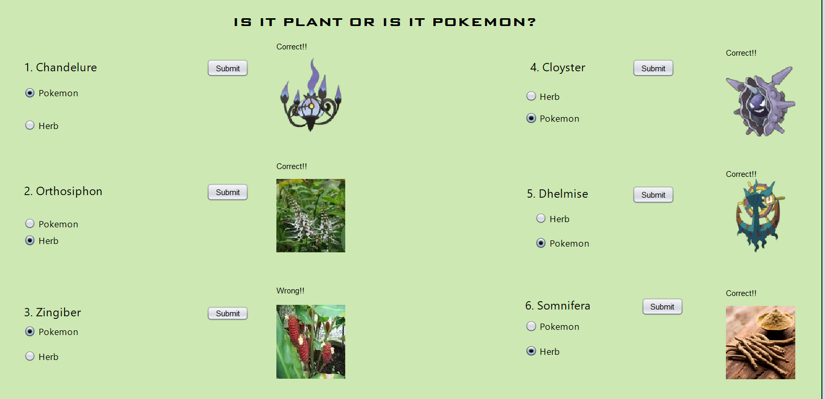
Figure 16 Game page after submit button is clicked
Users can test their knowledge about medicinal herbs and plants through a series of questions and challenges related to their characteristics, uses, or other relevant information.

      - Admin Login
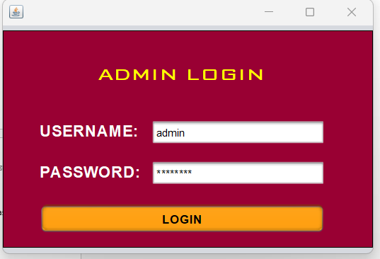
Figure 17 admin login page
There's a separate "Admin Login" page for administrators to access the administrative functionalities of the Malaysian Medicinal Herbs & Plants Database System. This is secure access to the administrative features and controls of the system.

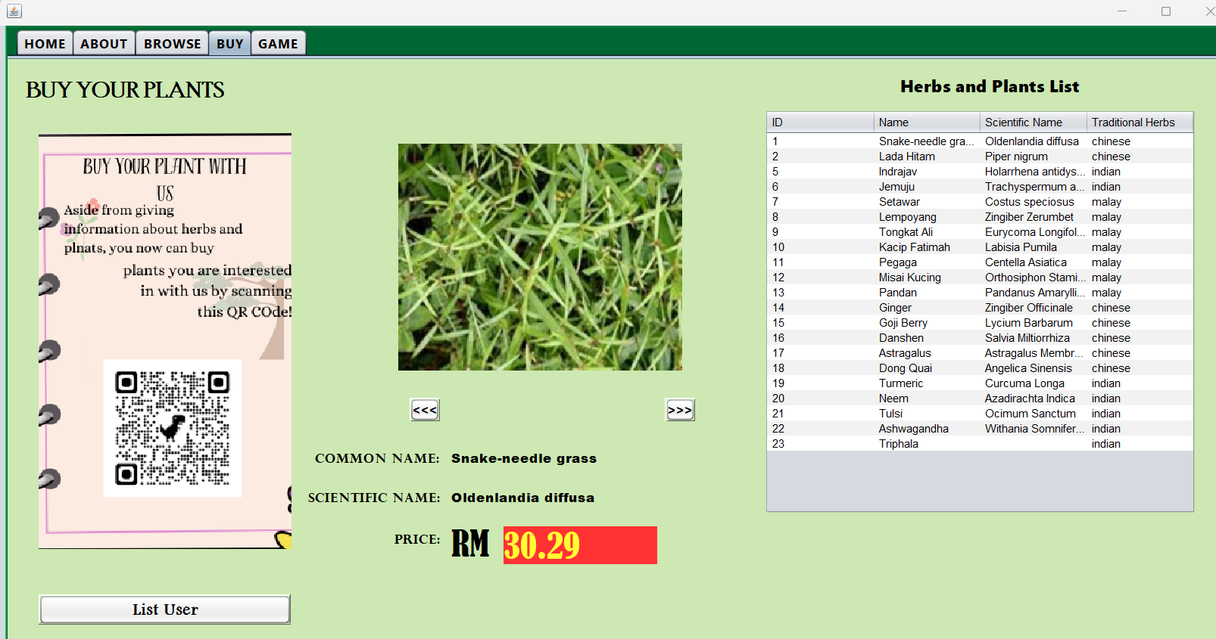
Figure 18 In buy page for admin, there is List User
There's an additional functionality on the "Buy” page that allows administrators to access and manage the list of users, including creating and deleting users. The Buy page not only serves as the platform for users to purchase plants through QR codes but also includes an administrative feature allowing administrators to manage user accounts.
Admin can click on the List User button to see the current users. One window will be shown as in Figure 19.
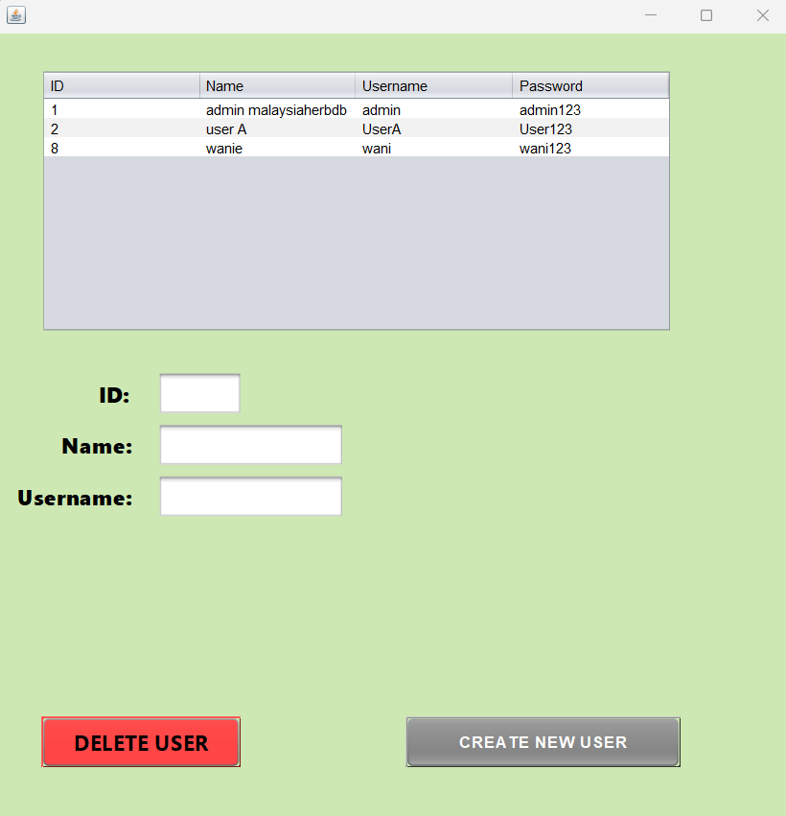
Figure 19 Initial state of panel after admin clicked on LIst User
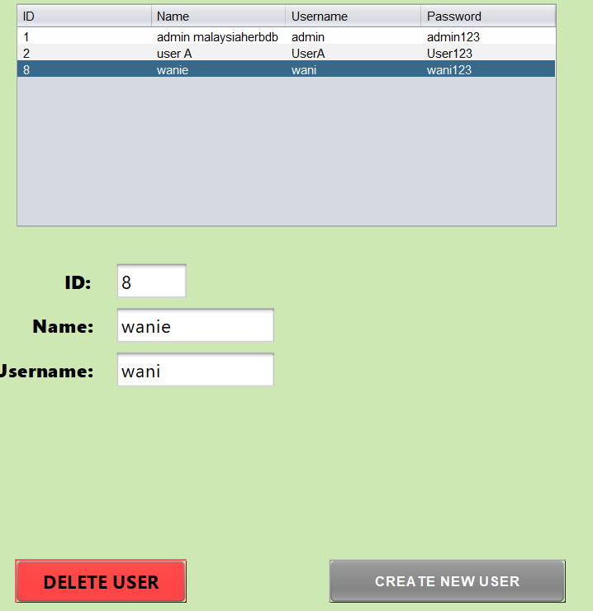
Figure 20 After admin selected on user from the list
Admin can create and delete new user from this page.

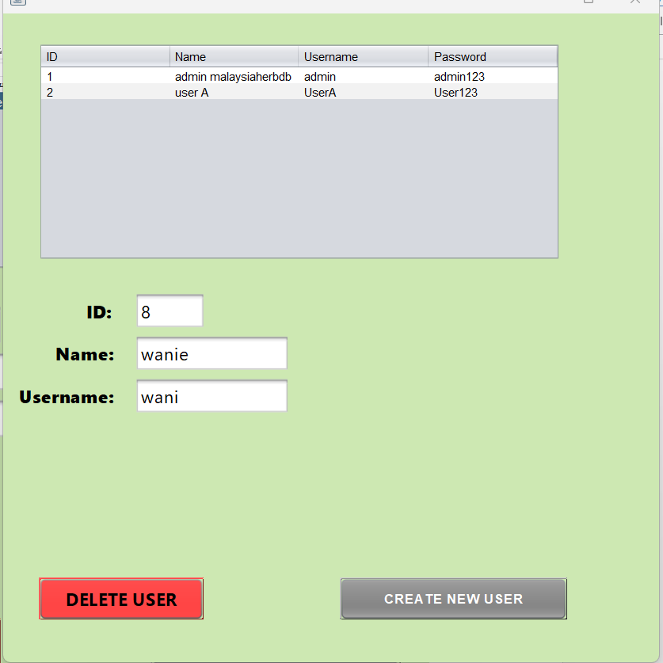
Figure 21 Notice the previous is no longer there after admin deleting it
As admin click on the create new user button, Create user panel will be displayed. This is the same panel that is shown when user want to create new user too.
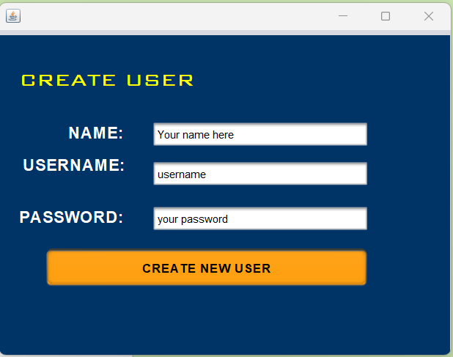
Figure 22 Create User page
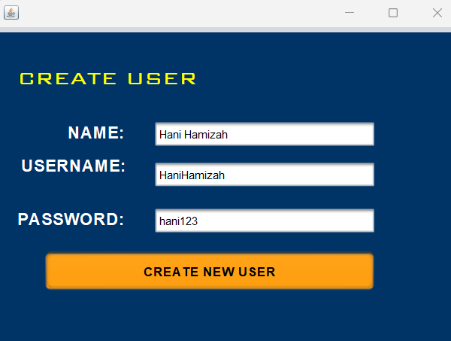
Figure 23 Fill in with all required details
A message dialog will be displayed to tell that new user is successfully created

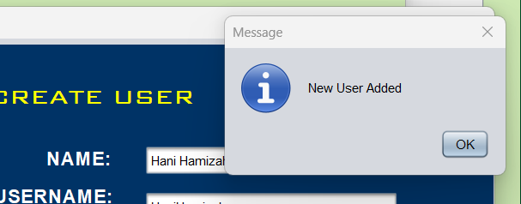
Figure 24 Confirmation message appears
It now displays an updated list that includes the newly created user. The list provides essential information about each user, including their User ID, Name, Username, and Password

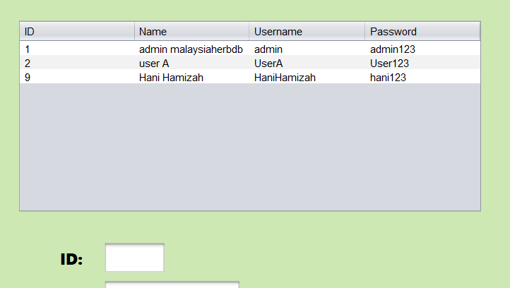
Figure 25 New user is added

Reference

1BestCsharpBlog. (2016, July 13). Java And Mysql Project Example - Simple Java And MySQL Database Program [With Source Code]. Retrieved from Youtube: https://www.youtube.com/watch?v=Jt62k0kyZDw&list=PLFDH5bKmoNqwOYnwOmljGuivo4a9EeIvC&index=5&t=707s
A. Thahira Banu, M. A. (2023). Role of Piper nigrum in functional food and nutraceuticals. Herbs, Spices and their Roles in Nutraceuticals and Functional Foods,, 41-60.
Arefin, N. S. (2023, May 10). Misai kucing leaves among the most nutritious and tasty herbs. Retrieved from Universit Putra Malaysia: https://www.upm.edu.my/news/misai_kucing_leaves_among_the_most_nutritious_and_tasty_herbs-66688
Berry, P. E. (2023, June 23). Piperales plant order. Retrieved from Britannica: https://www.britannica.com/plant/Piperaceae
Bodhare, D. A. (2023, August 22). Kutaja Benefits, Side Effects, Precautions & more! Retrieved from PharmEasy: https://pharmeasy.in/blog/ayurveda-benefits-side-effects-precautions-of-kutaja/#:~:text=The%20shrub%20Holarrhena%20antidysenterica%20Linn,has%20traditional%20and%20folklore%20values.
Clapham, P. (2016, March 9). SWING / AWT / SWT. Retrieved from JavaRanch: https://coderanch.com/t/663120/java/JText-Component
Kusler, H. B. (2022, May 19). Goji Berries (Lycium barbarum) in Chinese Medicine & Its Usage in Acupuncture Clinic. Retrieved from CITM Inspire Change: https://citcm.com/goji-berries-lycium-barbarum-in-chinese-medicine-its-usage-in-acupuncture-clinic/#:~:text=In%20Acupuncture%20%26%20Chinese%20Medicine%2C%20Goji,the%20urinary%20and%20reproductive%20systems.
Lal, N. (2022, May 22). What is neem? The health benefits of what Ayurveda calls the world’s most versatile medicinal plant, from boosting immunity to fighting cancer. Retrieved from South China Morning Post: https://www.scmp.com/lifestyle/health-wellness/article/3178624/what-neem-health-benefits-what-ayurveda-calls-worlds-most
N. J. Yob, S. Mohd. Jofrry, M. M. R. Meor. Mohd. Affandi, L. K. Teh, M. Z. Salleh, and Z. A. Zakaria . (2011, March 22). Zingiber zerumbet (L.) Smith: A Review of Its Ethnomedicinal, Chemical, and Pharmacological Uses. Retrieved from National Library of Madicine: https://www.ncbi.nlm.nih.gov/pmc/articles/PMC3092606/#:~:text=zerumbet%2C%20particularly%2C%20have%20been%20regularly,%2C%20worm%20infestation%20and%20diarrhea).
Negar Jamshidi, M. M. (2017, March 16). The Clinical Efficacy and Safety of Tulsi in Humans: A Systematic Review of the Literature. Retrieved from National Library of Medicine: https://www.ncbi.nlm.nih.gov/pmc/articles/PMC5376420/#:~:text=In%20the%20Ayurveda%20system%20tulsi,%2C%20and%20pyrexia%20%5B1%5D.
Nparks | Hedyotis diffusa. (2024, February 1). Retrieved from National Parks Flora & Fauna Web: https://www.nparks.gov.sg/florafaunaweb/flora/5/2/5248
Poonam Sachdev, M. (2022, September 14). Health Benefits of Pandan. Retrieved from WebMD: https://www.webmd.com/diet/health-benefits-pandan
Sudhir, C. W. (2023, September 17). How to connect MySql Database 8.0.34 & Java NetBeans IDE 19 Using Connector-j Driver || JDBC in java. Retrieved from Youtube: https://www.youtube.com/watch?v=Wd-rJSkpySs
Trachyspermum ammi. (2024). Retrieved from Mountain Herb Estate: https://www.herbgarden.co.za/mountainherb/herbinfo.php?id=592
Webmaster. (2022, February 14). Consumption of medicinal plants in Malaysia. Retrieved from GlobinMed: https://globinmed.com/trade_business/consumption-of-medicinal-plants-in-malaysia/
webmaster. (2024, February 14). Pegaga. Retrieved from Jabatan Perhutanan Semenanjung Malaysia: https://www.forestry.gov.my/my/pengumuman-berita/97-herba/521-pegaga

Appendix

Database.java
package ClassAll;

import java.sql.Connection;
import java.sql.DriverManager;
import java.sql.SQLException;

/**
*
* @author Hani Hamizah
*/
public class database {

private static String databasename = "malaysiaherbs";
private static String username = "root";
private static String passwd= "";

static Connection connect=null;
public static Connection getConnection()
{
if (connect != null)
return connect;
return getConnection(databasename,username,passwd);
}

private static Connection getConnection(String database_name, String user_name, String password)
{
try{
Class.forName("com.mysql.cj.jdbc.Driver");
connect = DriverManager.getConnection("jdbc:mysql://localhost/"+database_name+"?user="+user_name+"&password="+password);
System.out.println("connected");
}
catch (Exception e)
{
e.printStackTrace();
}
return connect;
}

}

Plant.java

package ClassAll;
import java.sql.PreparedStatement;
import java.sql.ResultSet;
import java.sql.Connection;
import java.sql.SQLException;
import java.sql.Statement;
import java.util.ArrayList;
import java.util.logging.Level;
import java.util.logging.Logger;
import javax.swing.ImageIcon;
import malaysiaherb.MAIN_WINDOW;

/**
*
* @author Hani Hamizah
*/
public class Plant {
private int id;
private String Name;
private String Scientific_name;
private String Description;
private String Plant_Usage;
private byte[] plantimg;
private String plantype;
private double price;
Connection connect;

public Plant(int pid, String pName, String pSN, String pD, String pUse, String pT, byte[] pimg, double pprice) {
this.id = pid;
this.Name = pName;
this.Scientific_name = pSN;
this.Plant_Usage = pUse;
this.Description = pD;
this.plantimg = pimg;
this.plantype = pT;
this.price=pprice;
}
public Plant(){}

// Getters and setters for all fields
public double getPrice() {
return price;
}

public void setprice(double price) {
this.price = price;
}

public int getId() {
return id;
}

public void setId(int id) {
this.id = id;
}

public String getName() {
return Name;
}

public void setName(String Name) {
this.Name = Name;
}

public String getSN() {
return Scientific_name;
}

public void setSN(String Scientific_name) {
this.Scientific_name = Scientific_name;
}

public String getDesc() {
return Description;
}

public void setDesc(String Description) {
this.Description = Description;
}

public String getPS() {
return Plant_Usage;
}

public void setPS(String Plant_Usage) {
this.Plant_Usage = Plant_Usage;
}

public String getPT() {
return plantype;
}

public void setPT(String plantype) {
this.plantype = plantype;
}

public byte[] getImage() {
return plantimg;
}

public void setImage(byte[] plantimg) {
this.plantimg = plantimg;
}

public ArrayList<Plant> getPlantlist(String plantname){

ArrayList<Plant> plant_list = new ArrayList<>();

connect = database.getConnection();
ResultSet rs;
PreparedStatement ps;

String query = "SELECT `ID`, `Name`, `Scientific_Name`, `Description`, `Plant_Usage`,`Plant_type`,`Plant_Image` FROM `plants`";

try {
ps = connect.prepareStatement(query);
rs = ps.executeQuery();

Plant plant;

while(rs.next()){
plant = new Plant(rs.getInt("id"),
rs.getString("Name"),
rs.getString("Scientfic_name"),
rs.getString("Description"),
rs.getString("Plant_Usage"),

rs.getString("plantype"),
rs.getBytes("plantimg"),
rs.getDouble("price")

);

plant_list.add(plant);
}

} catch (SQLException ex) {
Logger.getLogger(Plant.class.getName()).log(Level.SEVERE, null, ex);
}
return plant_list;

}

}

/*public void ShowPlant(int index, String planttype)
{
malaysiaherb.MAIN_WINDOW mainwindow=new malaysiaherb.MAIN_WINDOW();
mainwindow.jTextField_commonname.setString(getPlantlist().get(index).getName(),plantype);
}*/

Plant_User.java

package ClassAll;
import java.sql.Connection;
import java.sql.PreparedStatement;
import java.sql.ResultSet;
import java.sql.SQLException;
import java.sql.Statement;
import java.util.ArrayList;
import java.util.logging.Level;
import java.util.logging.Logger;
import javax.swing.JOptionPane;
/**
*
* @author Hani Hamizah
*/
public class Plant_User{
Connection connect;
private String name;
private String username;
private String passwd;
private int ID;
private String usertype;
public Plant_User (int id, String FName, String UName, String Pass, String user_type)
{
this.name=FName;
this.ID=id;
this.username=UName;
this.passwd=Pass;
this.usertype=user_type;
}

public Plant_User(Object object, String name, String username, String password, String user) {

throw new UnsupportedOperationException("Not supported yet.");
}

public int getID()
{
return ID;
}
public String getName(String name)
{
return name;
}
public String getName()
{
return name;
}

public String getUName(String username)
{
return username;

}

public String getUName()
{
return username;

}
public String getPass(String passwd)
{
return passwd;
}

public String getPass()
{
return passwd;
}
public static void insertuser(Plant_User user)
{
Connection c = database.getConnection();
PreparedStatement PS;

try {
// Exclude the ID column from the INSERT statement
PS = c.prepareStatement("INSERT INTO `users`(`NAME`, `Username`, `Password`, `Usertype`) VALUES (?,?,?,?)");
PS.setString(1, user.name);
PS.setString(2, user.username);
PS.setString(3, user.passwd);
PS.setString(4, user.usertype);

if (PS.executeUpdate() != 0) {
JOptionPane.showMessageDialog(null, "New User Added");
} else {
JOptionPane.showMessageDialog(null, "Something Wrong");
}
} catch (SQLException ex) {
Logger.getLogger(Plant_User.class.getName()).log(Level.SEVERE, null, ex);
}

}

public static void deleteuser(int id)
{
Connection c = database.getConnection();
PreparedStatement PS;

try {
// Exclude the ID column from the INSERT statement
PS = c.prepareStatement("DELETE FROM `users` WHERE `id`=?");
PS.setInt(1,id);
int confirmation = JOptionPane.showConfirmDialog(null, "Do you want to delete this user?", "Deleting User", JOptionPane.YES_NO_CANCEL_OPTION);
if (confirmation ==0)
{
if (PS.executeUpdate() != 0) {
JOptionPane.showMessageDialog(null, "User Deleted");
} else {
JOptionPane.showMessageDialog(null, "Something Wrong");
}
}
} catch (SQLException ex) {
Logger.getLogger(Plant_User.class.getName()).log(Level.SEVERE, null, ex);
}

}
}

Loginpage.java

package malaysiaherb;

import java.awt.Event;

/**
*
* @author Hani Hamizah
*/
public class loginpage extends javax.swing.JFrame {

/**
* Creates new form loginpage
*/
public loginpage() {
initComponents();
}

/**
* This method is called from within the constructor to initialize the form.
* WARNING: Do NOT modify this code. The content of this method is always
* regenerated by the Form Editor.
*/
@SuppressWarnings("unchecked")
// <editor-fold defaultstate="collapsed" desc="Generated Code">//GEN-BEGIN:initComponents
private void initComponents() {

jPanel1 = new javax.swing.JPanel();
jLabel1 = new javax.swing.JLabel();
jButton1 = new javax.swing.JButton();
jButton2 = new javax.swing.JButton();

setDefaultCloseOperation(javax.swing.WindowConstants.EXIT_ON_CLOSE);

jPanel1.setBackground(new java.awt.Color(0, 102, 51));
jPanel1.setBorder(javax.swing.BorderFactory.createEtchedBorder());
jPanel1.setToolTipText("");
jPanel1.setFont(new java.awt.Font("BankGothic Lt BT", 1, 24)); // NOI18N
jPanel1.setInheritsPopupMenu(true);

jLabel1.setFont(new java.awt.Font("BankGothic Lt BT", 1, 24)); // NOI18N
jLabel1.setForeground(new java.awt.Color(255, 255, 255));
jLabel1.setText("LOGIN AS:");

jButton1.setBackground(new java.awt.Color(255, 0, 0));
jButton1.setFont(new java.awt.Font("BankGothic Md BT", 1, 18)); // NOI18N
jButton1.setForeground(new java.awt.Color(255, 255, 51));
jButton1.setText("ADMIN");
jButton1.setBorder(new javax.swing.border.SoftBevelBorder(javax.swing.border.BevelBorder.RAISED));
jButton1.addActionListener(new java.awt.event.ActionListener() {
public void actionPerformed(java.awt.event.ActionEvent evt) {
jButton1ActionPerformed(evt);
}
});

jButton2.setBackground(new java.awt.Color(51, 51, 255));
jButton2.setFont(new java.awt.Font("BankGothic Md BT", 1, 18)); // NOI18N
jButton2.setForeground(new java.awt.Color(255, 255, 0));
jButton2.setText("USER");
jButton2.setBorder(javax.swing.BorderFactory.createBevelBorder(javax.swing.border.BevelBorder.RAISED));
jButton2.addActionListener(new java.awt.event.ActionListener() {
public void actionPerformed(java.awt.event.ActionEvent evt) {
jButton2ActionPerformed(evt);
}
});

javax.swing.GroupLayout jPanel1Layout = new javax.swing.GroupLayout(jPanel1);
jPanel1.setLayout(jPanel1Layout);
jPanel1Layout.setHorizontalGroup(
jPanel1Layout.createParallelGroup(javax.swing.GroupLayout.Alignment.LEADING)
.addGroup(jPanel1Layout.createSequentialGroup()
.addGap(81, 81, 81)
.addGroup(jPanel1Layout.createParallelGroup(javax.swing.GroupLayout.Alignment.LEADING)
.addComponent(jLabel1, javax.swing.GroupLayout.PREFERRED_SIZE, 158, javax.swing.GroupLayout.PREFERRED_SIZE)
.addComponent(jButton2, javax.swing.GroupLayout.PREFERRED_SIZE, 152, javax.swing.GroupLayout.PREFERRED_SIZE)
.addComponent(jButton1, javax.swing.GroupLayout.PREFERRED_SIZE, 152, javax.swing.GroupLayout.PREFERRED_SIZE))
.addContainerGap(75, Short.MAX_VALUE))
);
jPanel1Layout.setVerticalGroup(
jPanel1Layout.createParallelGroup(javax.swing.GroupLayout.Alignment.LEADING)
.addGroup(jPanel1Layout.createSequentialGroup()
.addContainerGap()
.addComponent(jLabel1, javax.swing.GroupLayout.PREFERRED_SIZE, 89, javax.swing.GroupLayout.PREFERRED_SIZE)
.addPreferredGap(javax.swing.LayoutStyle.ComponentPlacement.RELATED)
.addComponent(jButton1, javax.swing.GroupLayout.PREFERRED_SIZE, 45, javax.swing.GroupLayout.PREFERRED_SIZE)
.addGap(18, 18, 18)
.addComponent(jButton2, javax.swing.GroupLayout.PREFERRED_SIZE, 45, javax.swing.GroupLayout.PREFERRED_SIZE)
.addContainerGap(58, Short.MAX_VALUE))
);

javax.swing.GroupLayout layout = new javax.swing.GroupLayout(getContentPane());
getContentPane().setLayout(layout);
layout.setHorizontalGroup(
layout.createParallelGroup(javax.swing.GroupLayout.Alignment.LEADING)
.addGroup(layout.createSequentialGroup()
.addContainerGap()
.addComponent(jPanel1, javax.swing.GroupLayout.DEFAULT_SIZE, javax.swing.GroupLayout.DEFAULT_SIZE, Short.MAX_VALUE)
.addContainerGap())
);
layout.setVerticalGroup(
layout.createParallelGroup(javax.swing.GroupLayout.Alignment.LEADING)
.addGroup(layout.createSequentialGroup()
.addContainerGap()
.addComponent(jPanel1, javax.swing.GroupLayout.DEFAULT_SIZE, javax.swing.GroupLayout.DEFAULT_SIZE, Short.MAX_VALUE)
.addContainerGap())
);

pack();
}// </editor-fold>//GEN-END:initComponents

private void jButton1ActionPerformed(java.awt.event.ActionEvent evt) {//GEN-FIRST:event_jButton1ActionPerformed
// TODO add your handling code here:
AdminLogin a=new AdminLogin();

a.setVisible(true);
this.dispose();

}//GEN-LAST:event_jButton1ActionPerformed

private void jButton2ActionPerformed(java.awt.event.ActionEvent evt) {//GEN-FIRST:event_jButton2ActionPerformed
// TODO add your handling code here:
UseLogin b=new UseLogin();

b.setVisible(true);
this.dispose();
}//GEN-LAST:event_jButton2ActionPerformed

/**
* @param args the command line arguments
*/
public static void main(String args[]) {
/* Set the Nimbus look and feel */
//<editor-fold defaultstate="collapsed" desc=" Look and feel setting code (optional) ">
/* If Nimbus (introduced in Java SE 6) is not available, stay with the default look and feel.
* For details see http://download.oracle.com/javase/tutorial/uiswing/lookandfeel/plaf.html
*/
try {
for (javax.swing.UIManager.LookAndFeelInfo info : javax.swing.UIManager.getInstalledLookAndFeels()) {
if ("Nimbus".equals(info.getName())) {
javax.swing.UIManager.setLookAndFeel(info.getClassName());
break;
}
}
} catch (ClassNotFoundException ex) {
java.util.logging.Logger.getLogger(loginpage.class.getName()).log(java.util.logging.Level.SEVERE, null, ex);
} catch (InstantiationException ex) {
java.util.logging.Logger.getLogger(loginpage.class.getName()).log(java.util.logging.Level.SEVERE, null, ex);
} catch (IllegalAccessException ex) {
java.util.logging.Logger.getLogger(loginpage.class.getName()).log(java.util.logging.Level.SEVERE, null, ex);
} catch (javax.swing.UnsupportedLookAndFeelException ex) {
java.util.logging.Logger.getLogger(loginpage.class.getName()).log(java.util.logging.Level.SEVERE, null, ex);
}
//</editor-fold>

/* Create and display the form */
java.awt.EventQueue.invokeLater(new Runnable() {
public void run() {
new loginpage().setVisible(true);
}
});
}

// Variables declaration - do not modify//GEN-BEGIN:variables
private javax.swing.JButton jButton1;
private javax.swing.JButton jButton2;
private javax.swing.JLabel jLabel1;
private javax.swing.JPanel jPanel1;
// End of variables declaration//GEN-END:variables
}

UseLogin.java

package malaysiaherb;

import java.awt.Dimension;
import java.sql.PreparedStatement;
import java.sql.ResultSet;
import java.sql.SQLException;
import java.util.logging.Level;
import java.util.logging.Logger;
import javax.swing.JFrame;
import javax.swing.JOptionPane;

/**
*
* @author Hani Hamizah
*/
public class UseLogin extends javax.swing.JFrame {

/**
* Creates new form UseLogin
*/
public UseLogin() {
initComponents();
}

/**
* This method is called from within the constructor to initialize the form.
* WARNING: Do NOT modify this code. The content of this method is always
* regenerated by the Form Editor.
*/
@SuppressWarnings("unchecked")
// <editor-fold defaultstate="collapsed" desc="Generated Code">//GEN-BEGIN:initComponents
private void initComponents() {

jPanel1 = new javax.swing.JPanel();
jLabel1 = new javax.swing.JLabel();
jTextField1 = new javax.swing.JTextField();
jTextField2 = new javax.swing.JTextField();
jLabel2 = new javax.swing.JLabel();
jLabel3 = new javax.swing.JLabel();
jPanel2 = new javax.swing.JPanel();
jLabel4 = new javax.swing.JLabel();
jTextField_username = new javax.swing.JTextField();
jLabel5 = new javax.swing.JLabel();
jLabel6 = new javax.swing.JLabel();
jButton1_USER_Login = new javax.swing.JButton();
jPasswordField1 = new javax.swing.JPasswordField();
jButton3_createuser = new javax.swing.JButton();

jPanel1.setBackground(new java.awt.Color(153, 0, 51));
jPanel1.setBorder(javax.swing.BorderFactory.createLineBorder(new java.awt.Color(0, 0, 0)));

jLabel1.setBackground(new java.awt.Color(255, 255, 255));
jLabel1.setFont(new java.awt.Font("BankGothic Lt BT", 1, 24)); // NOI18N
jLabel1.setForeground(new java.awt.Color(255, 255, 0));
jLabel1.setText("ADMIN LOGIN");

jTextField1.setText("USERNAMEHERE");
jTextField1.addActionListener(new java.awt.event.ActionListener() {
public void actionPerformed(java.awt.event.ActionEvent evt) {
jTextField1ActionPerformed(evt);
}
});

jTextField2.setText("PASSWORDHERE");
jTextField2.setToolTipText("");

jLabel2.setFont(new java.awt.Font("Arial", 1, 18)); // NOI18N
jLabel2.setForeground(new java.awt.Color(255, 255, 255));
jLabel2.setText("USERNAME:");

jLabel3.setFont(new java.awt.Font("Arial", 1, 18)); // NOI18N
jLabel3.setForeground(new java.awt.Color(255, 255, 255));
jLabel3.setText("PASSWORD:");

javax.swing.GroupLayout jPanel1Layout = new javax.swing.GroupLayout(jPanel1);
jPanel1.setLayout(jPanel1Layout);
jPanel1Layout.setHorizontalGroup(
jPanel1Layout.createParallelGroup(javax.swing.GroupLayout.Alignment.LEADING)
.addGroup(jPanel1Layout.createSequentialGroup()
.addGroup(jPanel1Layout.createParallelGroup(javax.swing.GroupLayout.Alignment.LEADING)
.addGroup(jPanel1Layout.createSequentialGroup()
.addGap(41, 41, 41)
.addGroup(jPanel1Layout.createParallelGroup(javax.swing.GroupLayout.Alignment.LEADING, false)
.addComponent(jLabel2, javax.swing.GroupLayout.DEFAULT_SIZE, javax.swing.GroupLayout.DEFAULT_SIZE, Short.MAX_VALUE)
.addComponent(jLabel3, javax.swing.GroupLayout.DEFAULT_SIZE, 120, Short.MAX_VALUE))
.addPreferredGap(javax.swing.LayoutStyle.ComponentPlacement.RELATED)
.addGroup(jPanel1Layout.createParallelGroup(javax.swing.GroupLayout.Alignment.LEADING)
.addComponent(jTextField2, javax.swing.GroupLayout.PREFERRED_SIZE, 196, javax.swing.GroupLayout.PREFERRED_SIZE)
.addComponent(jTextField1, javax.swing.GroupLayout.PREFERRED_SIZE, 196, javax.swing.GroupLayout.PREFERRED_SIZE)))
.addGroup(jPanel1Layout.createSequentialGroup()
.addGap(106, 106, 106)
.addComponent(jLabel1)))
.addGap(0, 54, Short.MAX_VALUE))
);
jPanel1Layout.setVerticalGroup(
jPanel1Layout.createParallelGroup(javax.swing.GroupLayout.Alignment.LEADING)
.addGroup(jPanel1Layout.createSequentialGroup()
.addGap(18, 18, 18)
.addComponent(jLabel1, javax.swing.GroupLayout.PREFERRED_SIZE, 61, javax.swing.GroupLayout.PREFERRED_SIZE)
.addPreferredGap(javax.swing.LayoutStyle.ComponentPlacement.UNRELATED)
.addGroup(jPanel1Layout.createParallelGroup(javax.swing.GroupLayout.Alignment.BASELINE)
.addComponent(jLabel2, javax.swing.GroupLayout.PREFERRED_SIZE, 44, javax.swing.GroupLayout.PREFERRED_SIZE)
.addComponent(jTextField1, javax.swing.GroupLayout.PREFERRED_SIZE, javax.swing.GroupLayout.DEFAULT_SIZE, javax.swing.GroupLayout.PREFERRED_SIZE))
.addPreferredGap(javax.swing.LayoutStyle.ComponentPlacement.RELATED)
.addGroup(jPanel1Layout.createParallelGroup(javax.swing.GroupLayout.Alignment.BASELINE)
.addComponent(jLabel3, javax.swing.GroupLayout.PREFERRED_SIZE, 37, javax.swing.GroupLayout.PREFERRED_SIZE)
.addComponent(jTextField2, javax.swing.GroupLayout.PREFERRED_SIZE, javax.swing.GroupLayout.DEFAULT_SIZE, javax.swing.GroupLayout.PREFERRED_SIZE))
.addContainerGap(66, Short.MAX_VALUE))
);

setDefaultCloseOperation(javax.swing.WindowConstants.EXIT_ON_CLOSE);

jPanel2.setBackground(new java.awt.Color(0, 0, 102));
jPanel2.setBorder(javax.swing.BorderFactory.createLineBorder(new java.awt.Color(0, 0, 0)));

jLabel4.setBackground(new java.awt.Color(255, 255, 255));
jLabel4.setFont(new java.awt.Font("BankGothic Lt BT", 1, 24)); // NOI18N
jLabel4.setForeground(new java.awt.Color(255, 255, 0));
jLabel4.setText("USER LOGIN");

jTextField_username.setText("USERNAMEHERE");
jTextField_username.addActionListener(new java.awt.event.ActionListener() {
public void actionPerformed(java.awt.event.ActionEvent evt) {
jTextField_usernameActionPerformed(evt);
}
});

jLabel5.setFont(new java.awt.Font("Arial", 1, 18)); // NOI18N
jLabel5.setForeground(new java.awt.Color(255, 255, 255));
jLabel5.setText("USERNAME:");

jLabel6.setFont(new java.awt.Font("Arial", 1, 18)); // NOI18N
jLabel6.setForeground(new java.awt.Color(255, 255, 255));
jLabel6.setText("PASSWORD:");

jButton1_USER_Login.setBackground(new java.awt.Color(255, 153, 0));
jButton1_USER_Login.setFont(new java.awt.Font("Arial", 1, 14)); // NOI18N
jButton1_USER_Login.setText("LOGIN");
jButton1_USER_Login.setBorder(javax.swing.BorderFactory.createTitledBorder(""));
jButton1_USER_Login.addActionListener(new java.awt.event.ActionListener() {
public void actionPerformed(java.awt.event.ActionEvent evt) {
jButton1_USER_LoginActionPerformed(evt);
}
});

jPasswordField1.setText("jPasswordField1");

jButton3_createuser.setBackground(new java.awt.Color(102, 102, 102));
jButton3_createuser.setFont(new java.awt.Font("Arial", 1, 14)); // NOI18N
jButton3_createuser.setForeground(new java.awt.Color(255, 255, 255));
jButton3_createuser.setText("CREATE NEW USER");
jButton3_createuser.setBorder(javax.swing.BorderFactory.createTitledBorder(""));
jButton3_createuser.addActionListener(new java.awt.event.ActionListener() {
public void actionPerformed(java.awt.event.ActionEvent evt) {
jButton3_createuserActionPerformed(evt);
}
});

javax.swing.GroupLayout jPanel2Layout = new javax.swing.GroupLayout(jPanel2);
jPanel2.setLayout(jPanel2Layout);
jPanel2Layout.setHorizontalGroup(
jPanel2Layout.createParallelGroup(javax.swing.GroupLayout.Alignment.LEADING)
.addGroup(jPanel2Layout.createSequentialGroup()
.addGroup(jPanel2Layout.createParallelGroup(javax.swing.GroupLayout.Alignment.LEADING)
.addGroup(jPanel2Layout.createSequentialGroup()
.addGap(106, 106, 106)
.addComponent(jLabel4))
.addGroup(jPanel2Layout.createSequentialGroup()
.addGap(41, 41, 41)
.addGroup(jPanel2Layout.createParallelGroup(javax.swing.GroupLayout.Alignment.LEADING)
.addComponent(jButton1_USER_Login, javax.swing.GroupLayout.PREFERRED_SIZE, 322, javax.swing.GroupLayout.PREFERRED_SIZE)
.addGroup(jPanel2Layout.createSequentialGroup()
.addGroup(jPanel2Layout.createParallelGroup(javax.swing.GroupLayout.Alignment.LEADING, false)
.addComponent(jLabel5, javax.swing.GroupLayout.DEFAULT_SIZE, javax.swing.GroupLayout.DEFAULT_SIZE, Short.MAX_VALUE)
.addComponent(jLabel6, javax.swing.GroupLayout.DEFAULT_SIZE, 120, Short.MAX_VALUE))
.addPreferredGap(javax.swing.LayoutStyle.ComponentPlacement.RELATED)
.addGroup(jPanel2Layout.createParallelGroup(javax.swing.GroupLayout.Alignment.LEADING)
.addComponent(jTextField_username, javax.swing.GroupLayout.PREFERRED_SIZE, 196, javax.swing.GroupLayout.PREFERRED_SIZE)
.addComponent(jPasswordField1)))
.addComponent(jButton3_createuser, javax.swing.GroupLayout.PREFERRED_SIZE, 322, javax.swing.GroupLayout.PREFERRED_SIZE))))
.addGap(0, 54, Short.MAX_VALUE))
);
jPanel2Layout.setVerticalGroup(
jPanel2Layout.createParallelGroup(javax.swing.GroupLayout.Alignment.LEADING)
.addGroup(jPanel2Layout.createSequentialGroup()
.addGap(18, 18, 18)
.addComponent(jLabel4, javax.swing.GroupLayout.PREFERRED_SIZE, 61, javax.swing.GroupLayout.PREFERRED_SIZE)
.addPreferredGap(javax.swing.LayoutStyle.ComponentPlacement.UNRELATED)
.addGroup(jPanel2Layout.createParallelGroup(javax.swing.GroupLayout.Alignment.BASELINE)
.addComponent(jLabel5, javax.swing.GroupLayout.PREFERRED_SIZE, 44, javax.swing.GroupLayout.PREFERRED_SIZE)
.addComponent(jTextField_username, javax.swing.GroupLayout.PREFERRED_SIZE, javax.swing.GroupLayout.DEFAULT_SIZE, javax.swing.GroupLayout.PREFERRED_SIZE))
.addPreferredGap(javax.swing.LayoutStyle.ComponentPlacement.RELATED)
.addGroup(jPanel2Layout.createParallelGroup(javax.swing.GroupLayout.Alignment.BASELINE)
.addComponent(jLabel6, javax.swing.GroupLayout.PREFERRED_SIZE, 37, javax.swing.GroupLayout.PREFERRED_SIZE)
.addComponent(jPasswordField1, javax.swing.GroupLayout.PREFERRED_SIZE, javax.swing.GroupLayout.DEFAULT_SIZE, javax.swing.GroupLayout.PREFERRED_SIZE))
.addGap(18, 18, 18)
.addComponent(jButton1_USER_Login, javax.swing.GroupLayout.PREFERRED_SIZE, 32, javax.swing.GroupLayout.PREFERRED_SIZE)
.addGap(18, 18, 18)
.addComponent(jButton3_createuser, javax.swing.GroupLayout.PREFERRED_SIZE, 32, javax.swing.GroupLayout.PREFERRED_SIZE)
.addContainerGap(javax.swing.GroupLayout.DEFAULT_SIZE, Short.MAX_VALUE))
);

javax.swing.GroupLayout layout = new javax.swing.GroupLayout(getContentPane());
getContentPane().setLayout(layout);
layout.setHorizontalGroup(
layout.createParallelGroup(javax.swing.GroupLayout.Alignment.LEADING)
.addComponent(jPanel2, javax.swing.GroupLayout.PREFERRED_SIZE, javax.swing.GroupLayout.DEFAULT_SIZE, javax.swing.GroupLayout.PREFERRED_SIZE)
);
layout.setVerticalGroup(
layout.createParallelGroup(javax.swing.GroupLayout.Alignment.LEADING)
.addGroup(layout.createSequentialGroup()
.addContainerGap()
.addComponent(jPanel2, javax.swing.GroupLayout.DEFAULT_SIZE, javax.swing.GroupLayout.DEFAULT_SIZE, Short.MAX_VALUE)
.addContainerGap())
);

pack();
}// </editor-fold>//GEN-END:initComponents

private void jTextField1ActionPerformed(java.awt.event.ActionEvent evt) {//GEN-FIRST:event_jTextField1ActionPerformed
// TODO add your handling code here:
}//GEN-LAST:event_jTextField1ActionPerformed

private void jTextField_usernameActionPerformed(java.awt.event.ActionEvent evt) {//GEN-FIRST:event_jTextField_usernameActionPerformed
// TODO add your handling code here:
}//GEN-LAST:event_jTextField_usernameActionPerformed

private void jButton1_USER_LoginActionPerformed(java.awt.event.ActionEvent evt) {//GEN-FIRST:event_jButton1_USER_LoginActionPerformed
PreparedStatement input = null;
ResultSet rs;

try {
input=ClassAll.database.getConnection().prepareStatement("Select `Username`,`Password`,`Usertype` FROM `users` WHERE `Username`=? AND `Password`=?");

input.setString(1, jTextField_username.getText());
input.setString(2,String.valueOf(jPasswordField1.getPassword()));

rs=input.executeQuery();

if (rs.next())
{
MAIN_WINDOW mainwindow =new MAIN_WINDOW();

if (rs.getString("Usertype").equals("admin"))
{
JOptionPane.showMessageDialog(null, "Not A User!","Login Error",2);
//mainwindow.jPanel7_userlist.setVisible(false);
}
else
{
mainwindow.pack();
mainwindow.jButton1Userlist.setVisible(false);
// mainwindow.setExtendedState(mainwindow.getExtendedState() | JFrame.MAXIMIZED_BOTH);
Dimension r = mainwindow.getBounds().getSize();
mainwindow.jLabel13.setPreferredSize(r);
mainwindow.setVisible(true);

mainwindow.setLocationRelativeTo(null);
mainwindow.setDefaultCloseOperation(JFrame.EXIT_ON_CLOSE);

this.dispose();
}
}
else
{
JOptionPane.showMessageDialog(null, "invalid username or password","Login Error",2);
}
}
catch (SQLException ex)
{
Logger.getLogger(UseLogin.class.getName()).log(Level.SEVERE, null, ex);
}
this.dispose();
}//GEN-LAST:event_jButton1_USER_LoginActionPerformed

private void jButton3_createuserActionPerformed(java.awt.event.ActionEvent evt) {//GEN-FIRST:event_jButton3_createuserActionPerformed
// TODO add your handling code here:
CreateUser create =new CreateUser();
create.setVisible(true);
create.setDefaultCloseOperation(JFrame.DISPOSE_ON_CLOSE);

}//GEN-LAST:event_jButton3_createuserActionPerformed

/**
* @param args the command line arguments
*/
public static void main(String args[]) {
/* Set the Nimbus look and feel */
//<editor-fold defaultstate="collapsed" desc=" Look and feel setting code (optional) ">
/* If Nimbus (introduced in Java SE 6) is not available, stay with the default look and feel.
* For details see http://download.oracle.com/javase/tutorial/uiswing/lookandfeel/plaf.html
*/
try {
for (javax.swing.UIManager.LookAndFeelInfo info : javax.swing.UIManager.getInstalledLookAndFeels()) {
if ("Nimbus".equals(info.getName())) {
javax.swing.UIManager.setLookAndFeel(info.getClassName());
break;
}
}
} catch (ClassNotFoundException ex) {
java.util.logging.Logger.getLogger(UseLogin.class.getName()).log(java.util.logging.Level.SEVERE, null, ex);
} catch (InstantiationException ex) {
java.util.logging.Logger.getLogger(UseLogin.class.getName()).log(java.util.logging.Level.SEVERE, null, ex);
} catch (IllegalAccessException ex) {
java.util.logging.Logger.getLogger(UseLogin.class.getName()).log(java.util.logging.Level.SEVERE, null, ex);
} catch (javax.swing.UnsupportedLookAndFeelException ex) {
java.util.logging.Logger.getLogger(UseLogin.class.getName()).log(java.util.logging.Level.SEVERE, null, ex);
}
//</editor-fold>

/* Create and display the form */
java.awt.EventQueue.invokeLater(new Runnable() {
public void run() {
new UseLogin().setVisible(true);
}
});
}

// Variables declaration - do not modify//GEN-BEGIN:variables
private javax.swing.JButton jButton1_USER_Login;
private javax.swing.JButton jButton3_createuser;
private javax.swing.JLabel jLabel1;
private javax.swing.JLabel jLabel2;
private javax.swing.JLabel jLabel3;
private javax.swing.JLabel jLabel4;
private javax.swing.JLabel jLabel5;
private javax.swing.JLabel jLabel6;
private javax.swing.JPanel jPanel1;
private javax.swing.JPanel jPanel2;
private javax.swing.JPasswordField jPasswordField1;
private javax.swing.JTextField jTextField1;
private javax.swing.JTextField jTextField2;
private javax.swing.JTextField jTextField_username;
// End of variables declaration//GEN-END:variables
}

AdminLogin.java
package malaysiaherb;
import java.awt.Dimension;
import java.sql.PreparedStatement;
import java.sql.ResultSet;
import java.sql.SQLException;
import java.util.Map;
import java.util.logging.Level;
import java.util.logging.Logger;
import javax.swing.JFrame;
import javax.swing.JOptionPane;

/**
*
* @author Hani Hamizah
*/
public class AdminLogin extends javax.swing.JFrame {

/**
* Creates new form AdminLogin
*/
public AdminLogin() {
initComponents();
}

/**
* This method is called from within the constructor to initialize the form.
* WARNING: Do NOT modify this code. The content of this method is always
* regenerated by the Form Editor.
*/
@SuppressWarnings("unchecked")
// <editor-fold defaultstate="collapsed" desc="Generated Code">//GEN-BEGIN:initComponents
private void initComponents() {

jDialog1 = new javax.swing.JDialog();
jPanel1 = new javax.swing.JPanel();
jLabel1 = new javax.swing.JLabel();
jTextField1 = new javax.swing.JTextField();
jLabel2 = new javax.swing.JLabel();
jLabel3 = new javax.swing.JLabel();
jButton1 = new javax.swing.JButton();
jPasswordField1 = new javax.swing.JPasswordField();

javax.swing.GroupLayout jDialog1Layout = new javax.swing.GroupLayout(jDialog1.getContentPane());
jDialog1.getContentPane().setLayout(jDialog1Layout);
jDialog1Layout.setHorizontalGroup(
jDialog1Layout.createParallelGroup(javax.swing.GroupLayout.Alignment.LEADING)
.addGap(0, 400, Short.MAX_VALUE)
);
jDialog1Layout.setVerticalGroup(
jDialog1Layout.createParallelGroup(javax.swing.GroupLayout.Alignment.LEADING)
.addGap(0, 300, Short.MAX_VALUE)
);

setDefaultCloseOperation(javax.swing.WindowConstants.EXIT_ON_CLOSE);

jPanel1.setBackground(new java.awt.Color(153, 0, 51));
jPanel1.setBorder(javax.swing.BorderFactory.createLineBorder(new java.awt.Color(0, 0, 0)));

jLabel1.setBackground(new java.awt.Color(255, 255, 255));
jLabel1.setFont(new java.awt.Font("BankGothic Lt BT", 1, 24)); // NOI18N
jLabel1.setForeground(new java.awt.Color(255, 255, 0));
jLabel1.setText("ADMIN LOGIN");

jTextField1.setText("admin");
jTextField1.addActionListener(new java.awt.event.ActionListener() {
public void actionPerformed(java.awt.event.ActionEvent evt) {
jTextField1ActionPerformed(evt);
}
});

jLabel2.setFont(new java.awt.Font("Arial", 1, 18)); // NOI18N
jLabel2.setForeground(new java.awt.Color(255, 255, 255));
jLabel2.setText("USERNAME:");

jLabel3.setFont(new java.awt.Font("Arial", 1, 18)); // NOI18N
jLabel3.setForeground(new java.awt.Color(255, 255, 255));
jLabel3.setText("PASSWORD:");

jButton1.setBackground(new java.awt.Color(255, 153, 0));
jButton1.setFont(new java.awt.Font("Arial", 1, 14)); // NOI18N
jButton1.setText("LOGIN");
jButton1.setBorder(javax.swing.BorderFactory.createTitledBorder(""));
jButton1.addActionListener(new java.awt.event.ActionListener() {
public void actionPerformed(java.awt.event.ActionEvent evt) {
jButton1ActionPerformed(evt);
}
});

jPasswordField1.setText("admin123");
jPasswordField1.addActionListener(new java.awt.event.ActionListener() {
public void actionPerformed(java.awt.event.ActionEvent evt) {
jPasswordField1ActionPerformed(evt);
}
});

javax.swing.GroupLayout jPanel1Layout = new javax.swing.GroupLayout(jPanel1);
jPanel1.setLayout(jPanel1Layout);
jPanel1Layout.setHorizontalGroup(
jPanel1Layout.createParallelGroup(javax.swing.GroupLayout.Alignment.LEADING)
.addGroup(jPanel1Layout.createSequentialGroup()
.addGroup(jPanel1Layout.createParallelGroup(javax.swing.GroupLayout.Alignment.LEADING)
.addGroup(jPanel1Layout.createSequentialGroup()
.addGap(106, 106, 106)
.addComponent(jLabel1))
.addGroup(jPanel1Layout.createSequentialGroup()
.addGap(41, 41, 41)
.addGroup(jPanel1Layout.createParallelGroup(javax.swing.GroupLayout.Alignment.LEADING)
.addComponent(jButton1, javax.swing.GroupLayout.PREFERRED_SIZE, 322, javax.swing.GroupLayout.PREFERRED_SIZE)
.addGroup(jPanel1Layout.createSequentialGroup()
.addGroup(jPanel1Layout.createParallelGroup(javax.swing.GroupLayout.Alignment.LEADING, false)
.addComponent(jLabel2, javax.swing.GroupLayout.DEFAULT_SIZE, javax.swing.GroupLayout.DEFAULT_SIZE, Short.MAX_VALUE)
.addComponent(jLabel3, javax.swing.GroupLayout.DEFAULT_SIZE, 120, Short.MAX_VALUE))
.addPreferredGap(javax.swing.LayoutStyle.ComponentPlacement.RELATED)
.addGroup(jPanel1Layout.createParallelGroup(javax.swing.GroupLayout.Alignment.LEADING, false)
.addComponent(jTextField1, javax.swing.GroupLayout.DEFAULT_SIZE, 196, Short.MAX_VALUE)
.addComponent(jPasswordField1))))))
.addGap(0, 54, Short.MAX_VALUE))
);
jPanel1Layout.setVerticalGroup(
jPanel1Layout.createParallelGroup(javax.swing.GroupLayout.Alignment.LEADING)
.addGroup(jPanel1Layout.createSequentialGroup()
.addGap(18, 18, 18)
.addComponent(jLabel1, javax.swing.GroupLayout.PREFERRED_SIZE, 61, javax.swing.GroupLayout.PREFERRED_SIZE)
.addPreferredGap(javax.swing.LayoutStyle.ComponentPlacement.UNRELATED)
.addGroup(jPanel1Layout.createParallelGroup(javax.swing.GroupLayout.Alignment.BASELINE)
.addComponent(jLabel2, javax.swing.GroupLayout.PREFERRED_SIZE, 44, javax.swing.GroupLayout.PREFERRED_SIZE)
.addComponent(jTextField1, javax.swing.GroupLayout.PREFERRED_SIZE, javax.swing.GroupLayout.DEFAULT_SIZE, javax.swing.GroupLayout.PREFERRED_SIZE))
.addPreferredGap(javax.swing.LayoutStyle.ComponentPlacement.RELATED)
.addGroup(jPanel1Layout.createParallelGroup(javax.swing.GroupLayout.Alignment.BASELINE)
.addComponent(jLabel3, javax.swing.GroupLayout.PREFERRED_SIZE, 37, javax.swing.GroupLayout.PREFERRED_SIZE)
.addComponent(jPasswordField1, javax.swing.GroupLayout.PREFERRED_SIZE, javax.swing.GroupLayout.DEFAULT_SIZE, javax.swing.GroupLayout.PREFERRED_SIZE))
.addGap(18, 18, 18)
.addComponent(jButton1, javax.swing.GroupLayout.PREFERRED_SIZE, 32, javax.swing.GroupLayout.PREFERRED_SIZE)
.addContainerGap(16, Short.MAX_VALUE))
);

javax.swing.GroupLayout layout = new javax.swing.GroupLayout(getContentPane());
getContentPane().setLayout(layout);
layout.setHorizontalGroup(
layout.createParallelGroup(javax.swing.GroupLayout.Alignment.LEADING)
.addComponent(jPanel1, javax.swing.GroupLayout.PREFERRED_SIZE, javax.swing.GroupLayout.DEFAULT_SIZE, javax.swing.GroupLayout.PREFERRED_SIZE)
);
layout.setVerticalGroup(
layout.createParallelGroup(javax.swing.GroupLayout.Alignment.LEADING)
.addGroup(layout.createSequentialGroup()
.addContainerGap()
.addComponent(jPanel1, javax.swing.GroupLayout.DEFAULT_SIZE, javax.swing.GroupLayout.DEFAULT_SIZE, Short.MAX_VALUE)
.addContainerGap())
);

pack();
}// </editor-fold>//GEN-END:initComponents

private void jTextField1ActionPerformed(java.awt.event.ActionEvent evt) {//GEN-FIRST:event_jTextField1ActionPerformed
// TODO add your handling code here:
}//GEN-LAST:event_jTextField1ActionPerformed

private void jButton1ActionPerformed(java.awt.event.ActionEvent evt) {//GEN-FIRST:event_jButton1ActionPerformed
// TODO add your handling code here:
PreparedStatement input = null;
ResultSet rs;

try {
input=ClassAll.database.getConnection().prepareStatement("Select `Username`,`Password`,`Usertype` FROM `users` WHERE `Username`=? AND `Password`=?");

input.setString(1, jTextField1.getText());
input.setString(2,String.valueOf(jPasswordField1.getPassword()));

rs=input.executeQuery();

if (rs.next())
{
MAIN_WINDOW mainwindow =new MAIN_WINDOW();
if (rs.getString("Usertype").equals("user"))
{
JOptionPane.showMessageDialog(null, "invalid username or password","Login Error",2);

}
else
{
mainwindow.pack();
//mainwindow.setExtendedState(mainwindow.getExtendedState() | JFrame.MAXIMIZED_BOTH);
Dimension r = mainwindow.getBounds().getSize();
mainwindow.jLabel13.setPreferredSize(r);
mainwindow.setVisible(true);

mainwindow.setLocationRelativeTo(null);
mainwindow.setDefaultCloseOperation(JFrame.EXIT_ON_CLOSE);

this.dispose();
}
}
else
{
JOptionPane.showMessageDialog(null, "invalid username or password","Login Error",2);
}
}
catch (SQLException ex)
{
Logger.getLogger(AdminLogin.class.getName()).log(Level.SEVERE, null, ex);
}
this.dispose();
}//GEN-LAST:event_jButton1ActionPerformed

private void jPasswordField1ActionPerformed(java.awt.event.ActionEvent evt) {//GEN-FIRST:event_jPasswordField1ActionPerformed
// TODO add your handling code here:
}//GEN-LAST:event_jPasswordField1ActionPerformed

/**
* @param args the command line arguments
*/
public static void main(String args[]) {
/* Set the Nimbus look and feel */
//<editor-fold defaultstate="collapsed" desc=" Look and feel setting code (optional) ">
/* If Nimbus (introduced in Java SE 6) is not available, stay with the default look and feel.
* For details see http://download.oracle.com/javase/tutorial/uiswing/lookandfeel/plaf.html
*/
try {
for (javax.swing.UIManager.LookAndFeelInfo info : javax.swing.UIManager.getInstalledLookAndFeels()) {
if ("Nimbus".equals(info.getName())) {
javax.swing.UIManager.setLookAndFeel(info.getClassName());
break;
}
}
} catch (ClassNotFoundException ex) {
java.util.logging.Logger.getLogger(AdminLogin.class.getName()).log(java.util.logging.Level.SEVERE, null, ex);
} catch (InstantiationException ex) {
java.util.logging.Logger.getLogger(AdminLogin.class.getName()).log(java.util.logging.Level.SEVERE, null, ex);
} catch (IllegalAccessException ex) {
java.util.logging.Logger.getLogger(AdminLogin.class.getName()).log(java.util.logging.Level.SEVERE, null, ex);
} catch (javax.swing.UnsupportedLookAndFeelException ex) {
java.util.logging.Logger.getLogger(AdminLogin.class.getName()).log(java.util.logging.Level.SEVERE, null, ex);
}
//</editor-fold>

/* Create and display the form */
java.awt.EventQueue.invokeLater(new Runnable() {
public void run() {
new AdminLogin().setVisible(true);
}
});
}

// Variables declaration - do not modify//GEN-BEGIN:variables
private javax.swing.JButton jButton1;
private javax.swing.JDialog jDialog1;
private javax.swing.JLabel jLabel1;
private javax.swing.JLabel jLabel2;
private javax.swing.JLabel jLabel3;
private javax.swing.JPanel jPanel1;
private javax.swing.JPasswordField jPasswordField1;
private javax.swing.JTextField jTextField1;
// End of variables declaration//GEN-END:variables
}

CreateUser.java

package malaysiaherb;

/**
*
* @author Hani Hamizah
*/
public class CreateUser extends javax.swing.JFrame {

/**
* Creates new form CreateUser
*/
public CreateUser() {
initComponents();
}

/**
* This method is called from within the constructor to initialize the form.
* WARNING: Do NOT modify this code. The content of this method is always
* regenerated by the Form Editor.
*/
@SuppressWarnings("unchecked")
// <editor-fold defaultstate="collapsed" desc="Generated Code">//GEN-BEGIN:initComponents
private void initComponents() {

jPanel1 = new javax.swing.JPanel();
jDialog1 = new javax.swing.JDialog();
jDialog2 = new javax.swing.JDialog();
jTextField3 = new javax.swing.JTextField();
jPanel3 = new javax.swing.JPanel();
jLabel5 = new javax.swing.JLabel();
jTextField4 = new javax.swing.JTextField();
jLabel6 = new javax.swing.JLabel();
jLabel7 = new javax.swing.JLabel();
jButton3 = new javax.swing.JButton();
jPasswordField2 = new javax.swing.JPasswordField();
jPanel2 = new javax.swing.JPanel();
jTextField1_username = new javax.swing.JTextField();
jTextField2_Name = new javax.swing.JTextField();
jLabel8 = new javax.swing.JLabel();
jLabel9 = new javax.swing.JLabel();
jLabel10 = new javax.swing.JLabel();
jLabel11 = new javax.swing.JLabel();
jButton5createuser = new javax.swing.JButton();
jTextField_passwordfield = new javax.swing.JTextField();

javax.swing.GroupLayout jPanel1Layout = new javax.swing.GroupLayout(jPanel1);
jPanel1.setLayout(jPanel1Layout);
jPanel1Layout.setHorizontalGroup(
jPanel1Layout.createParallelGroup(javax.swing.GroupLayout.Alignment.LEADING)
.addGap(0, 473, Short.MAX_VALUE)
);
jPanel1Layout.setVerticalGroup(
jPanel1Layout.createParallelGroup(javax.swing.GroupLayout.Alignment.LEADING)
.addGap(0, 457, Short.MAX_VALUE)
);

javax.swing.GroupLayout jDialog1Layout = new javax.swing.GroupLayout(jDialog1.getContentPane());
jDialog1.getContentPane().setLayout(jDialog1Layout);
jDialog1Layout.setHorizontalGroup(
jDialog1Layout.createParallelGroup(javax.swing.GroupLayout.Alignment.LEADING)
.addGap(0, 400, Short.MAX_VALUE)
);
jDialog1Layout.setVerticalGroup(
jDialog1Layout.createParallelGroup(javax.swing.GroupLayout.Alignment.LEADING)
.addGap(0, 300, Short.MAX_VALUE)
);

javax.swing.GroupLayout jDialog2Layout = new javax.swing.GroupLayout(jDialog2.getContentPane());
jDialog2.getContentPane().setLayout(jDialog2Layout);
jDialog2Layout.setHorizontalGroup(
jDialog2Layout.createParallelGroup(javax.swing.GroupLayout.Alignment.LEADING)
.addGap(0, 400, Short.MAX_VALUE)
);
jDialog2Layout.setVerticalGroup(
jDialog2Layout.createParallelGroup(javax.swing.GroupLayout.Alignment.LEADING)
.addGap(0, 300, Short.MAX_VALUE)
);

jTextField3.setText("Your name here");
jTextField3.addActionListener(new java.awt.event.ActionListener() {
public void actionPerformed(java.awt.event.ActionEvent evt) {
jTextField3ActionPerformed(evt);
}
});

jPanel3.setBackground(new java.awt.Color(153, 0, 51));
jPanel3.setBorder(javax.swing.BorderFactory.createLineBorder(new java.awt.Color(0, 0, 0)));

jLabel5.setBackground(new java.awt.Color(255, 255, 255));
jLabel5.setFont(new java.awt.Font("BankGothic Lt BT", 1, 24)); // NOI18N
jLabel5.setForeground(new java.awt.Color(255, 255, 0));
jLabel5.setText("ADMIN LOGIN");

jTextField4.setText("USERNAMEHERE");
jTextField4.addActionListener(new java.awt.event.ActionListener() {
public void actionPerformed(java.awt.event.ActionEvent evt) {
jTextField4ActionPerformed(evt);
}
});

jLabel6.setFont(new java.awt.Font("Arial", 1, 18)); // NOI18N
jLabel6.setForeground(new java.awt.Color(255, 255, 255));
jLabel6.setText("USERNAME:");

jLabel7.setFont(new java.awt.Font("Arial", 1, 18)); // NOI18N
jLabel7.setForeground(new java.awt.Color(255, 255, 255));
jLabel7.setText("PASSWORD:");

jButton3.setBackground(new java.awt.Color(255, 153, 0));
jButton3.setFont(new java.awt.Font("Arial", 1, 14)); // NOI18N
jButton3.setText("LOGIN");
jButton3.setBorder(javax.swing.BorderFactory.createTitledBorder(""));
jButton3.addActionListener(new java.awt.event.ActionListener() {
public void actionPerformed(java.awt.event.ActionEvent evt) {
jButton3ActionPerformed(evt);
}
});

jPasswordField2.setText("jPasswordField1");

javax.swing.GroupLayout jPanel3Layout = new javax.swing.GroupLayout(jPanel3);
jPanel3.setLayout(jPanel3Layout);
jPanel3Layout.setHorizontalGroup(
jPanel3Layout.createParallelGroup(javax.swing.GroupLayout.Alignment.LEADING)
.addGroup(jPanel3Layout.createSequentialGroup()
.addGroup(jPanel3Layout.createParallelGroup(javax.swing.GroupLayout.Alignment.LEADING)
.addGroup(jPanel3Layout.createSequentialGroup()
.addGap(106, 106, 106)
.addComponent(jLabel5))
.addGroup(jPanel3Layout.createSequentialGroup()
.addGap(41, 41, 41)
.addGroup(jPanel3Layout.createParallelGroup(javax.swing.GroupLayout.Alignment.LEADING)
.addComponent(jButton3, javax.swing.GroupLayout.PREFERRED_SIZE, 322, javax.swing.GroupLayout.PREFERRED_SIZE)
.addGroup(jPanel3Layout.createSequentialGroup()
.addGroup(jPanel3Layout.createParallelGroup(javax.swing.GroupLayout.Alignment.LEADING, false)
.addComponent(jLabel6, javax.swing.GroupLayout.DEFAULT_SIZE, javax.swing.GroupLayout.DEFAULT_SIZE, Short.MAX_VALUE)
.addComponent(jLabel7, javax.swing.GroupLayout.DEFAULT_SIZE, 120, Short.MAX_VALUE))
.addPreferredGap(javax.swing.LayoutStyle.ComponentPlacement.RELATED)
.addGroup(jPanel3Layout.createParallelGroup(javax.swing.GroupLayout.Alignment.LEADING, false)
.addComponent(jTextField4, javax.swing.GroupLayout.DEFAULT_SIZE, 196, Short.MAX_VALUE)
.addComponent(jPasswordField2))))))
.addGap(0, 54, Short.MAX_VALUE))
);
jPanel3Layout.setVerticalGroup(
jPanel3Layout.createParallelGroup(javax.swing.GroupLayout.Alignment.LEADING)
.addGroup(jPanel3Layout.createSequentialGroup()
.addGap(18, 18, 18)
.addComponent(jLabel5, javax.swing.GroupLayout.PREFERRED_SIZE, 61, javax.swing.GroupLayout.PREFERRED_SIZE)
.addPreferredGap(javax.swing.LayoutStyle.ComponentPlacement.UNRELATED)
.addGroup(jPanel3Layout.createParallelGroup(javax.swing.GroupLayout.Alignment.BASELINE)
.addComponent(jLabel6, javax.swing.GroupLayout.PREFERRED_SIZE, 44, javax.swing.GroupLayout.PREFERRED_SIZE)
.addComponent(jTextField4, javax.swing.GroupLayout.PREFERRED_SIZE, javax.swing.GroupLayout.DEFAULT_SIZE, javax.swing.GroupLayout.PREFERRED_SIZE))
.addPreferredGap(javax.swing.LayoutStyle.ComponentPlacement.RELATED)
.addGroup(jPanel3Layout.createParallelGroup(javax.swing.GroupLayout.Alignment.BASELINE)
.addComponent(jLabel7, javax.swing.GroupLayout.PREFERRED_SIZE, 37, javax.swing.GroupLayout.PREFERRED_SIZE)
.addComponent(jPasswordField2, javax.swing.GroupLayout.PREFERRED_SIZE, javax.swing.GroupLayout.DEFAULT_SIZE, javax.swing.GroupLayout.PREFERRED_SIZE))
.addGap(18, 18, 18)
.addComponent(jButton3, javax.swing.GroupLayout.PREFERRED_SIZE, 32, javax.swing.GroupLayout.PREFERRED_SIZE)
.addContainerGap(16, Short.MAX_VALUE))
);

setDefaultCloseOperation(javax.swing.WindowConstants.EXIT_ON_CLOSE);

jPanel2.setBackground(new java.awt.Color(0, 51, 102));
jPanel2.setForeground(new java.awt.Color(255, 153, 0));

jTextField1_username.setText("username");
jTextField1_username.addActionListener(new java.awt.event.ActionListener() {
public void actionPerformed(java.awt.event.ActionEvent evt) {
jTextField1_usernameActionPerformed(evt);
}
});

jTextField2_Name.setText("Your name here");
jTextField2_Name.addActionListener(new java.awt.event.ActionListener() {
public void actionPerformed(java.awt.event.ActionEvent evt) {
jTextField2_NameActionPerformed(evt);
}
});

jLabel8.setBackground(new java.awt.Color(255, 255, 255));
jLabel8.setFont(new java.awt.Font("BankGothic Lt BT", 1, 24)); // NOI18N
jLabel8.setForeground(new java.awt.Color(255, 255, 0));
jLabel8.setText("CREATE USER");

jLabel9.setFont(new java.awt.Font("Arial", 1, 18)); // NOI18N
jLabel9.setForeground(new java.awt.Color(255, 255, 255));
jLabel9.setText("NAME:");

jLabel10.setFont(new java.awt.Font("Arial", 1, 18)); // NOI18N
jLabel10.setForeground(new java.awt.Color(255, 255, 255));
jLabel10.setText("USERNAME:");

jLabel11.setFont(new java.awt.Font("Arial", 1, 18)); // NOI18N
jLabel11.setForeground(new java.awt.Color(255, 255, 255));
jLabel11.setText("PASSWORD:");

jButton5createuser.setBackground(new java.awt.Color(255, 153, 0));
jButton5createuser.setFont(new java.awt.Font("Arial", 1, 14)); // NOI18N
jButton5createuser.setText("CREATE NEW USER");
jButton5createuser.setBorder(javax.swing.BorderFactory.createTitledBorder(""));
jButton5createuser.addActionListener(new java.awt.event.ActionListener() {
public void actionPerformed(java.awt.event.ActionEvent evt) {
jButton5createuserActionPerformed(evt);
}
});

jTextField_passwordfield.setText("your password");
jTextField_passwordfield.addActionListener(new java.awt.event.ActionListener() {
public void actionPerformed(java.awt.event.ActionEvent evt) {
jTextField_passwordfieldActionPerformed(evt);
}
});

javax.swing.GroupLayout jPanel2Layout = new javax.swing.GroupLayout(jPanel2);
jPanel2.setLayout(jPanel2Layout);
jPanel2Layout.setHorizontalGroup(
jPanel2Layout.createParallelGroup(javax.swing.GroupLayout.Alignment.LEADING)
.addGroup(javax.swing.GroupLayout.Alignment.TRAILING, jPanel2Layout.createSequentialGroup()
.addGroup(jPanel2Layout.createParallelGroup(javax.swing.GroupLayout.Alignment.TRAILING)
.addGroup(jPanel2Layout.createSequentialGroup()
.addGap(75, 75, 75)
.addComponent(jLabel9, javax.swing.GroupLayout.DEFAULT_SIZE, 86, Short.MAX_VALUE)
.addPreferredGap(javax.swing.LayoutStyle.ComponentPlacement.RELATED, javax.swing.GroupLayout.DEFAULT_SIZE, Short.MAX_VALUE)
.addComponent(jTextField2_Name, javax.swing.GroupLayout.PREFERRED_SIZE, 236, javax.swing.GroupLayout.PREFERRED_SIZE))
.addGroup(jPanel2Layout.createSequentialGroup()
.addContainerGap(javax.swing.GroupLayout.DEFAULT_SIZE, Short.MAX_VALUE)
.addComponent(jTextField1_username, javax.swing.GroupLayout.PREFERRED_SIZE, 236, javax.swing.GroupLayout.PREFERRED_SIZE))
.addGroup(javax.swing.GroupLayout.Alignment.LEADING, jPanel2Layout.createSequentialGroup()
.addGap(22, 22, 22)
.addGroup(jPanel2Layout.createParallelGroup(javax.swing.GroupLayout.Alignment.LEADING)
.addGroup(jPanel2Layout.createSequentialGroup()
.addComponent(jLabel8)
.addGap(0, 0, Short.MAX_VALUE))
.addGroup(jPanel2Layout.createSequentialGroup()
.addComponent(jLabel11, javax.swing.GroupLayout.DEFAULT_SIZE, 139, Short.MAX_VALUE)
.addPreferredGap(javax.swing.LayoutStyle.ComponentPlacement.RELATED)
.addComponent(jTextField_passwordfield, javax.swing.GroupLayout.PREFERRED_SIZE, 236, javax.swing.GroupLayout.PREFERRED_SIZE))
.addGroup(javax.swing.GroupLayout.Alignment.TRAILING, jPanel2Layout.createSequentialGroup()
.addGap(0, 0, Short.MAX_VALUE)
.addComponent(jButton5createuser, javax.swing.GroupLayout.PREFERRED_SIZE, 353, javax.swing.GroupLayout.PREFERRED_SIZE)))))
.addGap(90, 90, 90))
.addGroup(jPanel2Layout.createParallelGroup(javax.swing.GroupLayout.Alignment.LEADING)
.addGroup(jPanel2Layout.createSequentialGroup()
.addGap(26, 26, 26)
.addComponent(jLabel10, javax.swing.GroupLayout.DEFAULT_SIZE, javax.swing.GroupLayout.DEFAULT_SIZE, Short.MAX_VALUE)
.addGap(356, 356, 356)))
);
jPanel2Layout.setVerticalGroup(
jPanel2Layout.createParallelGroup(javax.swing.GroupLayout.Alignment.LEADING)
.addGroup(jPanel2Layout.createSequentialGroup()
.addGap(18, 18, 18)
.addComponent(jLabel8, javax.swing.GroupLayout.PREFERRED_SIZE, 61, javax.swing.GroupLayout.PREFERRED_SIZE)
.addPreferredGap(javax.swing.LayoutStyle.ComponentPlacement.RELATED)
.addGroup(jPanel2Layout.createParallelGroup(javax.swing.GroupLayout.Alignment.BASELINE)
.addComponent(jTextField2_Name, javax.swing.GroupLayout.PREFERRED_SIZE, javax.swing.GroupLayout.DEFAULT_SIZE, javax.swing.GroupLayout.PREFERRED_SIZE)
.addComponent(jLabel9, javax.swing.GroupLayout.PREFERRED_SIZE, 44, javax.swing.GroupLayout.PREFERRED_SIZE))
.addGap(8, 8, 8)
.addComponent(jTextField1_username, javax.swing.GroupLayout.PREFERRED_SIZE, javax.swing.GroupLayout.DEFAULT_SIZE, javax.swing.GroupLayout.PREFERRED_SIZE)
.addPreferredGap(javax.swing.LayoutStyle.ComponentPlacement.UNRELATED)
.addGroup(jPanel2Layout.createParallelGroup(javax.swing.GroupLayout.Alignment.BASELINE)
.addComponent(jLabel11, javax.swing.GroupLayout.PREFERRED_SIZE, 44, javax.swing.GroupLayout.PREFERRED_SIZE)
.addComponent(jTextField_passwordfield, javax.swing.GroupLayout.PREFERRED_SIZE, javax.swing.GroupLayout.DEFAULT_SIZE, javax.swing.GroupLayout.PREFERRED_SIZE))
.addPreferredGap(javax.swing.LayoutStyle.ComponentPlacement.UNRELATED)
.addComponent(jButton5createuser, javax.swing.GroupLayout.PREFERRED_SIZE, 42, javax.swing.GroupLayout.PREFERRED_SIZE)
.addContainerGap(74, Short.MAX_VALUE))
.addGroup(jPanel2Layout.createParallelGroup(javax.swing.GroupLayout.Alignment.LEADING)
.addGroup(jPanel2Layout.createSequentialGroup()
.addGap(120, 120, 120)
.addComponent(jLabel10, javax.swing.GroupLayout.PREFERRED_SIZE, 44, javax.swing.GroupLayout.PREFERRED_SIZE)
.addContainerGap(179, Short.MAX_VALUE)))
);

javax.swing.GroupLayout layout = new javax.swing.GroupLayout(getContentPane());
getContentPane().setLayout(layout);
layout.setHorizontalGroup(
layout.createParallelGroup(javax.swing.GroupLayout.Alignment.LEADING)
.addComponent(jPanel2, javax.swing.GroupLayout.DEFAULT_SIZE, javax.swing.GroupLayout.DEFAULT_SIZE, Short.MAX_VALUE)
);
layout.setVerticalGroup(
layout.createParallelGroup(javax.swing.GroupLayout.Alignment.LEADING)
.addGroup(javax.swing.GroupLayout.Alignment.TRAILING, layout.createSequentialGroup()
.addGap(0, 6, Short.MAX_VALUE)
.addComponent(jPanel2, javax.swing.GroupLayout.PREFERRED_SIZE, javax.swing.GroupLayout.DEFAULT_SIZE, javax.swing.GroupLayout.PREFERRED_SIZE))
);

pack();
}// </editor-fold>//GEN-END:initComponents

private void jTextField1_usernameActionPerformed(java.awt.event.ActionEvent evt) {//GEN-FIRST:event_jTextField1_usernameActionPerformed
// TODO add your handling code here:
}//GEN-LAST:event_jTextField1_usernameActionPerformed

private void jTextField2_NameActionPerformed(java.awt.event.ActionEvent evt) {//GEN-FIRST:event_jTextField2_NameActionPerformed
// TODO add your handling code here:
}//GEN-LAST:event_jTextField2_NameActionPerformed

private void jTextField3ActionPerformed(java.awt.event.ActionEvent evt) {//GEN-FIRST:event_jTextField3ActionPerformed
// TODO add your handling code here:
}//GEN-LAST:event_jTextField3ActionPerformed

private void jTextField4ActionPerformed(java.awt.event.ActionEvent evt) {//GEN-FIRST:event_jTextField4ActionPerformed
// TODO add your handling code here:
}//GEN-LAST:event_jTextField4ActionPerformed

private void jButton3ActionPerformed(java.awt.event.ActionEvent evt) {//GEN-FIRST:event_jButton3ActionPerformed
// TODO add your handling code here:
}//GEN-LAST:event_jButton3ActionPerformed

private void jButton5createuserActionPerformed(java.awt.event.ActionEvent evt) {//GEN-FIRST:event_jButton5createuserActionPerformed
// TODO add your handling code here:

// TODO add your handling code here:
String name = jTextField2_Name.getText();
String username = jTextField1_username.getText();
String password = jTextField_passwordfield.getText();
String usertype = "user";

// You don't need to provide a value for the ID field, as it's auto-generated
// Pass -1 or any other value that signifies it's not set
int id = -1;

ClassAll.Plant_User user = new ClassAll.Plant_User(id, name, username, password, usertype);
ClassAll.Plant_User.insertuser(user);
this.dispose();

}//GEN-LAST:event_jButton5createuserActionPerformed

private void jTextField_passwordfieldActionPerformed(java.awt.event.ActionEvent evt) {//GEN-FIRST:event_jTextField_passwordfieldActionPerformed
// TODO add your handling code here:
}//GEN-LAST:event_jTextField_passwordfieldActionPerformed

/**
* @param args the command line arguments
*/
public static void main(String args[]) {
/* Set the Nimbus look and feel */
//<editor-fold defaultstate="collapsed" desc=" Look and feel setting code (optional) ">
/* If Nimbus (introduced in Java SE 6) is not available, stay with the default look and feel.
* For details see http://download.oracle.com/javase/tutorial/uiswing/lookandfeel/plaf.html
*/
try {
for (javax.swing.UIManager.LookAndFeelInfo info : javax.swing.UIManager.getInstalledLookAndFeels()) {
if ("Nimbus".equals(info.getName())) {
javax.swing.UIManager.setLookAndFeel(info.getClassName());
break;
}
}
} catch (ClassNotFoundException ex) {
java.util.logging.Logger.getLogger(CreateUser.class.getName()).log(java.util.logging.Level.SEVERE, null, ex);
} catch (InstantiationException ex) {
java.util.logging.Logger.getLogger(CreateUser.class.getName()).log(java.util.logging.Level.SEVERE, null, ex);
} catch (IllegalAccessException ex) {
java.util.logging.Logger.getLogger(CreateUser.class.getName()).log(java.util.logging.Level.SEVERE, null, ex);
} catch (javax.swing.UnsupportedLookAndFeelException ex) {
java.util.logging.Logger.getLogger(CreateUser.class.getName()).log(java.util.logging.Level.SEVERE, null, ex);
}
//</editor-fold>

/* Create and display the form */
java.awt.EventQueue.invokeLater(new Runnable() {
public void run() {
new CreateUser().setVisible(true);
}
});
}

// Variables declaration - do not modify//GEN-BEGIN:variables
private javax.swing.JButton jButton3;
private javax.swing.JButton jButton5createuser;
private javax.swing.JDialog jDialog1;
private javax.swing.JDialog jDialog2;
private javax.swing.JLabel jLabel10;
private javax.swing.JLabel jLabel11;
private javax.swing.JLabel jLabel5;
private javax.swing.JLabel jLabel6;
private javax.swing.JLabel jLabel7;
private javax.swing.JLabel jLabel8;
private javax.swing.JLabel jLabel9;
private javax.swing.JPanel jPanel1;
private javax.swing.JPanel jPanel2;
private javax.swing.JPanel jPanel3;
private javax.swing.JPasswordField jPasswordField2;
private javax.swing.JTextField jTextField1_username;
private javax.swing.JTextField jTextField2_Name;
private javax.swing.JTextField jTextField3;
private javax.swing.JTextField jTextField4;
private javax.swing.JTextField jTextField_passwordfield;
// End of variables declaration//GEN-END:variables

}

Userlist.java

package malaysiaherb;

import ClassAll.Plant_User;
import java.sql.PreparedStatement;
import java.sql.ResultSet;
import java.sql.SQLException;
import java.util.ArrayList;
import java.util.logging.Level;
import java.util.logging.Logger;
import javax.swing.table.DefaultTableModel;

/**
*
* @author Hani Hamizah
*/
public class Userlist extends javax.swing.JFrame {

/**
* Creates new form Userlist
*/
public Userlist() {
initComponents();
usertable();
}

public ArrayList<Plant_User> getUseerList() {
ArrayList<Plant_User> userlist = new ArrayList<>();
//Connection connect = ClassAll.database.getConnection();
PreparedStatement input = null;
ResultSet rs = null;

try {
input = ClassAll.database.getConnection().prepareStatement("SELECT `ID`,`Name`, `Username`, `Password`, `Usertype` FROM `users`");

rs = input.executeQuery();

while (rs.next()) {
Plant_User user = new Plant_User(
rs.getInt("ID"),
rs.getString("Name"),
rs.getString("Username"),
rs.getString("Password"),
rs.getString("Usertype")

);
userlist.add(user);
}
} catch (SQLException ex) {
Logger.getLogger(MAIN_WINDOW.class.getName()).log(Level.SEVERE, null, ex);
} finally {
// Close resources in finally block
if (rs != null) {
try {
rs.close();
} catch (SQLException e) {
Logger.getLogger(MAIN_WINDOW.class.getName()).log(Level.SEVERE, null, e);
}
}
if (input != null) {
try {
input.close();
} catch (SQLException e) {
Logger.getLogger(MAIN_WINDOW.class.getName()).log(Level.SEVERE, null, e);
}
}
}
return userlist;
}

public void usertable()
{

ArrayList<Plant_User> userlist = getUseerList();
DefaultTableModel table = (DefaultTableModel) jTable1.getModel();
table.setRowCount(0);
for (Plant_User user : userlist) {
Object[] row = new Object[4];
row[0] = user.getID();
row[1] = user.getName();
row[2] = user.getUName();
row[3] = user.getPass();
// Add the rest of the columns if needed
table.addRow(row);
}
}
/**
* This method is called from within the constructor to initialize the form.
* WARNING: Do NOT modify this code. The content of this method is always
* regenerated by the Form Editor.
*/
@SuppressWarnings("unchecked")
// <editor-fold defaultstate="collapsed" desc="Generated Code">//GEN-BEGIN:initComponents
private void initComponents() {

jPanel7_userlist = new javax.swing.JPanel();
jScrollPane1 = new javax.swing.JScrollPane();
jTable1 = new javax.swing.JTable();
deletebutton = new javax.swing.JButton();
jButton9 = new javax.swing.JButton();
jLabel1 = new javax.swing.JLabel();
jLabel2 = new javax.swing.JLabel();
jLabel3 = new javax.swing.JLabel();
idfield = new javax.swing.JTextField();
namefield = new javax.swing.JTextField();
usernamefield = new javax.swing.JTextField();

setDefaultCloseOperation(javax.swing.WindowConstants.EXIT_ON_CLOSE);

jPanel7_userlist.setBackground(new java.awt.Color(205, 232, 178));

jTable1.setBorder(javax.swing.BorderFactory.createEmptyBorder(1, 1, 1, 1));
jTable1.setModel(new javax.swing.table.DefaultTableModel(
new Object [][] {

},
new String [] {
"ID", "Name", "Username", "Password"
}
));
jTable1.addMouseListener(new java.awt.event.MouseAdapter() {
public void mouseClicked(java.awt.event.MouseEvent evt) {
jTable1MouseClicked(evt);
}
});
jScrollPane1.setViewportView(jTable1);

deletebutton.setBackground(new java.awt.Color(255, 51, 51));
deletebutton.setFont(new java.awt.Font("Segoe UI", 1, 18)); // NOI18N
deletebutton.setText("DELETE USER");
deletebutton.setBorder(new javax.swing.border.SoftBevelBorder(javax.swing.border.BevelBorder.RAISED));
deletebutton.addActionListener(new java.awt.event.ActionListener() {
public void actionPerformed(java.awt.event.ActionEvent evt) {
deletebuttonActionPerformed(evt);
}
});

jButton9.setBackground(new java.awt.Color(102, 102, 102));
jButton9.setFont(new java.awt.Font("Arial", 1, 14)); // NOI18N
jButton9.setForeground(new java.awt.Color(255, 255, 255));
jButton9.setText("CREATE NEW USER");
jButton9.setBorder(new javax.swing.border.SoftBevelBorder(javax.swing.border.BevelBorder.RAISED));
jButton9.addActionListener(new java.awt.event.ActionListener() {
public void actionPerformed(java.awt.event.ActionEvent evt) {
jButton9ActionPerformed(evt);
}
});

jLabel1.setFont(new java.awt.Font("Segoe UI Black", 0, 18)); // NOI18N
jLabel1.setText("ID:");

jLabel2.setFont(new java.awt.Font("Segoe UI Black", 0, 18)); // NOI18N
jLabel2.setText("Name:");

jLabel3.setFont(new java.awt.Font("Segoe UI Black", 0, 18)); // NOI18N
jLabel3.setText("Username:");

idfield.setFont(new java.awt.Font("Segoe UI", 0, 18)); // NOI18N
idfield.addActionListener(new java.awt.event.ActionListener() {
public void actionPerformed(java.awt.event.ActionEvent evt) {
idfieldActionPerformed(evt);
}
});

namefield.setFont(new java.awt.Font("Segoe UI", 0, 18)); // NOI18N

usernamefield.setFont(new java.awt.Font("Segoe UI", 0, 18)); // NOI18N

javax.swing.GroupLayout jPanel7_userlistLayout = new javax.swing.GroupLayout(jPanel7_userlist);
jPanel7_userlist.setLayout(jPanel7_userlistLayout);
jPanel7_userlistLayout.setHorizontalGroup(
jPanel7_userlistLayout.createParallelGroup(javax.swing.GroupLayout.Alignment.LEADING)
.addGroup(jPanel7_userlistLayout.createSequentialGroup()
.addGap(36, 36, 36)
.addGroup(jPanel7_userlistLayout.createParallelGroup(javax.swing.GroupLayout.Alignment.LEADING)
.addGroup(jPanel7_userlistLayout.createSequentialGroup()
.addComponent(deletebutton, javax.swing.GroupLayout.PREFERRED_SIZE, 167, javax.swing.GroupLayout.PREFERRED_SIZE)
.addPreferredGap(javax.swing.LayoutStyle.ComponentPlacement.RELATED, 137, Short.MAX_VALUE)
.addComponent(jButton9, javax.swing.GroupLayout.PREFERRED_SIZE, 230, javax.swing.GroupLayout.PREFERRED_SIZE))
.addComponent(jScrollPane1, javax.swing.GroupLayout.PREFERRED_SIZE, 527, javax.swing.GroupLayout.PREFERRED_SIZE))
.addContainerGap(93, Short.MAX_VALUE))
.addGroup(jPanel7_userlistLayout.createSequentialGroup()
.addGroup(jPanel7_userlistLayout.createParallelGroup(javax.swing.GroupLayout.Alignment.LEADING)
.addGroup(jPanel7_userlistLayout.createSequentialGroup()
.addGap(16, 16, 16)
.addGroup(jPanel7_userlistLayout.createParallelGroup(javax.swing.GroupLayout.Alignment.TRAILING)
.addComponent(jLabel3)
.addComponent(jLabel2)))
.addGroup(jPanel7_userlistLayout.createSequentialGroup()
.addGap(84, 84, 84)
.addComponent(jLabel1, javax.swing.GroupLayout.PREFERRED_SIZE, 37, javax.swing.GroupLayout.PREFERRED_SIZE)))
.addPreferredGap(javax.swing.LayoutStyle.ComponentPlacement.UNRELATED)
.addGroup(jPanel7_userlistLayout.createParallelGroup(javax.swing.GroupLayout.Alignment.LEADING)
.addComponent(idfield, javax.swing.GroupLayout.PREFERRED_SIZE, 71, javax.swing.GroupLayout.PREFERRED_SIZE)
.addComponent(usernamefield, javax.swing.GroupLayout.PREFERRED_SIZE, 156, javax.swing.GroupLayout.PREFERRED_SIZE)
.addComponent(namefield, javax.swing.GroupLayout.PREFERRED_SIZE, 156, javax.swing.GroupLayout.PREFERRED_SIZE))
.addContainerGap(javax.swing.GroupLayout.DEFAULT_SIZE, Short.MAX_VALUE))
);
jPanel7_userlistLayout.setVerticalGroup(
jPanel7_userlistLayout.createParallelGroup(javax.swing.GroupLayout.Alignment.LEADING)
.addGroup(jPanel7_userlistLayout.createSequentialGroup()
.addGap(30, 30, 30)
.addComponent(jScrollPane1, javax.swing.GroupLayout.PREFERRED_SIZE, 220, javax.swing.GroupLayout.PREFERRED_SIZE)
.addGap(32, 32, 32)
.addGroup(jPanel7_userlistLayout.createParallelGroup(javax.swing.GroupLayout.Alignment.BASELINE)
.addComponent(jLabel1)
.addComponent(idfield, javax.swing.GroupLayout.PREFERRED_SIZE, javax.swing.GroupLayout.DEFAULT_SIZE, javax.swing.GroupLayout.PREFERRED_SIZE))
.addPreferredGap(javax.swing.LayoutStyle.ComponentPlacement.RELATED)
.addGroup(jPanel7_userlistLayout.createParallelGroup(javax.swing.GroupLayout.Alignment.BASELINE)
.addComponent(jLabel2)
.addComponent(namefield, javax.swing.GroupLayout.PREFERRED_SIZE, javax.swing.GroupLayout.DEFAULT_SIZE, javax.swing.GroupLayout.PREFERRED_SIZE))
.addPreferredGap(javax.swing.LayoutStyle.ComponentPlacement.RELATED)
.addGroup(jPanel7_userlistLayout.createParallelGroup(javax.swing.GroupLayout.Alignment.BASELINE)
.addComponent(jLabel3)
.addComponent(usernamefield, javax.swing.GroupLayout.PREFERRED_SIZE, javax.swing.GroupLayout.DEFAULT_SIZE, javax.swing.GroupLayout.PREFERRED_SIZE))
.addPreferredGap(javax.swing.LayoutStyle.ComponentPlacement.RELATED, 165, Short.MAX_VALUE)
.addGroup(jPanel7_userlistLayout.createParallelGroup(javax.swing.GroupLayout.Alignment.LEADING, false)
.addComponent(deletebutton, javax.swing.GroupLayout.DEFAULT_SIZE, 43, Short.MAX_VALUE)
.addComponent(jButton9, javax.swing.GroupLayout.DEFAULT_SIZE, javax.swing.GroupLayout.DEFAULT_SIZE, Short.MAX_VALUE))
.addGap(43, 43, 43))
);

javax.swing.GroupLayout layout = new javax.swing.GroupLayout(getContentPane());
getContentPane().setLayout(layout);
layout.setHorizontalGroup(
layout.createParallelGroup(javax.swing.GroupLayout.Alignment.LEADING)
.addGap(0, 663, Short.MAX_VALUE)
.addGroup(layout.createParallelGroup(javax.swing.GroupLayout.Alignment.LEADING)
.addGroup(layout.createSequentialGroup()
.addGap(0, 0, Short.MAX_VALUE)
.addComponent(jPanel7_userlist, javax.swing.GroupLayout.PREFERRED_SIZE, javax.swing.GroupLayout.DEFAULT_SIZE, javax.swing.GroupLayout.PREFERRED_SIZE)
.addGap(0, 0, Short.MAX_VALUE)))
);
layout.setVerticalGroup(
layout.createParallelGroup(javax.swing.GroupLayout.Alignment.LEADING)
.addGap(0, 638, Short.MAX_VALUE)
.addGroup(layout.createParallelGroup(javax.swing.GroupLayout.Alignment.LEADING)
.addGroup(layout.createSequentialGroup()
.addGap(0, 0, Short.MAX_VALUE)
.addComponent(jPanel7_userlist, javax.swing.GroupLayout.PREFERRED_SIZE, javax.swing.GroupLayout.DEFAULT_SIZE, javax.swing.GroupLayout.PREFERRED_SIZE)
.addGap(0, 0, Short.MAX_VALUE)))
);

pack();
}// </editor-fold>//GEN-END:initComponents

private void deletebuttonActionPerformed(java.awt.event.ActionEvent evt) {//GEN-FIRST:event_deletebuttonActionPerformed
// TODO add your handling code here:
int id = Integer.valueOf(idfield.getText());
ClassAll.Plant_User.deleteuser(id);
usertable();

}//GEN-LAST:event_deletebuttonActionPerformed

private void jButton9ActionPerformed(java.awt.event.ActionEvent evt) {//GEN-FIRST:event_jButton9ActionPerformed
CreateUser create =new CreateUser();
create.setVisible(true); // TODO add your handling code here:
}//GEN-LAST:event_jButton9ActionPerformed

private void idfieldActionPerformed(java.awt.event.ActionEvent evt) {//GEN-FIRST:event_idfieldActionPerformed
// TODO add your handling code here:
}//GEN-LAST:event_idfieldActionPerformed

private void jTable1MouseClicked(java.awt.event.MouseEvent evt) {//GEN-FIRST:event_jTable1MouseClicked
// TODO add your handling code here:
int index = jTable1.getSelectedRow();
// ArrayList <Plant_User> user = ArrayList<>;
idfield.setText(jTable1.getValueAt(index, 0).toString());
namefield.setText(jTable1.getValueAt(index, 1).toString());
usernamefield.setText(jTable1.getValueAt(index, 2).toString());

}//GEN-LAST:event_jTable1MouseClicked

/**
* @param args the command line arguments
*/
public static void main(String args[]) {
/* Set the Nimbus look and feel */
//<editor-fold defaultstate="collapsed" desc=" Look and feel setting code (optional) ">
/* If Nimbus (introduced in Java SE 6) is not available, stay with the default look and feel.
* For details see http://download.oracle.com/javase/tutorial/uiswing/lookandfeel/plaf.html
*/
try {
for (javax.swing.UIManager.LookAndFeelInfo info : javax.swing.UIManager.getInstalledLookAndFeels()) {
if ("Nimbus".equals(info.getName())) {
javax.swing.UIManager.setLookAndFeel(info.getClassName());
break;
}
}
} catch (ClassNotFoundException ex) {
java.util.logging.Logger.getLogger(Userlist.class.getName()).log(java.util.logging.Level.SEVERE, null, ex);
} catch (InstantiationException ex) {
java.util.logging.Logger.getLogger(Userlist.class.getName()).log(java.util.logging.Level.SEVERE, null, ex);
} catch (IllegalAccessException ex) {
java.util.logging.Logger.getLogger(Userlist.class.getName()).log(java.util.logging.Level.SEVERE, null, ex);
} catch (javax.swing.UnsupportedLookAndFeelException ex) {
java.util.logging.Logger.getLogger(Userlist.class.getName()).log(java.util.logging.Level.SEVERE, null, ex);
}
//</editor-fold>

/* Create and display the form */
java.awt.EventQueue.invokeLater(new Runnable() {
public void run() {
new Userlist().setVisible(true);
}
});
}

// Variables declaration - do not modify//GEN-BEGIN:variables
private javax.swing.JButton deletebutton;
private javax.swing.JTextField idfield;
private javax.swing.JButton jButton9;
private javax.swing.JLabel jLabel1;
private javax.swing.JLabel jLabel2;
private javax.swing.JLabel jLabel3;
public javax.swing.JPanel jPanel7_userlist;
private javax.swing.JScrollPane jScrollPane1;
private javax.swing.JTable jTable1;
private javax.swing.JTextField namefield;
private javax.swing.JTextField usernamefield;
// End of variables declaration//GEN-END:variables
}

MAIN_WINDOW.java
package malaysiaherb;
import ClassAll.Plant;
import ClassAll.database;
import static ClassAll.database.getConnection;
import com.sun.jdi.connect.spi.Connection;

import java.awt.Image;
import java.sql.Statement;
import java.sql.PreparedStatement;
import javax.swing.ImageIcon;
import javax.swing.JFrame;
import java.sql.ResultSet;
import java.sql.SQLException;
import java.util.ArrayList;
import java.util.logging.Level;
import java.util.logging.Logger;
import javax.swing.table.DefaultTableModel;

/**
*
* @author Hani Hamizah
*/
public class MAIN_WINDOW extends javax.swing.JFrame{

/**
* Creates new form MAIN_WINDOW
*/
public MAIN_WINDOW() {
initComponents();
ImageIcon backgroundimage = new ImageIcon ("src\\img\\home1.png");
ImageIcon aboutphoto = new ImageIcon ("src\\img\\about.png");
ImageIcon buy = new ImageIcon ("src\\img\\Buy Your Plant With Us.png");
jLabel13.setIcon(backgroundimage);
aboutlbl.setIcon(aboutphoto);
buylbl.setIcon(buy);
ClassAll.database.getConnection();

selectedtable("");
selectedtable2();
Showplanttobuy(imageindex);

}

/**
* This method is called from within the constructor to initialize the form.
* WARNING: Do NOT modify this code. The content of this method is always
* regenerated by the Form Editor.
*/
@SuppressWarnings("unchecked")
// <editor-fold defaultstate="collapsed" desc="Generated Code">//GEN-BEGIN:initComponents
private void initComponents() {

jPopupMenu1 = new javax.swing.JPopupMenu();
jMenuItem1 = new javax.swing.JMenuItem();
jMenu1 = new javax.swing.JMenu();
buttonGroup1 = new javax.swing.ButtonGroup();
buttonGroup2 = new javax.swing.ButtonGroup();
buttonGroup3 = new javax.swing.ButtonGroup();
buttonGroup4 = new javax.swing.ButtonGroup();
buttonGroup5 = new javax.swing.ButtonGroup();
buttonGroup6 = new javax.swing.ButtonGroup();
buttonGroup7 = new javax.swing.ButtonGroup();
mainwindowtab = new javax.swing.JTabbedPane();
jPanel3 = new javax.swing.JPanel();
jLabel13 = new javax.swing.JLabel();
About = new javax.swing.JPanel();
jLabel2 = new javax.swing.JLabel();
aboutlbl = new javax.swing.JLabel();
jPanel1_browsepanel = new javax.swing.JPanel();
jButton_previousplant = new javax.swing.JButton();
jButton_nextplant = new javax.swing.JButton();
jLabel1 = new javax.swing.JLabel();
jLabel4 = new javax.swing.JLabel();
jLabel5 = new javax.swing.JLabel();
jLabel6 = new javax.swing.JLabel();
jLabel7 = new javax.swing.JLabel();
jTextField_commonname = new javax.swing.JTextField();
jTextField_scientificname = new javax.swing.JTextField();
jLabel_plantimg = new javax.swing.JLabel();
jScrollPane1 = new javax.swing.JScrollPane();
desc_area = new javax.swing.JTextArea();
jScrollPane2 = new javax.swing.JScrollPane();
plantusage_area = new javax.swing.JTextArea();
showbutton = new javax.swing.JButton();
jScrollPane5 = new javax.swing.JScrollPane();
jTable2_Plant = new javax.swing.JTable();
jPanel4 = new javax.swing.JPanel();
jLabel8 = new javax.swing.JLabel();
jLabel_plantimg1buypage = new javax.swing.JLabel();
jButton_previousplant1 = new javax.swing.JButton();
jButton_nextplant2 = new javax.swing.JButton();
jLabel9 = new javax.swing.JLabel();
jLabel10 = new javax.swing.JLabel();
jLabel11 = new javax.swing.JLabel();
jTextField_commonnamebuypage = new javax.swing.JTextField();
jTextField_scientificnamebuypage = new javax.swing.JTextField();
jLabel_priceLabel = new javax.swing.JLabel();
jScrollPane6 = new javax.swing.JScrollPane();
jTablebuypage = new javax.swing.JTable();
jLabel3 = new javax.swing.JLabel();
jLabel12 = new javax.swing.JLabel();
jButton1Userlist = new javax.swing.JButton();
buylbl = new javax.swing.JLabel();
cloylbl = new javax.swing.JPanel();
jLabel14 = new javax.swing.JLabel();
jPanel6 = new javax.swing.JPanel();
jPanel9 = new javax.swing.JPanel();
jLabel15 = new javax.swing.JLabel();
Pk1 = new javax.swing.JRadioButton();
Hb1 = new javax.swing.JRadioButton();
jButton1 = new javax.swing.JButton();
Hb2 = new javax.swing.JRadioButton();
Pk2 = new javax.swing.JRadioButton();
Hb3 = new javax.swing.JRadioButton();
Pk3 = new javax.swing.JRadioButton();
Hb4 = new javax.swing.JRadioButton();
Pk6 = new javax.swing.JRadioButton();
Pk5 = new javax.swing.JRadioButton();
Hb5 = new javax.swing.JRadioButton();
Hb6 = new javax.swing.JRadioButton();
Pk4 = new javax.swing.JRadioButton();
jButton2 = new javax.swing.JButton();
jButton3 = new javax.swing.JButton();
jButton4 = new javax.swing.JButton();
jButton5 = new javax.swing.JButton();
jButton6 = new javax.swing.JButton();
jLabel16 = new javax.swing.JLabel();
jLabel17 = new javax.swing.JLabel();
jLabel18 = new javax.swing.JLabel();
jLabel19 = new javax.swing.JLabel();
jLabel20 = new javax.swing.JLabel();
Cloyster = new javax.swing.JLabel();
Chandelure2 = new javax.swing.JLabel();
Zingiber = new javax.swing.JLabel();
Dhelmise = new javax.swing.JLabel();
Somnifera = new javax.swing.JLabel();
Chandelure5 = new javax.swing.JLabel();
Chandelurelbl = new javax.swing.JLabel();
Zingiberlbl = new javax.swing.JLabel();
Ortholbl = new javax.swing.JLabel();
Somniferalbl = new javax.swing.JLabel();
Chelmiselbl = new javax.swing.JLabel();
Cloysterlbl = new javax.swing.JLabel();

jMenuItem1.setText("jMenuItem1");

jMenu1.setText("jMenu1");

setDefaultCloseOperation(javax.swing.WindowConstants.EXIT_ON_CLOSE);

mainwindowtab.setBackground(new java.awt.Color(0, 102, 51));
mainwindowtab.setBorder(javax.swing.BorderFactory.createBevelBorder(javax.swing.border.BevelBorder.RAISED));
mainwindowtab.setForeground(new java.awt.Color(255, 255, 255));
mainwindowtab.setCursor(new java.awt.Cursor(java.awt.Cursor.DEFAULT_CURSOR));
mainwindowtab.setFont(new java.awt.Font("Segoe UI", 1, 14)); // NOI18N
mainwindowtab.setName(""); // NOI18N
mainwindowtab.setOpaque(true);

jPanel3.setBackground(new java.awt.Color(0, 102, 0));

jLabel13.setText("jLabel13");
jLabel13.setOpaque(true);

javax.swing.GroupLayout jPanel3Layout = new javax.swing.GroupLayout(jPanel3);
jPanel3.setLayout(jPanel3Layout);
jPanel3Layout.setHorizontalGroup(
jPanel3Layout.createParallelGroup(javax.swing.GroupLayout.Alignment.LEADING)
.addComponent(jLabel13, javax.swing.GroupLayout.DEFAULT_SIZE, 1288, Short.MAX_VALUE)
);
jPanel3Layout.setVerticalGroup(
jPanel3Layout.createParallelGroup(javax.swing.GroupLayout.Alignment.LEADING)
.addComponent(jLabel13, javax.swing.GroupLayout.DEFAULT_SIZE, 631, Short.MAX_VALUE)
);

mainwindowtab.addTab("HOME", jPanel3);

About.setBackground(new java.awt.Color(205, 232, 178));

jLabel2.setBackground(new java.awt.Color(0, 153, 51));
jLabel2.setFont(new java.awt.Font("Poor Richard", 1, 24)); // NOI18N
jLabel2.setText("ABOUT US");

aboutlbl.setText("jLabel21");

javax.swing.GroupLayout AboutLayout = new javax.swing.GroupLayout(About);
About.setLayout(AboutLayout);
AboutLayout.setHorizontalGroup(
AboutLayout.createParallelGroup(javax.swing.GroupLayout.Alignment.LEADING)
.addGroup(AboutLayout.createSequentialGroup()
.addGroup(AboutLayout.createParallelGroup(javax.swing.GroupLayout.Alignment.LEADING)
.addGroup(AboutLayout.createSequentialGroup()
.addGap(21, 21, 21)
.addComponent(jLabel2, javax.swing.GroupLayout.PREFERRED_SIZE, 130, javax.swing.GroupLayout.PREFERRED_SIZE))
.addGroup(AboutLayout.createSequentialGroup()
.addContainerGap()
.addComponent(aboutlbl, javax.swing.GroupLayout.PREFERRED_SIZE, 1142, javax.swing.GroupLayout.PREFERRED_SIZE)))
.addContainerGap(140, Short.MAX_VALUE))
);
AboutLayout.setVerticalGroup(
AboutLayout.createParallelGroup(javax.swing.GroupLayout.Alignment.LEADING)
.addGroup(AboutLayout.createSequentialGroup()
.addGap(12, 12, 12)
.addComponent(jLabel2, javax.swing.GroupLayout.PREFERRED_SIZE, 35, javax.swing.GroupLayout.PREFERRED_SIZE)
.addPreferredGap(javax.swing.LayoutStyle.ComponentPlacement.RELATED)
.addComponent(aboutlbl, javax.swing.GroupLayout.PREFERRED_SIZE, 551, javax.swing.GroupLayout.PREFERRED_SIZE)
.addContainerGap(27, Short.MAX_VALUE))
);

mainwindowtab.addTab("ABOUT", About);

jPanel1_browsepanel.setBackground(new java.awt.Color(205, 232, 178));

jButton_previousplant.setBackground(new java.awt.Color(204, 204, 204));
jButton_previousplant.setFont(new java.awt.Font("Century Gothic", 1, 14)); // NOI18N
jButton_previousplant.setText("<<<");
jButton_previousplant.setBorder(new javax.swing.border.SoftBevelBorder(javax.swing.border.BevelBorder.RAISED));
jButton_previousplant.addActionListener(new java.awt.event.ActionListener() {
public void actionPerformed(java.awt.event.ActionEvent evt) {
jButton_previousplantActionPerformed(evt);
}
});

jButton_nextplant.setBackground(new java.awt.Color(204, 204, 204));
jButton_nextplant.setFont(new java.awt.Font("Century Gothic", 1, 14)); // NOI18N
jButton_nextplant.setText(">>>");
jButton_nextplant.setBorder(new javax.swing.border.SoftBevelBorder(javax.swing.border.BevelBorder.RAISED));
jButton_nextplant.addActionListener(new java.awt.event.ActionListener() {
public void actionPerformed(java.awt.event.ActionEvent evt) {
jButton_nextplantActionPerformed(evt);
}
});

jLabel1.setBackground(new java.awt.Color(0, 153, 51));
jLabel1.setFont(new java.awt.Font("Poor Richard", 1, 24)); // NOI18N
jLabel1.setText("OUR HERBS:");

jLabel4.setFont(new java.awt.Font("Perpetua Titling MT", 1, 14)); // NOI18N
jLabel4.setText("Common Name:");

jLabel5.setFont(new java.awt.Font("Perpetua Titling MT", 1, 14)); // NOI18N
jLabel5.setText("Scientific name:");

jLabel6.setFont(new java.awt.Font("Perpetua Titling MT", 1, 14)); // NOI18N
jLabel6.setText("Description:");

jLabel7.setFont(new java.awt.Font("Perpetua Titling MT", 1, 14)); // NOI18N
jLabel7.setText("Plant Usage:");

jTextField_commonname.setEditable(false);
jTextField_commonname.setBackground(new java.awt.Color(205, 232, 178));
jTextField_commonname.setFont(new java.awt.Font("Arial Black", 0, 12)); // NOI18N
jTextField_commonname.setAutoscrolls(false);
jTextField_commonname.setBorder(null);
jTextField_commonname.addInputMethodListener(new java.awt.event.InputMethodListener() {
public void caretPositionChanged(java.awt.event.InputMethodEvent evt) {
}
public void inputMethodTextChanged(java.awt.event.InputMethodEvent evt) {
jTextField_commonnameInputMethodTextChanged(evt);
}
});
jTextField_commonname.addActionListener(new java.awt.event.ActionListener() {
public void actionPerformed(java.awt.event.ActionEvent evt) {
jTextField_commonnameActionPerformed(evt);
}
});

jTextField_scientificname.setEditable(false);
jTextField_scientificname.setBackground(new java.awt.Color(205, 232, 178));
jTextField_scientificname.setFont(new java.awt.Font("Arial Black", 0, 12)); // NOI18N
jTextField_scientificname.setBorder(null);

jLabel_plantimg.setBackground(new java.awt.Color(255, 255, 255));
jLabel_plantimg.setBorder(javax.swing.BorderFactory.createCompoundBorder());
jLabel_plantimg.setMaximumSize(new java.awt.Dimension(360, 302));
jLabel_plantimg.setMinimumSize(new java.awt.Dimension(360, 302));
jLabel_plantimg.setPreferredSize(new java.awt.Dimension(360, 302));
jLabel_plantimg.setVerifyInputWhenFocusTarget(false);

desc_area.setEditable(false);
desc_area.setBackground(new java.awt.Color(205, 232, 178));
desc_area.setColumns(20);
desc_area.setFont(new java.awt.Font("Arial", 0, 14)); // NOI18N
desc_area.setRows(5);
desc_area.setBorder(null);
jScrollPane1.setViewportView(desc_area);

plantusage_area.setEditable(false);
plantusage_area.setBackground(new java.awt.Color(205, 232, 178));
plantusage_area.setColumns(20);
plantusage_area.setFont(new java.awt.Font("Arial", 0, 14)); // NOI18N
plantusage_area.setRows(5);
plantusage_area.setBorder(null);
jScrollPane2.setViewportView(plantusage_area);

showbutton.setBackground(new java.awt.Color(204, 204, 255));
showbutton.setFont(new java.awt.Font("Segoe UI", 1, 18)); // NOI18N
showbutton.setText("Show Plant");
showbutton.setBorder(javax.swing.BorderFactory.createBevelBorder(javax.swing.border.BevelBorder.RAISED));
showbutton.addActionListener(new java.awt.event.ActionListener() {
public void actionPerformed(java.awt.event.ActionEvent evt) {
showbuttonActionPerformed(evt);
}
});

jTable2_Plant.setFont(new java.awt.Font("Tahoma", 0, 14)); // NOI18N
jTable2_Plant.setModel(new javax.swing.table.DefaultTableModel(
new Object [][] {

},
new String [] {
"ID", "Name", "Scientific Name", "Traditional Herbs"
}
));
jTable2_Plant.addMouseListener(new java.awt.event.MouseAdapter() {
public void mouseClicked(java.awt.event.MouseEvent evt) {
jTable2_PlantMouseClicked(evt);
}
});
jScrollPane5.setViewportView(jTable2_Plant);

javax.swing.GroupLayout jPanel1_browsepanelLayout = new javax.swing.GroupLayout(jPanel1_browsepanel);
jPanel1_browsepanel.setLayout(jPanel1_browsepanelLayout);
jPanel1_browsepanelLayout.setHorizontalGroup(
jPanel1_browsepanelLayout.createParallelGroup(javax.swing.GroupLayout.Alignment.LEADING)
.addGroup(jPanel1_browsepanelLayout.createSequentialGroup()
.addGap(17, 17, 17)
.addGroup(jPanel1_browsepanelLayout.createParallelGroup(javax.swing.GroupLayout.Alignment.LEADING)
.addGroup(jPanel1_browsepanelLayout.createSequentialGroup()
.addGap(4, 4, 4)
.addGroup(jPanel1_browsepanelLayout.createParallelGroup(javax.swing.GroupLayout.Alignment.LEADING)
.addComponent(jLabel6)
.addGroup(jPanel1_browsepanelLayout.createSequentialGroup()
.addComponent(jLabel5)
.addPreferredGap(javax.swing.LayoutStyle.ComponentPlacement.RELATED)
.addComponent(jTextField_scientificname, javax.swing.GroupLayout.PREFERRED_SIZE, 263, javax.swing.GroupLayout.PREFERRED_SIZE))))
.addGroup(jPanel1_browsepanelLayout.createSequentialGroup()
.addGroup(jPanel1_browsepanelLayout.createParallelGroup(javax.swing.GroupLayout.Alignment.LEADING)
.addComponent(jLabel1, javax.swing.GroupLayout.PREFERRED_SIZE, 130, javax.swing.GroupLayout.PREFERRED_SIZE)
.addGroup(javax.swing.GroupLayout.Alignment.TRAILING, jPanel1_browsepanelLayout.createSequentialGroup()
.addGap(4, 4, 4)
.addComponent(jLabel4, javax.swing.GroupLayout.PREFERRED_SIZE, 132, javax.swing.GroupLayout.PREFERRED_SIZE)))
.addPreferredGap(javax.swing.LayoutStyle.ComponentPlacement.UNRELATED)
.addComponent(jTextField_commonname, javax.swing.GroupLayout.PREFERRED_SIZE, 264, javax.swing.GroupLayout.PREFERRED_SIZE))
.addComponent(jLabel7)
.addGroup(jPanel1_browsepanelLayout.createParallelGroup(javax.swing.GroupLayout.Alignment.TRAILING, false)
.addComponent(jScrollPane2, javax.swing.GroupLayout.Alignment.LEADING, javax.swing.GroupLayout.DEFAULT_SIZE, 347, Short.MAX_VALUE)
.addComponent(jScrollPane1, javax.swing.GroupLayout.Alignment.LEADING)))
.addGroup(jPanel1_browsepanelLayout.createParallelGroup(javax.swing.GroupLayout.Alignment.LEADING)
.addGroup(jPanel1_browsepanelLayout.createSequentialGroup()
.addGap(0, 18, Short.MAX_VALUE)
.addComponent(jLabel_plantimg, javax.swing.GroupLayout.PREFERRED_SIZE, 361, javax.swing.GroupLayout.PREFERRED_SIZE))
.addGroup(jPanel1_browsepanelLayout.createSequentialGroup()
.addPreferredGap(javax.swing.LayoutStyle.ComponentPlacement.RELATED, javax.swing.GroupLayout.DEFAULT_SIZE, Short.MAX_VALUE)
.addComponent(jButton_previousplant)
.addGap(44, 44, 44)
.addComponent(showbutton, javax.swing.GroupLayout.PREFERRED_SIZE, 136, javax.swing.GroupLayout.PREFERRED_SIZE)
.addGap(49, 49, 49)
.addComponent(jButton_nextplant)
.addGap(76, 76, 76)))
.addPreferredGap(javax.swing.LayoutStyle.ComponentPlacement.RELATED)
.addComponent(jScrollPane5, javax.swing.GroupLayout.PREFERRED_SIZE, javax.swing.GroupLayout.DEFAULT_SIZE, javax.swing.GroupLayout.PREFERRED_SIZE)
.addGap(47, 47, 47))
);
jPanel1_browsepanelLayout.setVerticalGroup(
jPanel1_browsepanelLayout.createParallelGroup(javax.swing.GroupLayout.Alignment.LEADING)
.addGroup(jPanel1_browsepanelLayout.createSequentialGroup()
.addGroup(jPanel1_browsepanelLayout.createParallelGroup(javax.swing.GroupLayout.Alignment.LEADING)
.addGroup(jPanel1_browsepanelLayout.createSequentialGroup()
.addGap(22, 22, 22)
.addComponent(jLabel_plantimg, javax.swing.GroupLayout.PREFERRED_SIZE, javax.swing.GroupLayout.DEFAULT_SIZE, javax.swing.GroupLayout.PREFERRED_SIZE)
.addGap(18, 18, 18)
.addGroup(jPanel1_browsepanelLayout.createParallelGroup(javax.swing.GroupLayout.Alignment.LEADING)
.addComponent(showbutton, javax.swing.GroupLayout.PREFERRED_SIZE, 44, javax.swing.GroupLayout.PREFERRED_SIZE)
.addComponent(jButton_previousplant)
.addComponent(jButton_nextplant)))
.addGroup(jPanel1_browsepanelLayout.createSequentialGroup()
.addGap(14, 14, 14)
.addGroup(jPanel1_browsepanelLayout.createParallelGroup(javax.swing.GroupLayout.Alignment.TRAILING)
.addComponent(jScrollPane5, javax.swing.GroupLayout.PREFERRED_SIZE, 345, javax.swing.GroupLayout.PREFERRED_SIZE)
.addGroup(jPanel1_browsepanelLayout.createSequentialGroup()
.addComponent(jLabel1, javax.swing.GroupLayout.PREFERRED_SIZE, 35, javax.swing.GroupLayout.PREFERRED_SIZE)
.addGap(52, 52, 52)
.addGroup(jPanel1_browsepanelLayout.createParallelGroup(javax.swing.GroupLayout.Alignment.BASELINE)
.addComponent(jLabel4)
.addComponent(jTextField_commonname, javax.swing.GroupLayout.PREFERRED_SIZE, 31, javax.swing.GroupLayout.PREFERRED_SIZE))
.addGap(26, 26, 26)
.addGroup(jPanel1_browsepanelLayout.createParallelGroup(javax.swing.GroupLayout.Alignment.BASELINE)
.addComponent(jLabel5)
.addComponent(jTextField_scientificname, javax.swing.GroupLayout.PREFERRED_SIZE, 28, javax.swing.GroupLayout.PREFERRED_SIZE))
.addGap(18, 18, 18)
.addComponent(jLabel6)
.addGap(18, 18, 18)
.addComponent(jScrollPane1, javax.swing.GroupLayout.PREFERRED_SIZE, 154, javax.swing.GroupLayout.PREFERRED_SIZE)
.addGap(18, 18, 18)
.addComponent(jLabel7)))
.addPreferredGap(javax.swing.LayoutStyle.ComponentPlacement.RELATED)
.addComponent(jScrollPane2, javax.swing.GroupLayout.PREFERRED_SIZE, 172, javax.swing.GroupLayout.PREFERRED_SIZE)))
.addContainerGap(23, Short.MAX_VALUE))
);

mainwindowtab.addTab("BROWSE", jPanel1_browsepanel);

jPanel4.setBackground(new java.awt.Color(205, 232, 178));

jLabel8.setBackground(new java.awt.Color(0, 153, 51));
jLabel8.setFont(new java.awt.Font("Poor Richard", 1, 24)); // NOI18N
jLabel8.setText("BUY YOUR PLANTS");

jLabel_plantimg1buypage.setBackground(new java.awt.Color(102, 255, 255));

jButton_previousplant1.setBackground(new java.awt.Color(204, 204, 204));
jButton_previousplant1.setFont(new java.awt.Font("Century Gothic", 1, 14)); // NOI18N
jButton_previousplant1.setText("<<<");
jButton_previousplant1.setBorder(new javax.swing.border.SoftBevelBorder(javax.swing.border.BevelBorder.RAISED));
jButton_previousplant1.addActionListener(new java.awt.event.ActionListener() {
public void actionPerformed(java.awt.event.ActionEvent evt) {
jButton_previousplant1ActionPerformed(evt);
}
});

jButton_nextplant2.setBackground(new java.awt.Color(204, 204, 204));
jButton_nextplant2.setFont(new java.awt.Font("Century Gothic", 1, 14)); // NOI18N
jButton_nextplant2.setText(">>>");
jButton_nextplant2.setBorder(new javax.swing.border.SoftBevelBorder(javax.swing.border.BevelBorder.RAISED));
jButton_nextplant2.addActionListener(new java.awt.event.ActionListener() {
public void actionPerformed(java.awt.event.ActionEvent evt) {
jButton_nextplant2ActionPerformed(evt);
}
});

jLabel9.setFont(new java.awt.Font("Perpetua Titling MT", 1, 14)); // NOI18N
jLabel9.setText("Common Name:");

jLabel10.setFont(new java.awt.Font("Perpetua Titling MT", 1, 14)); // NOI18N
jLabel10.setText("Scientific name:");

jLabel11.setFont(new java.awt.Font("Perpetua Titling MT", 1, 14)); // NOI18N
jLabel11.setText("PRICE:");

jTextField_commonnamebuypage.setEditable(false);
jTextField_commonnamebuypage.setBackground(new java.awt.Color(205, 232, 178));
jTextField_commonnamebuypage.setFont(new java.awt.Font("Arial Black", 0, 14)); // NOI18N
jTextField_commonnamebuypage.setAutoscrolls(false);
jTextField_commonnamebuypage.setBorder(null);
jTextField_commonnamebuypage.addInputMethodListener(new java.awt.event.InputMethodListener() {
public void caretPositionChanged(java.awt.event.InputMethodEvent evt) {
}
public void inputMethodTextChanged(java.awt.event.InputMethodEvent evt) {
jTextField_commonnamebuypageInputMethodTextChanged(evt);
}
});
jTextField_commonnamebuypage.addActionListener(new java.awt.event.ActionListener() {
public void actionPerformed(java.awt.event.ActionEvent evt) {
jTextField_commonnamebuypageActionPerformed(evt);
}
});

jTextField_scientificnamebuypage.setEditable(false);
jTextField_scientificnamebuypage.setBackground(new java.awt.Color(205, 232, 178));
jTextField_scientificnamebuypage.setFont(new java.awt.Font("Arial Black", 0, 14)); // NOI18N
jTextField_scientificnamebuypage.setBorder(null);

jLabel_priceLabel.setBackground(new java.awt.Color(255, 51, 51));
jLabel_priceLabel.setFont(new java.awt.Font("Bernard MT Condensed", 0, 36)); // NOI18N
jLabel_priceLabel.setForeground(new java.awt.Color(255, 255, 51));
jLabel_priceLabel.setOpaque(true);

jTablebuypage.setModel(new javax.swing.table.DefaultTableModel(
new Object [][] {

},
new String [] {
"ID", "Name", "Scientific Name", "Traditional Herbs"
}
));
jTablebuypage.addMouseListener(new java.awt.event.MouseAdapter() {
public void mouseClicked(java.awt.event.MouseEvent evt) {
jTablebuypageMouseClicked(evt);
}
});
jScrollPane6.setViewportView(jTablebuypage);

jLabel3.setFont(new java.awt.Font("Segoe UI Black", 0, 18)); // NOI18N
jLabel3.setText("Herbs and Plants List");

jLabel12.setFont(new java.awt.Font("Bernard MT Condensed", 0, 36)); // NOI18N
jLabel12.setText("RM");

jButton1Userlist.setBackground(new java.awt.Color(204, 204, 204));
jButton1Userlist.setFont(new java.awt.Font("Andalus", 1, 18)); // NOI18N
jButton1Userlist.setText("List User");
jButton1Userlist.setBorder(javax.swing.BorderFactory.createBevelBorder(javax.swing.border.BevelBorder.RAISED));
jButton1Userlist.addActionListener(new java.awt.event.ActionListener() {
public void actionPerformed(java.awt.event.ActionEvent evt) {
jButton1UserlistActionPerformed(evt);
}
});

javax.swing.GroupLayout jPanel4Layout = new javax.swing.GroupLayout(jPanel4);
jPanel4.setLayout(jPanel4Layout);
jPanel4Layout.setHorizontalGroup(
jPanel4Layout.createParallelGroup(javax.swing.GroupLayout.Alignment.LEADING)
.addGroup(jPanel4Layout.createSequentialGroup()
.addGap(19, 19, 19)
.addGroup(jPanel4Layout.createParallelGroup(javax.swing.GroupLayout.Alignment.LEADING)
.addGroup(jPanel4Layout.createSequentialGroup()
.addGap(14, 14, 14)
.addGroup(jPanel4Layout.createParallelGroup(javax.swing.GroupLayout.Alignment.LEADING, false)
.addComponent(jButton1Userlist, javax.swing.GroupLayout.DEFAULT_SIZE, 267, Short.MAX_VALUE)
.addComponent(buylbl, javax.swing.GroupLayout.DEFAULT_SIZE, javax.swing.GroupLayout.DEFAULT_SIZE, Short.MAX_VALUE))
.addGroup(jPanel4Layout.createParallelGroup(javax.swing.GroupLayout.Alignment.LEADING)
.addGroup(jPanel4Layout.createSequentialGroup()
.addGap(18, 18, 18)
.addGroup(jPanel4Layout.createParallelGroup(javax.swing.GroupLayout.Alignment.LEADING)
.addGroup(jPanel4Layout.createParallelGroup(javax.swing.GroupLayout.Alignment.TRAILING)
.addComponent(jButton_previousplant1)
.addComponent(jLabel10)
.addComponent(jLabel9, javax.swing.GroupLayout.PREFERRED_SIZE, 132, javax.swing.GroupLayout.PREFERRED_SIZE))
.addComponent(jLabel11, javax.swing.GroupLayout.Alignment.TRAILING))
.addGroup(jPanel4Layout.createParallelGroup(javax.swing.GroupLayout.Alignment.LEADING)
.addGroup(jPanel4Layout.createSequentialGroup()
.addGap(238, 238, 238)
.addComponent(jButton_nextplant2))
.addGroup(jPanel4Layout.createSequentialGroup()
.addPreferredGap(javax.swing.LayoutStyle.ComponentPlacement.UNRELATED)
.addGroup(jPanel4Layout.createParallelGroup(javax.swing.GroupLayout.Alignment.LEADING, false)
.addGroup(jPanel4Layout.createSequentialGroup()
.addComponent(jLabel12, javax.swing.GroupLayout.PREFERRED_SIZE, 43, javax.swing.GroupLayout.PREFERRED_SIZE)
.addGap(12, 12, 12)
.addComponent(jLabel_priceLabel, javax.swing.GroupLayout.PREFERRED_SIZE, 163, javax.swing.GroupLayout.PREFERRED_SIZE))
.addComponent(jTextField_scientificnamebuypage, javax.swing.GroupLayout.DEFAULT_SIZE, 308, Short.MAX_VALUE)
.addComponent(jTextField_commonnamebuypage))))
.addPreferredGap(javax.swing.LayoutStyle.ComponentPlacement.RELATED, 27, Short.MAX_VALUE))
.addGroup(javax.swing.GroupLayout.Alignment.TRAILING, jPanel4Layout.createSequentialGroup()
.addPreferredGap(javax.swing.LayoutStyle.ComponentPlacement.RELATED, javax.swing.GroupLayout.DEFAULT_SIZE, Short.MAX_VALUE)
.addComponent(jLabel_plantimg1buypage, javax.swing.GroupLayout.PREFERRED_SIZE, 320, javax.swing.GroupLayout.PREFERRED_SIZE)
.addGap(67, 67, 67)))
.addComponent(jScrollPane6, javax.swing.GroupLayout.PREFERRED_SIZE, javax.swing.GroupLayout.DEFAULT_SIZE, javax.swing.GroupLayout.PREFERRED_SIZE)
.addGap(32, 32, 32))
.addGroup(jPanel4Layout.createSequentialGroup()
.addComponent(jLabel8)
.addPreferredGap(javax.swing.LayoutStyle.ComponentPlacement.RELATED, javax.swing.GroupLayout.DEFAULT_SIZE, Short.MAX_VALUE)
.addComponent(jLabel3, javax.swing.GroupLayout.PREFERRED_SIZE, 201, javax.swing.GroupLayout.PREFERRED_SIZE)
.addGap(144, 144, 144))))
);
jPanel4Layout.setVerticalGroup(
jPanel4Layout.createParallelGroup(javax.swing.GroupLayout.Alignment.LEADING)
.addGroup(jPanel4Layout.createSequentialGroup()
.addGap(15, 15, 15)
.addGroup(jPanel4Layout.createParallelGroup(javax.swing.GroupLayout.Alignment.LEADING)
.addGroup(jPanel4Layout.createParallelGroup(javax.swing.GroupLayout.Alignment.TRAILING)
.addGroup(jPanel4Layout.createSequentialGroup()
.addGroup(jPanel4Layout.createParallelGroup(javax.swing.GroupLayout.Alignment.LEADING)
.addComponent(jLabel8, javax.swing.GroupLayout.PREFERRED_SIZE, 35, javax.swing.GroupLayout.PREFERRED_SIZE)
.addGroup(jPanel4Layout.createSequentialGroup()
.addComponent(jLabel3)
.addPreferredGap(javax.swing.LayoutStyle.ComponentPlacement.UNRELATED)
.addComponent(jScrollPane6, javax.swing.GroupLayout.PREFERRED_SIZE, javax.swing.GroupLayout.DEFAULT_SIZE, javax.swing.GroupLayout.PREFERRED_SIZE)))
.addGap(75, 75, 75))
.addGroup(jPanel4Layout.createSequentialGroup()
.addComponent(jLabel11)
.addGap(37, 37, 37)))
.addGroup(jPanel4Layout.createSequentialGroup()
.addGap(63, 63, 63)
.addGroup(jPanel4Layout.createParallelGroup(javax.swing.GroupLayout.Alignment.LEADING)
.addComponent(buylbl, javax.swing.GroupLayout.PREFERRED_SIZE, 440, javax.swing.GroupLayout.PREFERRED_SIZE)
.addGroup(jPanel4Layout.createSequentialGroup()
.addComponent(jLabel_plantimg1buypage, javax.swing.GroupLayout.PREFERRED_SIZE, 262, javax.swing.GroupLayout.PREFERRED_SIZE)
.addGap(18, 18, 18)
.addGroup(jPanel4Layout.createParallelGroup(javax.swing.GroupLayout.Alignment.TRAILING)
.addGroup(jPanel4Layout.createSequentialGroup()
.addGroup(jPanel4Layout.createParallelGroup(javax.swing.GroupLayout.Alignment.BASELINE)
.addComponent(jButton_previousplant1)
.addComponent(jButton_nextplant2))
.addGap(23, 23, 23)
.addGroup(jPanel4Layout.createParallelGroup(javax.swing.GroupLayout.Alignment.BASELINE)
.addComponent(jLabel9)
.addComponent(jTextField_commonnamebuypage, javax.swing.GroupLayout.PREFERRED_SIZE, 31, javax.swing.GroupLayout.PREFERRED_SIZE))
.addPreferredGap(javax.swing.LayoutStyle.ComponentPlacement.UNRELATED)
.addGroup(jPanel4Layout.createParallelGroup(javax.swing.GroupLayout.Alignment.BASELINE)
.addComponent(jLabel10)
.addComponent(jTextField_scientificnamebuypage, javax.swing.GroupLayout.PREFERRED_SIZE, 28, javax.swing.GroupLayout.PREFERRED_SIZE))
.addGap(17, 17, 17)
.addComponent(jLabel_priceLabel, javax.swing.GroupLayout.PREFERRED_SIZE, 40, javax.swing.GroupLayout.PREFERRED_SIZE))
.addComponent(jLabel12))))
.addGap(32, 32, 32)))
.addComponent(jButton1Userlist)
.addContainerGap(33, Short.MAX_VALUE))
);

mainwindowtab.addTab("BUY", jPanel4);

cloylbl.setBackground(new java.awt.Color(205, 232, 178));
cloylbl.setCursor(new java.awt.Cursor(java.awt.Cursor.DEFAULT_CURSOR));

jLabel14.setBackground(new java.awt.Color(0, 153, 51));
jLabel14.setFont(new java.awt.Font("BankGothic Md BT", 1, 24)); // NOI18N
jLabel14.setText("IS IT PLANT OR IS IT POKEMON?");

javax.swing.GroupLayout jPanel6Layout = new javax.swing.GroupLayout(jPanel6);
jPanel6.setLayout(jPanel6Layout);
jPanel6Layout.setHorizontalGroup(
jPanel6Layout.createParallelGroup(javax.swing.GroupLayout.Alignment.LEADING)
.addGap(0, 0, Short.MAX_VALUE)
);
jPanel6Layout.setVerticalGroup(
jPanel6Layout.createParallelGroup(javax.swing.GroupLayout.Alignment.LEADING)
.addGap(0, 100, Short.MAX_VALUE)
);

javax.swing.GroupLayout jPanel9Layout = new javax.swing.GroupLayout(jPanel9);
jPanel9.setLayout(jPanel9Layout);
jPanel9Layout.setHorizontalGroup(
jPanel9Layout.createParallelGroup(javax.swing.GroupLayout.Alignment.LEADING)
.addGap(0, 0, Short.MAX_VALUE)
);
jPanel9Layout.setVerticalGroup(
jPanel9Layout.createParallelGroup(javax.swing.GroupLayout.Alignment.LEADING)
.addGap(0, 112, Short.MAX_VALUE)
);

jLabel15.setFont(new java.awt.Font("Segoe UI", 0, 18)); // NOI18N
jLabel15.setText("1. Chandelure");

buttonGroup1.add(Pk1);
Pk1.setFont(new java.awt.Font("Segoe UI", 0, 14)); // NOI18N
Pk1.setText("Pokemon");
Pk1.addActionListener(new java.awt.event.ActionListener() {
public void actionPerformed(java.awt.event.ActionEvent evt) {
Pk1ActionPerformed(evt);
}
});

buttonGroup1.add(Hb1);
Hb1.setFont(new java.awt.Font("Segoe UI", 0, 14)); // NOI18N
Hb1.setText("Herb");

jButton1.setText("Submit");
jButton1.addActionListener(new java.awt.event.ActionListener() {
public void actionPerformed(java.awt.event.ActionEvent evt) {
jButton1ActionPerformed(evt);
}
});

buttonGroup2.add(Hb2);
Hb2.setFont(new java.awt.Font("Segoe UI", 0, 14)); // NOI18N
Hb2.setText("Herb");
Hb2.addActionListener(new java.awt.event.ActionListener() {
public void actionPerformed(java.awt.event.ActionEvent evt) {
Hb2ActionPerformed(evt);
}
});

buttonGroup2.add(Pk2);
Pk2.setFont(new java.awt.Font("Segoe UI", 0, 14)); // NOI18N
Pk2.setText("Pokemon");
Pk2.addActionListener(new java.awt.event.ActionListener() {
public void actionPerformed(java.awt.event.ActionEvent evt) {
Pk2ActionPerformed(evt);
}
});

buttonGroup3.add(Hb3);
Hb3.setFont(new java.awt.Font("Segoe UI", 0, 14)); // NOI18N
Hb3.setText("Herb");
Hb3.addActionListener(new java.awt.event.ActionListener() {
public void actionPerformed(java.awt.event.ActionEvent evt) {
Hb3ActionPerformed(evt);
}
});

buttonGroup3.add(Pk3);
Pk3.setFont(new java.awt.Font("Segoe UI", 0, 14)); // NOI18N
Pk3.setText("Pokemon");
Pk3.addActionListener(new java.awt.event.ActionListener() {
public void actionPerformed(java.awt.event.ActionEvent evt) {
Pk3ActionPerformed(evt);
}
});

buttonGroup4.add(Hb4);
Hb4.setFont(new java.awt.Font("Segoe UI", 0, 14)); // NOI18N
Hb4.setText("Pokemon");
Hb4.addActionListener(new java.awt.event.ActionListener() {
public void actionPerformed(java.awt.event.ActionEvent evt) {
Hb4ActionPerformed(evt);
}
});

buttonGroup6.add(Pk6);
Pk6.setFont(new java.awt.Font("Segoe UI", 0, 14)); // NOI18N
Pk6.setText("Pokemon");
Pk6.addActionListener(new java.awt.event.ActionListener() {
public void actionPerformed(java.awt.event.ActionEvent evt) {
Pk6ActionPerformed(evt);
}
});

buttonGroup5.add(Pk5);
Pk5.setFont(new java.awt.Font("Segoe UI", 0, 14)); // NOI18N
Pk5.setText("Pokemon");
Pk5.addActionListener(new java.awt.event.ActionListener() {
public void actionPerformed(java.awt.event.ActionEvent evt) {
Pk5ActionPerformed(evt);
}
});

buttonGroup5.add(Hb5);
Hb5.setFont(new java.awt.Font("Segoe UI", 0, 14)); // NOI18N
Hb5.setText("Herb");
Hb5.addActionListener(new java.awt.event.ActionListener() {
public void actionPerformed(java.awt.event.ActionEvent evt) {
Hb5ActionPerformed(evt);
}
});

buttonGroup6.add(Hb6);
Hb6.setFont(new java.awt.Font("Segoe UI", 0, 14)); // NOI18N
Hb6.setText("Herb");
Hb6.addActionListener(new java.awt.event.ActionListener() {
public void actionPerformed(java.awt.event.ActionEvent evt) {
Hb6ActionPerformed(evt);
}
});

buttonGroup4.add(Pk4);
Pk4.setFont(new java.awt.Font("Segoe UI", 0, 14)); // NOI18N
Pk4.setText("Herb");
Pk4.addActionListener(new java.awt.event.ActionListener() {
public void actionPerformed(java.awt.event.ActionEvent evt) {
Pk4ActionPerformed(evt);
}
});

jButton2.setText("Submit");
jButton2.addActionListener(new java.awt.event.ActionListener() {
public void actionPerformed(java.awt.event.ActionEvent evt) {
jButton2ActionPerformed(evt);
}
});

jButton3.setText("Submit");
jButton3.addActionListener(new java.awt.event.ActionListener() {
public void actionPerformed(java.awt.event.ActionEvent evt) {
jButton3ActionPerformed(evt);
}
});

jButton4.setText("Submit");
jButton4.addActionListener(new java.awt.event.ActionListener() {
public void actionPerformed(java.awt.event.ActionEvent evt) {
jButton4ActionPerformed(evt);
}
});

jButton5.setText("Submit");
jButton5.addActionListener(new java.awt.event.ActionListener() {
public void actionPerformed(java.awt.event.ActionEvent evt) {
jButton5ActionPerformed(evt);
}
});

jButton6.setText("Submit");
jButton6.addActionListener(new java.awt.event.ActionListener() {
public void actionPerformed(java.awt.event.ActionEvent evt) {
jButton6ActionPerformed(evt);
}
});

jLabel16.setFont(new java.awt.Font("Segoe UI", 0, 18)); // NOI18N
jLabel16.setText("2. Orthosiphon");

jLabel17.setFont(new java.awt.Font("Segoe UI", 0, 18)); // NOI18N
jLabel17.setText("3. Zingiber ");

jLabel18.setFont(new java.awt.Font("Segoe UI", 0, 18)); // NOI18N
jLabel18.setText("4. Cloyster");

jLabel19.setFont(new java.awt.Font("Segoe UI", 0, 18)); // NOI18N
jLabel19.setText("6. Somnifera ");

jLabel20.setFont(new java.awt.Font("Segoe UI", 0, 18)); // NOI18N
jLabel20.setText("5. Dhelmise");

Cloyster.setBackground(new java.awt.Color(205, 232, 178));
Cloyster.setOpaque(true);

Chandelure2.setBackground(new java.awt.Color(205, 232, 178));
Chandelure2.setOpaque(true);

Zingiber.setBackground(new java.awt.Color(205, 232, 178));
Zingiber.setOpaque(true);

Dhelmise.setBackground(new java.awt.Color(205, 232, 178));
Dhelmise.setOpaque(true);

Somnifera.setBackground(new java.awt.Color(205, 232, 178));
Somnifera.setOpaque(true);

Chandelure5.setBackground(new java.awt.Color(205, 232, 178));
Chandelure5.setOpaque(true);

Chandelurelbl.setText(" ");

Zingiberlbl.setText(" ");

Ortholbl.setText(" ");

Somniferalbl.setText(" ");

Chelmiselbl.setText(" ");

Cloysterlbl.setText(" ");

javax.swing.GroupLayout cloylblLayout = new javax.swing.GroupLayout(cloylbl);
cloylbl.setLayout(cloylblLayout);
cloylblLayout.setHorizontalGroup(
cloylblLayout.createParallelGroup(javax.swing.GroupLayout.Alignment.LEADING)
.addGroup(javax.swing.GroupLayout.Alignment.TRAILING, cloylblLayout.createSequentialGroup()
.addGroup(cloylblLayout.createParallelGroup(javax.swing.GroupLayout.Alignment.LEADING)
.addGroup(cloylblLayout.createSequentialGroup()
.addGap(385, 385, 385)
.addComponent(jLabel14, javax.swing.GroupLayout.PREFERRED_SIZE, 533, javax.swing.GroupLayout.PREFERRED_SIZE))
.addGroup(cloylblLayout.createSequentialGroup()
.addGap(65, 65, 65)
.addGroup(cloylblLayout.createParallelGroup(javax.swing.GroupLayout.Alignment.LEADING)
.addGroup(cloylblLayout.createSequentialGroup()
.addGroup(cloylblLayout.createParallelGroup(javax.swing.GroupLayout.Alignment.LEADING)
.addComponent(Pk1, javax.swing.GroupLayout.PREFERRED_SIZE, 98, javax.swing.GroupLayout.PREFERRED_SIZE)
.addComponent(Hb1, javax.swing.GroupLayout.PREFERRED_SIZE, 98, javax.swing.GroupLayout.PREFERRED_SIZE)
.addComponent(Hb2, javax.swing.GroupLayout.PREFERRED_SIZE, 98, javax.swing.GroupLayout.PREFERRED_SIZE)
.addGroup(cloylblLayout.createSequentialGroup()
.addGroup(cloylblLayout.createParallelGroup(javax.swing.GroupLayout.Alignment.LEADING)
.addComponent(Pk2, javax.swing.GroupLayout.PREFERRED_SIZE, 98, javax.swing.GroupLayout.PREFERRED_SIZE)
.addComponent(jLabel17, javax.swing.GroupLayout.PREFERRED_SIZE, 124, javax.swing.GroupLayout.PREFERRED_SIZE)
.addComponent(jLabel16, javax.swing.GroupLayout.PREFERRED_SIZE, 124, javax.swing.GroupLayout.PREFERRED_SIZE)
.addComponent(jLabel15, javax.swing.GroupLayout.PREFERRED_SIZE, 124, javax.swing.GroupLayout.PREFERRED_SIZE))
.addGap(156, 156, 156)
.addGroup(cloylblLayout.createParallelGroup(javax.swing.GroupLayout.Alignment.LEADING)
.addComponent(jButton1)
.addComponent(jButton3)
.addComponent(jButton2))))
.addGap(42, 42, 42)
.addGroup(cloylblLayout.createParallelGroup(javax.swing.GroupLayout.Alignment.LEADING)
.addComponent(Zingiber, javax.swing.GroupLayout.PREFERRED_SIZE, 106, javax.swing.GroupLayout.PREFERRED_SIZE)
.addComponent(Chandelure2, javax.swing.GroupLayout.PREFERRED_SIZE, 106, javax.swing.GroupLayout.PREFERRED_SIZE)
.addComponent(Chandelure5, javax.swing.GroupLayout.PREFERRED_SIZE, 106, javax.swing.GroupLayout.PREFERRED_SIZE)
.addComponent(Chandelurelbl, javax.swing.GroupLayout.PREFERRED_SIZE, 95, javax.swing.GroupLayout.PREFERRED_SIZE)
.addComponent(Zingiberlbl, javax.swing.GroupLayout.PREFERRED_SIZE, 95, javax.swing.GroupLayout.PREFERRED_SIZE)
.addComponent(Ortholbl, javax.swing.GroupLayout.PREFERRED_SIZE, 95, javax.swing.GroupLayout.PREFERRED_SIZE)))
.addComponent(Hb3, javax.swing.GroupLayout.PREFERRED_SIZE, 98, javax.swing.GroupLayout.PREFERRED_SIZE)
.addComponent(Pk3, javax.swing.GroupLayout.PREFERRED_SIZE, 98, javax.swing.GroupLayout.PREFERRED_SIZE))
.addPreferredGap(javax.swing.LayoutStyle.ComponentPlacement.RELATED, 262, Short.MAX_VALUE)
.addGroup(cloylblLayout.createParallelGroup(javax.swing.GroupLayout.Alignment.LEADING)
.addGroup(cloylblLayout.createParallelGroup(javax.swing.GroupLayout.Alignment.LEADING, false)
.addComponent(Hb4, javax.swing.GroupLayout.PREFERRED_SIZE, 98, javax.swing.GroupLayout.PREFERRED_SIZE)
.addComponent(Pk6, javax.swing.GroupLayout.PREFERRED_SIZE, 98, javax.swing.GroupLayout.PREFERRED_SIZE)
.addGroup(javax.swing.GroupLayout.Alignment.TRAILING, cloylblLayout.createSequentialGroup()
.addGroup(cloylblLayout.createParallelGroup(javax.swing.GroupLayout.Alignment.TRAILING)
.addGroup(javax.swing.GroupLayout.Alignment.LEADING, cloylblLayout.createSequentialGroup()
.addComponent(Pk4, javax.swing.GroupLayout.PREFERRED_SIZE, 98, javax.swing.GroupLayout.PREFERRED_SIZE)
.addGap(0, 0, Short.MAX_VALUE))
.addGroup(cloylblLayout.createSequentialGroup()
.addGap(0, 2, Short.MAX_VALUE)
.addGroup(cloylblLayout.createParallelGroup(javax.swing.GroupLayout.Alignment.TRAILING)
.addGroup(cloylblLayout.createSequentialGroup()
.addComponent(jLabel18, javax.swing.GroupLayout.PREFERRED_SIZE, 124, javax.swing.GroupLayout.PREFERRED_SIZE)
.addGap(32, 32, 32)
.addComponent(jButton4))
.addGroup(cloylblLayout.createSequentialGroup()
.addComponent(jLabel20, javax.swing.GroupLayout.PREFERRED_SIZE, 124, javax.swing.GroupLayout.PREFERRED_SIZE)
.addGap(38, 38, 38)
.addComponent(jButton5))))
.addGroup(cloylblLayout.createSequentialGroup()
.addGroup(cloylblLayout.createParallelGroup(javax.swing.GroupLayout.Alignment.TRAILING)
.addGroup(cloylblLayout.createSequentialGroup()
.addGroup(cloylblLayout.createParallelGroup(javax.swing.GroupLayout.Alignment.TRAILING)
.addComponent(Pk5, javax.swing.GroupLayout.PREFERRED_SIZE, 98, javax.swing.GroupLayout.PREFERRED_SIZE)
.addComponent(Hb5, javax.swing.GroupLayout.PREFERRED_SIZE, 98, javax.swing.GroupLayout.PREFERRED_SIZE))
.addPreferredGap(javax.swing.LayoutStyle.ComponentPlacement.RELATED))
.addGroup(javax.swing.GroupLayout.Alignment.LEADING, cloylblLayout.createSequentialGroup()
.addComponent(Hb6, javax.swing.GroupLayout.PREFERRED_SIZE, 98, javax.swing.GroupLayout.PREFERRED_SIZE)
.addPreferredGap(javax.swing.LayoutStyle.ComponentPlacement.RELATED, javax.swing.GroupLayout.DEFAULT_SIZE, Short.MAX_VALUE)))
.addGroup(cloylblLayout.createParallelGroup(javax.swing.GroupLayout.Alignment.LEADING, false)
.addComponent(jPanel6, javax.swing.GroupLayout.DEFAULT_SIZE, javax.swing.GroupLayout.DEFAULT_SIZE, Short.MAX_VALUE)
.addComponent(jPanel9, javax.swing.GroupLayout.DEFAULT_SIZE, javax.swing.GroupLayout.DEFAULT_SIZE, Short.MAX_VALUE))
.addGap(110, 110, 110)))
.addGap(9, 9, 9)))
.addGroup(cloylblLayout.createSequentialGroup()
.addComponent(jLabel19, javax.swing.GroupLayout.PREFERRED_SIZE, 124, javax.swing.GroupLayout.PREFERRED_SIZE)
.addGap(54, 54, 54)
.addComponent(jButton6)))))
.addGap(65, 65, 65)
.addGroup(cloylblLayout.createParallelGroup(javax.swing.GroupLayout.Alignment.LEADING)
.addComponent(Chelmiselbl, javax.swing.GroupLayout.PREFERRED_SIZE, 95, javax.swing.GroupLayout.PREFERRED_SIZE)
.addComponent(Dhelmise, javax.swing.GroupLayout.PREFERRED_SIZE, 106, javax.swing.GroupLayout.PREFERRED_SIZE)
.addComponent(Cloyster, javax.swing.GroupLayout.PREFERRED_SIZE, 106, javax.swing.GroupLayout.PREFERRED_SIZE)
.addComponent(Somnifera, javax.swing.GroupLayout.PREFERRED_SIZE, 106, javax.swing.GroupLayout.PREFERRED_SIZE)
.addComponent(Somniferalbl, javax.swing.GroupLayout.PREFERRED_SIZE, 95, javax.swing.GroupLayout.PREFERRED_SIZE)
.addComponent(Cloysterlbl, javax.swing.GroupLayout.PREFERRED_SIZE, 95, javax.swing.GroupLayout.PREFERRED_SIZE))
.addGap(40, 40, 40))
);
cloylblLayout.setVerticalGroup(
cloylblLayout.createParallelGroup(javax.swing.GroupLayout.Alignment.LEADING)
.addGroup(cloylblLayout.createSequentialGroup()
.addGap(19, 19, 19)
.addComponent(jLabel14, javax.swing.GroupLayout.PREFERRED_SIZE, 35, javax.swing.GroupLayout.PREFERRED_SIZE)
.addPreferredGap(javax.swing.LayoutStyle.ComponentPlacement.UNRELATED)
.addComponent(Chandelurelbl)
.addGap(10, 10, 10)
.addGroup(cloylblLayout.createParallelGroup(javax.swing.GroupLayout.Alignment.LEADING)
.addGroup(cloylblLayout.createSequentialGroup()
.addGap(10, 10, 10)
.addComponent(Cloyster, javax.swing.GroupLayout.PREFERRED_SIZE, 113, javax.swing.GroupLayout.PREFERRED_SIZE)
.addGap(47, 47, 47)
.addComponent(Chelmiselbl))
.addGroup(cloylblLayout.createSequentialGroup()
.addGroup(cloylblLayout.createParallelGroup(javax.swing.GroupLayout.Alignment.LEADING)
.addGroup(cloylblLayout.createParallelGroup(javax.swing.GroupLayout.Alignment.BASELINE)
.addComponent(jLabel18)
.addComponent(jButton4, javax.swing.GroupLayout.DEFAULT_SIZE, javax.swing.GroupLayout.DEFAULT_SIZE, Short.MAX_VALUE))
.addGroup(cloylblLayout.createParallelGroup(javax.swing.GroupLayout.Alignment.TRAILING)
.addComponent(Hb1)
.addComponent(Chandelure2, javax.swing.GroupLayout.PREFERRED_SIZE, 113, javax.swing.GroupLayout.PREFERRED_SIZE))
.addGroup(cloylblLayout.createSequentialGroup()
.addGroup(cloylblLayout.createParallelGroup(javax.swing.GroupLayout.Alignment.BASELINE)
.addComponent(jLabel15)
.addComponent(jButton1))
.addPreferredGap(javax.swing.LayoutStyle.ComponentPlacement.UNRELATED)
.addComponent(Pk1, javax.swing.GroupLayout.PREFERRED_SIZE, 25, javax.swing.GroupLayout.PREFERRED_SIZE)))
.addGap(45, 45, 45)
.addComponent(Ortholbl)
.addGap(12, 12, 12)))
.addGroup(cloylblLayout.createParallelGroup(javax.swing.GroupLayout.Alignment.LEADING)
.addGroup(cloylblLayout.createSequentialGroup()
.addGroup(cloylblLayout.createParallelGroup(javax.swing.GroupLayout.Alignment.TRAILING)
.addComponent(Chandelure5, javax.swing.GroupLayout.PREFERRED_SIZE, 113, javax.swing.GroupLayout.PREFERRED_SIZE)
.addComponent(Dhelmise, javax.swing.GroupLayout.PREFERRED_SIZE, 113, javax.swing.GroupLayout.PREFERRED_SIZE))
.addGap(54, 54, 54)
.addComponent(Somniferalbl)
.addPreferredGap(javax.swing.LayoutStyle.ComponentPlacement.UNRELATED)
.addComponent(Somnifera, javax.swing.GroupLayout.PREFERRED_SIZE, 113, javax.swing.GroupLayout.PREFERRED_SIZE)
.addContainerGap())
.addGroup(cloylblLayout.createSequentialGroup()
.addGap(9, 9, 9)
.addGroup(cloylblLayout.createParallelGroup(javax.swing.GroupLayout.Alignment.TRAILING)
.addGroup(cloylblLayout.createSequentialGroup()
.addComponent(Zingiberlbl, javax.swing.GroupLayout.PREFERRED_SIZE, 22, javax.swing.GroupLayout.PREFERRED_SIZE)
.addPreferredGap(javax.swing.LayoutStyle.ComponentPlacement.UNRELATED)
.addComponent(Zingiber, javax.swing.GroupLayout.PREFERRED_SIZE, 113, javax.swing.GroupLayout.PREFERRED_SIZE)
.addGap(43, 43, 43))
.addGroup(cloylblLayout.createSequentialGroup()
.addGroup(cloylblLayout.createParallelGroup(javax.swing.GroupLayout.Alignment.BASELINE)
.addComponent(jLabel20)
.addComponent(jButton5, javax.swing.GroupLayout.DEFAULT_SIZE, javax.swing.GroupLayout.DEFAULT_SIZE, Short.MAX_VALUE))
.addPreferredGap(javax.swing.LayoutStyle.ComponentPlacement.UNRELATED)
.addGroup(cloylblLayout.createParallelGroup(javax.swing.GroupLayout.Alignment.LEADING)
.addGroup(cloylblLayout.createSequentialGroup()
.addComponent(Hb5)
.addGap(18, 18, 18)
.addComponent(Pk5))
.addComponent(jPanel6, javax.swing.GroupLayout.PREFERRED_SIZE, javax.swing.GroupLayout.DEFAULT_SIZE, javax.swing.GroupLayout.PREFERRED_SIZE))
.addPreferredGap(javax.swing.LayoutStyle.ComponentPlacement.RELATED, javax.swing.GroupLayout.DEFAULT_SIZE, Short.MAX_VALUE)
.addComponent(jPanel9, javax.swing.GroupLayout.PREFERRED_SIZE, javax.swing.GroupLayout.DEFAULT_SIZE, javax.swing.GroupLayout.PREFERRED_SIZE))))))
.addGroup(cloylblLayout.createSequentialGroup()
.addGap(75, 75, 75)
.addComponent(Cloysterlbl)
.addGap(49, 49, 49)
.addComponent(Pk4)
.addPreferredGap(javax.swing.LayoutStyle.ComponentPlacement.UNRELATED)
.addComponent(Hb4, javax.swing.GroupLayout.PREFERRED_SIZE, 25, javax.swing.GroupLayout.PREFERRED_SIZE)
.addGroup(cloylblLayout.createParallelGroup(javax.swing.GroupLayout.Alignment.LEADING)
.addGroup(cloylblLayout.createSequentialGroup()
.addPreferredGap(javax.swing.LayoutStyle.ComponentPlacement.RELATED, javax.swing.GroupLayout.DEFAULT_SIZE, Short.MAX_VALUE)
.addGroup(cloylblLayout.createParallelGroup(javax.swing.GroupLayout.Alignment.BASELINE)
.addComponent(jLabel16)
.addComponent(jButton3))
.addGap(24, 24, 24)
.addComponent(Pk2)
.addPreferredGap(javax.swing.LayoutStyle.ComponentPlacement.RELATED)
.addComponent(Hb2)
.addPreferredGap(javax.swing.LayoutStyle.ComponentPlacement.RELATED, javax.swing.GroupLayout.DEFAULT_SIZE, Short.MAX_VALUE)
.addGroup(cloylblLayout.createParallelGroup(javax.swing.GroupLayout.Alignment.BASELINE)
.addComponent(jLabel17)
.addComponent(jButton2, javax.swing.GroupLayout.PREFERRED_SIZE, 23, javax.swing.GroupLayout.PREFERRED_SIZE))
.addPreferredGap(javax.swing.LayoutStyle.ComponentPlacement.RELATED)
.addComponent(Pk3)
.addGap(18, 18, 18)
.addComponent(Hb3))
.addGroup(cloylblLayout.createSequentialGroup()
.addGap(262, 262, 262)
.addGroup(cloylblLayout.createParallelGroup(javax.swing.GroupLayout.Alignment.BASELINE)
.addComponent(jLabel19)
.addComponent(jButton6))
.addPreferredGap(javax.swing.LayoutStyle.ComponentPlacement.RELATED)
.addComponent(Pk6)
.addGap(18, 18, 18)
.addComponent(Hb6)))
.addGap(68, 68, 68))
);

mainwindowtab.addTab("GAME", cloylbl);

javax.swing.GroupLayout layout = new javax.swing.GroupLayout(getContentPane());
getContentPane().setLayout(layout);
layout.setHorizontalGroup(
layout.createParallelGroup(javax.swing.GroupLayout.Alignment.LEADING)
.addGroup(javax.swing.GroupLayout.Alignment.TRAILING, layout.createSequentialGroup()
.addContainerGap(javax.swing.GroupLayout.DEFAULT_SIZE, Short.MAX_VALUE)
.addComponent(mainwindowtab, javax.swing.GroupLayout.PREFERRED_SIZE, 1292, javax.swing.GroupLayout.PREFERRED_SIZE)
.addContainerGap())
);
layout.setVerticalGroup(
layout.createParallelGroup(javax.swing.GroupLayout.Alignment.LEADING)
.addComponent(mainwindowtab, javax.swing.GroupLayout.PREFERRED_SIZE, 666, javax.swing.GroupLayout.PREFERRED_SIZE)
);

pack();
}// </editor-fold>//GEN-END:initComponents

String ImgPath=null;
int imageindex=0;
public ImageIcon ResizeImg(String imgpath, byte[] plantimg)
{
ImageIcon image=null;

if (imgpath !=null)
{
image = new ImageIcon(imgpath);

}
else {
image = new ImageIcon(plantimg);
}
Image img = image.getImage();
Image img2 = img.getScaledInstance(jLabel_plantimg.getWidth(),jLabel_plantimg.getHeight(), jLabel_plantimg.getWidth());
ImageIcon imagenow= new ImageIcon(img2);
return image;
}

public ArrayList<Plant> getPlantList(String plantname) {
ArrayList<Plant> plantlist = new ArrayList<>();
//connect = database.getConnection();
PreparedStatement input = null;
ResultSet rs = null;

try {
input = ClassAll.database.getConnection().prepareStatement("SELECT `ID`,`Name`, `Scientific_name`, `Description`, `Plant_Usage`, `Plant_type`, `Plant_Image`,`Price` FROM `plants`");

rs = input.executeQuery();

while (rs.next()) {
Plant plant = new Plant(
rs.getInt("id"),
rs.getString("Name"),
rs.getString("Scientific_name"),
rs.getString("Description"),
rs.getString("Plant_Usage"),
rs.getString("plant_type"),
rs.getBytes("plant_image"),
rs.getDouble("Price")
);
plantlist.add(plant);
}
} catch (SQLException ex) {
Logger.getLogger(MAIN_WINDOW.class.getName()).log(Level.SEVERE, null, ex);
} finally {
// Close resources in finally block
if (rs != null) {
try {
rs.close();
} catch (SQLException e) {
Logger.getLogger(MAIN_WINDOW.class.getName()).log(Level.SEVERE, null, e);
}
}
if (input != null) {
try {
input.close();
} catch (SQLException e) {
Logger.getLogger(MAIN_WINDOW.class.getName()).log(Level.SEVERE, null, e);
}
}
}
return plantlist;
}

public void Showplant(int index) {
ArrayList<Plant> showplant = getPlantList("");

if (index >= 0 && index < showplant.size()) {
Plant plant = showplant.get(index);
jTextField_commonname.setText(plant.getName());
jTextField_scientificname.setText(plant.getSN());
desc_area.setText(plant.getDesc());
desc_area.setLineWrap(true); // Enable line wrap
desc_area.setWrapStyleWord(true); // Enable word wrap
desc_area.setEditable(false);
plantusage_area.setText(plant.getPS());
plantusage_area.setLineWrap(true); // Enable line wrap
plantusage_area.setWrapStyleWord(true); // Enable word wrap
plantusage_area.setEditable(false);
jLabel_plantimg.setIcon(ResizeImg(null, plant.getImage()));
jTextField_commonname.setEditable(false);
jTextField_scientificname.setEditable(false);
} else {
// Handle out of bounds index
System.out.println("Index out of bounds");
}
}

public void Showplanttobuy (int index) {
ArrayList<Plant> showplant = getPlantList("");
if (index >= 0 && index < showplant.size()) {
Plant plant = showplant.get(index);
jTextField_commonnamebuypage.setText(plant.getName());
jTextField_scientificnamebuypage.setText(plant.getSN());
jLabel_priceLabel.setText(Double.toString(plant.getPrice()));
jLabel_plantimg1buypage.setIcon(ResizeImg(null, plant.getImage()));
jTextField_commonname.setEditable(false);
jTextField_scientificname.setEditable(false);
} else {
// Handle out of bounds index
System.out.println("Index out of bounds");
}

}

public void selectedtable(String plant)
{
DefaultTableModel table = (DefaultTableModel) jTable2_Plant.getModel();
table.setRowCount(0);
ClassAll.Plant plantname= new ClassAll.Plant();
ArrayList<Plant> plant_list = getPlantList(plant);
for (int i = 0; i < plant_list.size(); i++) {
Object[] row = new Object[4];
row[0] = plant_list.get(i).getId();
row[1] = plant_list.get(i).getName();
row[2] = plant_list.get(i).getSN();
row[3] =plant_list.get(i).getPT();
// Add the rest of the columns if needed
table.addRow(row);
}
}

public void selectedtable2()
{

ArrayList<Plant> plant_list = getPlantList("");
DefaultTableModel table = (DefaultTableModel) jTablebuypage.getModel();

for (Plant plant : plant_list) {
Object[] row = new Object[4];
row[0] = plant.getId();
row[1] = plant.getName();
row[2] = plant.getSN();
row[3] = plant.getPT();
// Add the rest of the columns if needed
table.addRow(row);
}

}

private void jTextField_commonnameActionPerformed(java.awt.event.ActionEvent evt) {//GEN-FIRST:event_jTextField_commonnameActionPerformed
// TODO add your handling code here:
}//GEN-LAST:event_jTextField_commonnameActionPerformed

private void jButton_nextplantActionPerformed(java.awt.event.ActionEvent evt) {//GEN-FIRST:event_jButton_nextplantActionPerformed
// TODO add your handling code here:
imageindex++;
if(imageindex >=getPlantList("").size())
{
imageindex =getPlantList("").size()-1;
}
Showplant(imageindex);
}//GEN-LAST:event_jButton_nextplantActionPerformed

private void jButton_previousplantActionPerformed(java.awt.event.ActionEvent evt) {//GEN-FIRST:event_jButton_previousplantActionPerformed
// TODO add your handling code here:
imageindex--;
if (imageindex < 0)
{
imageindex=0;
}
Showplant(imageindex);

}//GEN-LAST:event_jButton_previousplantActionPerformed

private void jTextField_commonnameInputMethodTextChanged(java.awt.event.InputMethodEvent evt) {//GEN-FIRST:event_jTextField_commonnameInputMethodTextChanged
// TODO add your handling code here:
}//GEN-LAST:event_jTextField_commonnameInputMethodTextChanged

private void showbuttonActionPerformed(java.awt.event.ActionEvent evt) {//GEN-FIRST:event_showbuttonActionPerformed
// TODO add your handling code here:
imageindex=0;
Showplant(imageindex);
}//GEN-LAST:event_showbuttonActionPerformed

private void jTable2_PlantMouseClicked(java.awt.event.MouseEvent evt) {//GEN-FIRST:event_jTable2_PlantMouseClicked
// TODO add your handling code here:
int index = jTable2_Plant.getSelectedRow();
Showplant(index);
}//GEN-LAST:event_jTable2_PlantMouseClicked

private void jButton_previousplant1ActionPerformed(java.awt.event.ActionEvent evt) {//GEN-FIRST:event_jButton_previousplant1ActionPerformed
// TODO add your handling code here:
imageindex--;
if (imageindex < 0)
{
imageindex=0;
}
Showplanttobuy(imageindex);
}//GEN-LAST:event_jButton_previousplant1ActionPerformed

private void jButton_nextplant2ActionPerformed(java.awt.event.ActionEvent evt) {//GEN-FIRST:event_jButton_nextplant2ActionPerformed
// TODO add your handling code here:
imageindex++;
if(imageindex >=getPlantList("").size())
{
imageindex =getPlantList("").size()-1;
}
Showplanttobuy(imageindex);
}//GEN-LAST:event_jButton_nextplant2ActionPerformed

private void jTextField_commonnamebuypageInputMethodTextChanged(java.awt.event.InputMethodEvent evt) {//GEN-FIRST:event_jTextField_commonnamebuypageInputMethodTextChanged
// TODO add your handling code here:
}//GEN-LAST:event_jTextField_commonnamebuypageInputMethodTextChanged

private void jTextField_commonnamebuypageActionPerformed(java.awt.event.ActionEvent evt) {//GEN-FIRST:event_jTextField_commonnamebuypageActionPerformed
// TODO add your handling code here:
}//GEN-LAST:event_jTextField_commonnamebuypageActionPerformed

private void jTablebuypageMouseClicked(java.awt.event.MouseEvent evt) {//GEN-FIRST:event_jTablebuypageMouseClicked
// TODO add your handling code here:
int index = jTablebuypage.getSelectedRow();
Showplanttobuy(index);
}//GEN-LAST:event_jTablebuypageMouseClicked

private void jButton1UserlistActionPerformed(java.awt.event.ActionEvent evt) {//GEN-FIRST:event_jButton1UserlistActionPerformed
// TODO add your handling code here:
Userlist userlist = new Userlist();
userlist.setVisible(true);
userlist.pack();
userlist.setDefaultCloseOperation(JFrame.DISPOSE_ON_CLOSE);
}//GEN-LAST:event_jButton1UserlistActionPerformed

private void Pk4ActionPerformed(java.awt.event.ActionEvent evt) {//GEN-FIRST:event_Pk4ActionPerformed
// TODO add your handling code here:
}//GEN-LAST:event_Pk4ActionPerformed

private void Hb6ActionPerformed(java.awt.event.ActionEvent evt) {//GEN-FIRST:event_Hb6ActionPerformed
// TODO add your handling code here:
}//GEN-LAST:event_Hb6ActionPerformed

private void Hb5ActionPerformed(java.awt.event.ActionEvent evt) {//GEN-FIRST:event_Hb5ActionPerformed
// TODO add your handling code here:
}//GEN-LAST:event_Hb5ActionPerformed

private void Pk5ActionPerformed(java.awt.event.ActionEvent evt) {//GEN-FIRST:event_Pk5ActionPerformed
// TODO add your handling code here:
}//GEN-LAST:event_Pk5ActionPerformed

private void Pk6ActionPerformed(java.awt.event.ActionEvent evt) {//GEN-FIRST:event_Pk6ActionPerformed
// TODO add your handling code here:
}//GEN-LAST:event_Pk6ActionPerformed

private void Hb4ActionPerformed(java.awt.event.ActionEvent evt) {//GEN-FIRST:event_Hb4ActionPerformed
// TODO add your handling code here:
}//GEN-LAST:event_Hb4ActionPerformed

private void Pk3ActionPerformed(java.awt.event.ActionEvent evt) {//GEN-FIRST:event_Pk3ActionPerformed
// TODO add your handling code here:
}//GEN-LAST:event_Pk3ActionPerformed

private void Hb3ActionPerformed(java.awt.event.ActionEvent evt) {//GEN-FIRST:event_Hb3ActionPerformed
// TODO add your handling code here:
}//GEN-LAST:event_Hb3ActionPerformed

private void Pk2ActionPerformed(java.awt.event.ActionEvent evt) {//GEN-FIRST:event_Pk2ActionPerformed
// TODO add your handling code here:
}//GEN-LAST:event_Pk2ActionPerformed

private void Hb2ActionPerformed(java.awt.event.ActionEvent evt) {//GEN-FIRST:event_Hb2ActionPerformed
// TODO add your handling code here:
}//GEN-LAST:event_Hb2ActionPerformed

private void Pk1ActionPerformed(java.awt.event.ActionEvent evt) {//GEN-FIRST:event_Pk1ActionPerformed
// TODO add your handling code here:
}//GEN-LAST:event_Pk1ActionPerformed

private void jButton1ActionPerformed(java.awt.event.ActionEvent evt) {//GEN-FIRST:event_jButton1ActionPerformed
// TODO add your handling code here:
ImageIcon Chandelurepic =new ImageIcon ("src\\img\\Chandelure.png");
if (Pk1.isSelected())
{
Chandelurelbl.setText("Correct!!");
}
else
{
Chandelurelbl.setText("Wrong!!");

}
Chandelure2.setIcon(Chandelurepic);
}//GEN-LAST:event_jButton1ActionPerformed

private void jButton3ActionPerformed(java.awt.event.ActionEvent evt) {//GEN-FIRST:event_jButton3ActionPerformed
// TODO add your handling code here:
ImageIcon misaikucing =new ImageIcon ("src\\img\\Misai Kucing.jpg");
if (Hb2.isSelected())
{
Ortholbl.setText("Correct!!");
}
else
{
Ortholbl.setText("Wrong!!");

}
Chandelure5.setIcon(misaikucing);
}//GEN-LAST:event_jButton3ActionPerformed

private void jButton2ActionPerformed(java.awt.event.ActionEvent evt) {//GEN-FIRST:event_jButton2ActionPerformed
// TODO add your handling code here:
ImageIcon lempoyang =new ImageIcon ("src\\img\\lempoyang.jpg");
if (Hb3.isSelected())
{
Zingiberlbl.setText("Correct!!");
}
else
{
Zingiberlbl.setText("Wrong!!");

}
Zingiber.setIcon(lempoyang);
}//GEN-LAST:event_jButton2ActionPerformed

private void jButton4ActionPerformed(java.awt.event.ActionEvent evt) {//GEN-FIRST:event_jButton4ActionPerformed
// TODO add your handling code here:
ImageIcon cloyster =new ImageIcon ("src\\img\\Cloyster.png");
if (Hb4.isSelected())
{
Cloysterlbl.setText("Correct!!");
}
else
{
Cloysterlbl.setText("Wrong!!");

}
Cloyster.setIcon(cloyster);
}//GEN-LAST:event_jButton4ActionPerformed

private void jButton5ActionPerformed(java.awt.event.ActionEvent evt) {//GEN-FIRST:event_jButton5ActionPerformed
// TODO add your handling code here:
ImageIcon dhelmise =new ImageIcon ("src\\img\\Dhelmise.png");
if (Pk5.isSelected())
{
Chelmiselbl.setText("Correct!!");
}
else
{
Chelmiselbl.setText("Wrong!!");

}
Dhelmise.setIcon(dhelmise);
}//GEN-LAST:event_jButton5ActionPerformed

private void jButton6ActionPerformed(java.awt.event.ActionEvent evt) {//GEN-FIRST:event_jButton6ActionPerformed
// TODO add your handling code here:
ImageIcon somni =new ImageIcon ("src\\img\\Ashwaganda.jpg");
if (Hb6.isSelected())
{
Somniferalbl.setText("Correct!!");
}
else
{
Somniferalbl.setText("Wrong!!");

}
Somnifera.setIcon(somni);
}//GEN-LAST:event_jButton6ActionPerformed

/**
* @param args the command line arguments
*/
public static void main(String args[]) {
/* Set the Nimbus look and feel */
//<editor-fold defaultstate="collapsed" desc=" Look and feel setting code (optional) ">
/* If Nimbus (introduced in Java SE 6) is not available, stay with the default look and feel.
* For details see http://download.oracle.com/javase/tutorial/uiswing/lookandfeel/plaf.html
*/
try {
for (javax.swing.UIManager.LookAndFeelInfo info : javax.swing.UIManager.getInstalledLookAndFeels()) {
if ("Nimbus".equals(info.getName())) {
javax.swing.UIManager.setLookAndFeel(info.getClassName());
break;
}
}
} catch (ClassNotFoundException ex) {
java.util.logging.Logger.getLogger(MAIN_WINDOW.class.getName()).log(java.util.logging.Level.SEVERE, null, ex);
} catch (InstantiationException ex) {
java.util.logging.Logger.getLogger(MAIN_WINDOW.class.getName()).log(java.util.logging.Level.SEVERE, null, ex);
} catch (IllegalAccessException ex) {
java.util.logging.Logger.getLogger(MAIN_WINDOW.class.getName()).log(java.util.logging.Level.SEVERE, null, ex);
} catch (javax.swing.UnsupportedLookAndFeelException ex) {
java.util.logging.Logger.getLogger(MAIN_WINDOW.class.getName()).log(java.util.logging.Level.SEVERE, null, ex);
}
//</editor-fold>

/* Create and display the form */
java.awt.EventQueue.invokeLater(new Runnable() {
public void run() {
new MAIN_WINDOW().setVisible(true);
}
});
}

// Variables declaration - do not modify//GEN-BEGIN:variables
private javax.swing.JPanel About;
private javax.swing.JLabel Chandelure2;
private javax.swing.JLabel Chandelure5;
private javax.swing.JLabel Chandelurelbl;
private javax.swing.JLabel Chelmiselbl;
private javax.swing.JLabel Cloyster;
private javax.swing.JLabel Cloysterlbl;
private javax.swing.JLabel Dhelmise;
private javax.swing.JRadioButton Hb1;
private javax.swing.JRadioButton Hb2;
private javax.swing.JRadioButton Hb3;
private javax.swing.JRadioButton Hb4;
private javax.swing.JRadioButton Hb5;
private javax.swing.JRadioButton Hb6;
private javax.swing.JLabel Ortholbl;
private javax.swing.JRadioButton Pk1;
private javax.swing.JRadioButton Pk2;
private javax.swing.JRadioButton Pk3;
private javax.swing.JRadioButton Pk4;
private javax.swing.JRadioButton Pk5;
private javax.swing.JRadioButton Pk6;
private javax.swing.JLabel Somnifera;
private javax.swing.JLabel Somniferalbl;
private javax.swing.JLabel Zingiber;
private javax.swing.JLabel Zingiberlbl;
private javax.swing.JLabel aboutlbl;
private javax.swing.ButtonGroup buttonGroup1;
private javax.swing.ButtonGroup buttonGroup2;
private javax.swing.ButtonGroup buttonGroup3;
private javax.swing.ButtonGroup buttonGroup4;
private javax.swing.ButtonGroup buttonGroup5;
private javax.swing.ButtonGroup buttonGroup6;
private javax.swing.ButtonGroup buttonGroup7;
private javax.swing.JLabel buylbl;
private javax.swing.JPanel cloylbl;
private javax.swing.JTextArea desc_area;
private javax.swing.JButton jButton1;
protected javax.swing.JButton jButton1Userlist;
private javax.swing.JButton jButton2;
private javax.swing.JButton jButton3;
private javax.swing.JButton jButton4;
private javax.swing.JButton jButton5;
private javax.swing.JButton jButton6;
private javax.swing.JButton jButton_nextplant;
private javax.swing.JButton jButton_nextplant2;
private javax.swing.JButton jButton_previousplant;
private javax.swing.JButton jButton_previousplant1;
private javax.swing.JLabel jLabel1;
private javax.swing.JLabel jLabel10;
private javax.swing.JLabel jLabel11;
private javax.swing.JLabel jLabel12;
public javax.swing.JLabel jLabel13;
private javax.swing.JLabel jLabel14;
private javax.swing.JLabel jLabel15;
private javax.swing.JLabel jLabel16;
private javax.swing.JLabel jLabel17;
private javax.swing.JLabel jLabel18;
private javax.swing.JLabel jLabel19;
private javax.swing.JLabel jLabel2;
private javax.swing.JLabel jLabel20;
private javax.swing.JLabel jLabel3;
private javax.swing.JLabel jLabel4;
private javax.swing.JLabel jLabel5;
private javax.swing.JLabel jLabel6;
private javax.swing.JLabel jLabel7;
private javax.swing.JLabel jLabel8;
private javax.swing.JLabel jLabel9;
private javax.swing.JLabel jLabel_plantimg;
private javax.swing.JLabel jLabel_plantimg1buypage;
private javax.swing.JLabel jLabel_priceLabel;
private javax.swing.JMenu jMenu1;
private javax.swing.JMenuItem jMenuItem1;
private javax.swing.JPanel jPanel1_browsepanel;
private javax.swing.JPanel jPanel3;
private javax.swing.JPanel jPanel4;
private javax.swing.JPanel jPanel6;
private javax.swing.JPanel jPanel9;
private javax.swing.JPopupMenu jPopupMenu1;
private javax.swing.JScrollPane jScrollPane1;
private javax.swing.JScrollPane jScrollPane2;
private javax.swing.JScrollPane jScrollPane5;
private javax.swing.JScrollPane jScrollPane6;
private javax.swing.JTable jTable2_Plant;
private javax.swing.JTable jTablebuypage;
javax.swing.JTextField jTextField_commonname;
javax.swing.JTextField jTextField_commonnamebuypage;
private javax.swing.JTextField jTextField_scientificname;
private javax.swing.JTextField jTextField_scientificnamebuypage;
private javax.swing.JTabbedPane mainwindowtab;
private javax.swing.JTextArea plantusage_area;
private javax.swing.JButton showbutton;
// End of variables declaration//GEN-END:variables
}

